Snap Up Demo Supermarket
Barcode Test Catalogue
SnapMart – Srirangam | Trichy, Tamil Nadu
Total SKUs: 547 | Generated: 2026-09-02
#1 | India Gate Classic Basmati Rice 1 kg
Brand: India Gate
Variant: 1.000 kg
SKU Code: SMSKU-000001
MRP: ₹220.00 | Sell: ₹210.00 | Discount: ₹10.00 flat | Final: ₹200.00
Available Qty: 20
Barcode: SNAP0000000001
 | 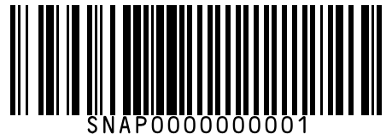
#2 | India Gate Classic Basmati Rice 5 kg
Brand: India Gate
Variant: 5.000 kg
SKU Code: SMSKU-000002
MRP: ₹1050.00 | Sell: ₹999.00 | Discount: ₹51.00 flat | Final: ₹948.00
Available Qty: 12
Barcode: SNAP0000000002
 | 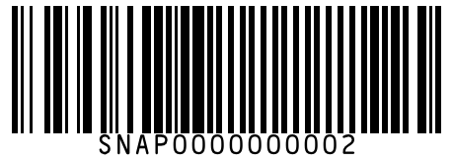
#3 | Daawat Rozana Basmati Rice 1 kg
Brand: Daawat
Variant: 1.000 kg
SKU Code: SMSKU-000003
MRP: ₹150.00 | Sell: ₹140.00 | Discount: ₹10.00 flat | Final: ₹130.00
Available Qty: 18
Barcode: SNAP0000000003
 | 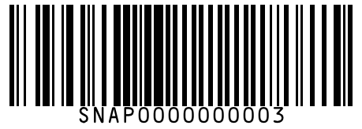
#4 | Daawat Rozana Basmati Rice 5 kg
Brand: Daawat
Variant: 5.000 kg
SKU Code: SMSKU-000004
MRP: ₹720.00 | Sell: ₹680.00 | Discount: ₹40.00 flat | Final: ₹640.00
Available Qty: 10
Barcode: SNAP0000000004
 | 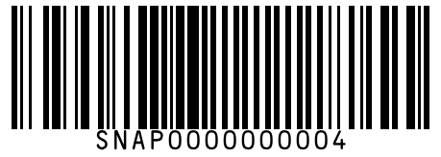
#5 | Fortune Everyday Basmati Rice 1 kg
Brand: Fortune
Variant: 1.000 kg
SKU Code: SMSKU-000005
MRP: ₹130.00 | Sell: ₹125.00 | Discount: 3.85% | Final: ₹120.19
Available Qty: 22
Barcode: SNAP0000000005
 | 
#6 | Fortune Everyday Basmati Rice 5 kg
Brand: Fortune
Variant: 5.000 kg
SKU Code: SMSKU-000006
MRP: ₹625.00 | Sell: ₹599.00 | Discount: ₹26.00 flat | Final: ₹573.00
Available Qty: 8
Barcode: SNAP0000000006
 | 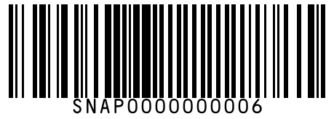
#7 | Sona Masoori HMT Sona Masoori Rice 1 kg
Brand: Sona Masoori
Variant: 1.000 kg
SKU Code: SMSKU-000007
MRP: ₹60.00 | Sell: ₹58.00 | Discount: ₹2.00 flat | Final: ₹56.00
Available Qty: 30
Barcode: SNAP0000000007
 | 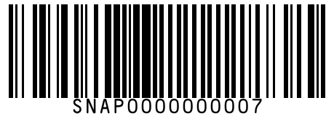
#8 | Sona Masoori HMT Sona Masoori Rice 5 kg
Brand: Sona Masoori
Variant: 5.000 kg
SKU Code: SMSKU-000008
MRP: ₹280.00 | Sell: ₹265.00 | Discount: ₹15.00 flat | Final: ₹250.00
Available Qty: 14
Barcode: SNAP0000000008
 | 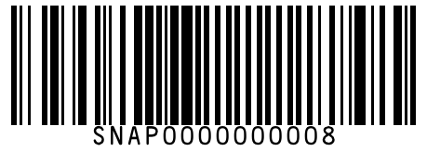
#9 | Sona Masoori HMT Sona Masoori Rice 10 kg
Brand: Sona Masoori
Variant: 10.000 kg
SKU Code: SMSKU-000009
MRP: ₹540.00 | Sell: ₹520.00 | Discount: ₹20.00 flat | Final: ₹500.00
Available Qty: 6
Barcode: SNAP0000000009
 | 
#10 | 24 Mantra Organic Sonamasuri Brown Rice 1 kg
Brand: 24 Mantra Organic
Variant: 1.000 kg
SKU Code: SMSKU-000010
MRP: ₹145.00 | Sell: ₹138.00 | Discount: 4.83% | Final: ₹131.33
Available Qty: 15
Barcode: SNAP0000000010
 | 
#11 | Kohinoor Super Silver Aged Basmati Rice 1 kg
Brand: Kohinoor
Variant: 1.000 kg
SKU Code: SMSKU-000011
MRP: ₹260.00 | Sell: ₹245.00 | Discount: ₹15.00 flat | Final: ₹230.00
Available Qty: 10
Barcode: SNAP0000000011
 | 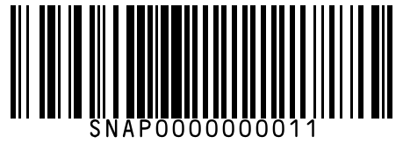
#12 | Kohinoor Super Silver Aged Basmati Rice 5 kg
Brand: Kohinoor
Variant: 5.000 kg
SKU Code: SMSKU-000012
MRP: ₹1250.00 | Sell: ₹1190.00 | Discount: ₹60.00 flat | Final: ₹1130.00
Available Qty: 5
Barcode: SNAP0000000012
 | 
#13 | BB Royal Ponni Boiled Rice 1 kg
Brand: BB Royal
Variant: 1.000 kg
SKU Code: SMSKU-000013
MRP: ₹55.00 | Sell: ₹52.00 | Discount: ₹3.00 flat | Final: ₹49.00
Available Qty: 35
Barcode: SNAP0000000013
 | 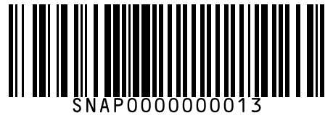
#14 | BB Royal Ponni Boiled Rice 5 kg
Brand: BB Royal
Variant: 5.000 kg
SKU Code: SMSKU-000014
MRP: ₹260.00 | Sell: ₹245.00 | Discount: ₹15.00 flat | Final: ₹230.00
Available Qty: 12
Barcode: SNAP0000000014
 | 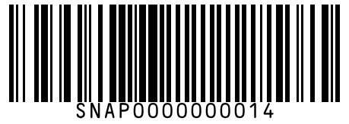
#15 | Fortune Biryani Special Basmati Rice 1 kg
Brand: Fortune
Variant: 1.000 kg
SKU Code: SMSKU-000015
MRP: ₹190.00 | Sell: ₹180.00 | Discount: ₹10.00 flat | Final: ₹170.00
Available Qty: 14
Barcode: SNAP0000000015
 | 
#16 | Dawat Brown Basmati Rice 1 kg
Brand: Dawat
Variant: 1.000 kg
SKU Code: SMSKU-000016
MRP: ₹180.00 | Sell: ₹170.00 | Discount: ₹10.00 flat | Final: ₹160.00
Available Qty: 8
Barcode: SNAP0000000016
 | 
#17 | Sri Lalitha Idli Rice 1 kg
Brand: Sri Lalitha
Variant: 1.000 kg
SKU Code: SMSKU-000017
MRP: ₹58.00 | Sell: ₹55.00 | Discount: ₹3.00 flat | Final: ₹52.00
Available Qty: 25
Barcode: SNAP0000000017
 | 
#18 | Sri Lalitha Idli Rice 5 kg
Brand: Sri Lalitha
Variant: 5.000 kg
SKU Code: SMSKU-000018
MRP: ₹275.00 | Sell: ₹260.00 | Discount: ₹15.00 flat | Final: ₹245.00
Available Qty: 10
Barcode: SNAP0000000018
 | 
#19 | Tata Sampann Toor Dal 500 g
Brand: Tata Sampann
Variant: 500.000 g
SKU Code: SMSKU-000019
MRP: ₹80.00 | Sell: ₹75.00 | Discount: ₹5.00 flat | Final: ₹70.00
Available Qty: 25
Barcode: SNAP0000000019
 | 
#20 | Tata Sampann Toor Dal 1 kg
Brand: Tata Sampann
Variant: 1.000 kg
SKU Code: SMSKU-000020
MRP: ₹155.00 | Sell: ₹145.00 | Discount: ₹10.00 flat | Final: ₹135.00
Available Qty: 15
Barcode: SNAP0000000020
 | 
#21 | Tata Sampann Moong Dal 500 g
Brand: Tata Sampann
Variant: 500.000 g
SKU Code: SMSKU-000021
MRP: ₹95.00 | Sell: ₹88.00 | Discount: ₹7.00 flat | Final: ₹81.00
Available Qty: 20
Barcode: SNAP0000000021
 | 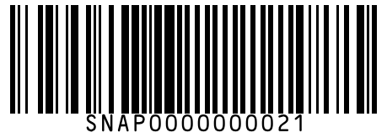
#22 | Tata Sampann Moong Dal 1 kg
Brand: Tata Sampann
Variant: 1.000 kg
SKU Code: SMSKU-000022
MRP: ₹185.00 | Sell: ₹175.00 | Discount: ₹10.00 flat | Final: ₹165.00
Available Qty: 12
Barcode: SNAP0000000022
 | 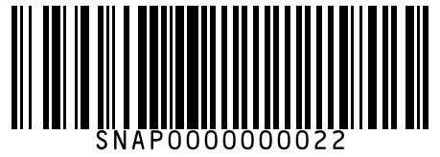
#23 | Tata Sampann Chana Dal 500 g
Brand: Tata Sampann
Variant: 500.000 g
SKU Code: SMSKU-000023
MRP: ₹70.00 | Sell: ₹65.00 | Discount: ₹5.00 flat | Final: ₹60.00
Available Qty: 22
Barcode: SNAP0000000023
 | 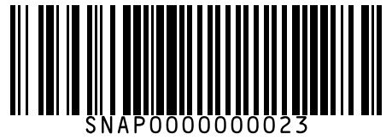
#24 | Tata Sampann Chana Dal 1 kg
Brand: Tata Sampann
Variant: 1.000 kg
SKU Code: SMSKU-000024
MRP: ₹135.00 | Sell: ₹128.00 | Discount: ₹7.00 flat | Final: ₹121.00
Available Qty: 14
Barcode: SNAP0000000024
 | 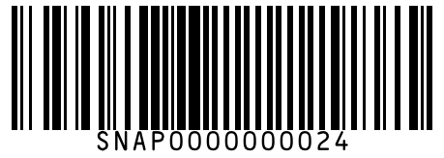
#25 | Tata Sampann Masoor Dal 500 g
Brand: Tata Sampann
Variant: 500.000 g
SKU Code: SMSKU-000025
MRP: ₹75.00 | Sell: ₹70.00 | Discount: ₹5.00 flat | Final: ₹65.00
Available Qty: 18
Barcode: SNAP0000000025
 | 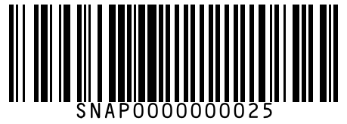
#26 | Tata Sampann Masoor Dal 1 kg
Brand: Tata Sampann
Variant: 1.000 kg
SKU Code: SMSKU-000026
MRP: ₹145.00 | Sell: ₹138.00 | Discount: ₹7.00 flat | Final: ₹131.00
Available Qty: 10
Barcode: SNAP0000000026
 | 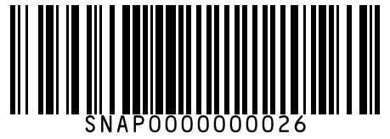
#27 | Tata Sampann Urad Dal 500 g
Brand: Tata Sampann
Variant: 500.000 g
SKU Code: SMSKU-000027
MRP: ₹90.00 | Sell: ₹85.00 | Discount: 5.56% | Final: ₹80.27
Available Qty: 16
Barcode: SNAP0000000027
 | 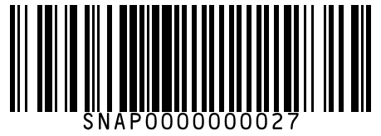
#28 | Tata Sampann Urad Dal 1 kg
Brand: Tata Sampann
Variant: 1.000 kg
SKU Code: SMSKU-000028
MRP: ₹175.00 | Sell: ₹165.00 | Discount: ₹10.00 flat | Final: ₹155.00
Available Qty: 8
Barcode: SNAP0000000028
 | 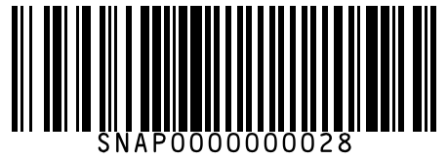
#29 | 24 Mantra Organic Organic Toor Dal 500 g
Brand: 24 Mantra Organic
Variant: 500.000 g
SKU Code: SMSKU-000029
MRP: ₹110.00 | Sell: ₹105.00 | Discount: 4.55% | Final: ₹100.22
Available Qty: 10
Barcode: SNAP0000000029
 | 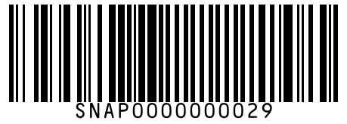
#30 | BB Royal Rajma (Red Kidney Beans) 500 g
Brand: BB Royal
Variant: 500.000 g
SKU Code: SMSKU-000030
MRP: ₹85.00 | Sell: ₹80.00 | Discount: ₹5.00 flat | Final: ₹75.00
Available Qty: 14
Barcode: SNAP0000000030
 | 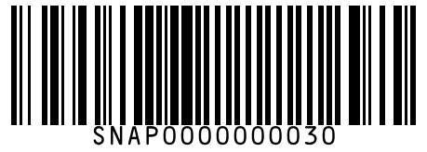
#31 | BB Royal Rajma (Red Kidney Beans) 1 kg
Brand: BB Royal
Variant: 1.000 kg
SKU Code: SMSKU-000031
MRP: ₹165.00 | Sell: ₹155.00 | Discount: ₹10.00 flat | Final: ₹145.00
Available Qty: 8
Barcode: SNAP0000000031
 | 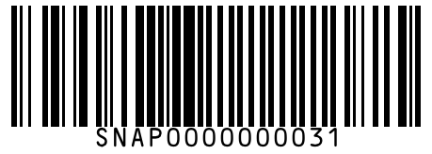
#32 | BB Royal Kabuli Chana 500 g
Brand: BB Royal
Variant: 500.000 g
SKU Code: SMSKU-000032
MRP: ₹95.00 | Sell: ₹90.00 | Discount: ₹5.00 flat | Final: ₹85.00
Available Qty: 12
Barcode: SNAP0000000032
 | 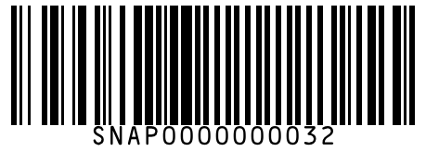
#33 | BB Royal Kabuli Chana 1 kg
Brand: BB Royal
Variant: 1.000 kg
SKU Code: SMSKU-000033
MRP: ₹185.00 | Sell: ₹175.00 | Discount: ₹10.00 flat | Final: ₹165.00
Available Qty: 7
Barcode: SNAP0000000033
 | 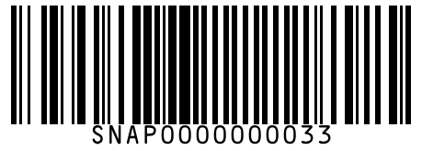
#34 | BB Royal Black Urad Whole 500 g
Brand: BB Royal
Variant: 500.000 g
SKU Code: SMSKU-000034
MRP: ₹88.00 | Sell: ₹82.00 | Discount: ₹6.00 flat | Final: ₹76.00
Available Qty: 15
Barcode: SNAP0000000034
 | 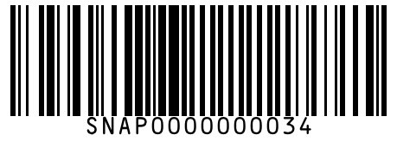
#35 | Fortune Arhar Dal 1 kg
Brand: Fortune
Variant: 1.000 kg
SKU Code: SMSKU-000035
MRP: ₹160.00 | Sell: ₹150.00 | Discount: ₹10.00 flat | Final: ₹140.00
Available Qty: 11
Barcode: SNAP0000000035
 | 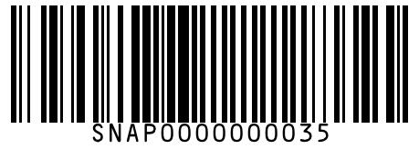
#36 | Aashirvaad Whole Wheat Atta 1 kg
Brand: Aashirvaad
Variant: 1.000 kg
SKU Code: SMSKU-000036
MRP: ₹62.00 | Sell: ₹58.00 | Discount: ₹4.00 flat | Final: ₹54.00
Available Qty: 30
Barcode: SNAP0000000036
 | 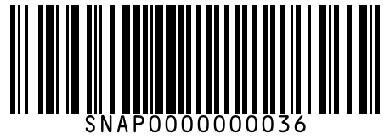
#37 | Aashirvaad Whole Wheat Atta 5 kg
Brand: Aashirvaad
Variant: 5.000 kg
SKU Code: SMSKU-000037
MRP: ₹295.00 | Sell: ₹279.00 | Discount: ₹16.00 flat | Final: ₹263.00
Available Qty: 15
Barcode: SNAP0000000037
 | 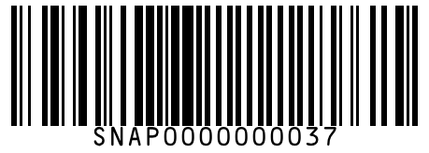
#38 | Aashirvaad Whole Wheat Atta 10 kg
Brand: Aashirvaad
Variant: 10.000 kg
SKU Code: SMSKU-000038
MRP: ₹570.00 | Sell: ₹545.00 | Discount: ₹25.00 flat | Final: ₹520.00
Available Qty: 8
Barcode: SNAP0000000038
 | 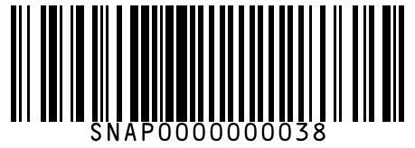
#39 | Aashirvaad Multigrains Atta 1 kg
Brand: Aashirvaad
Variant: 1.000 kg
SKU Code: SMSKU-000039
MRP: ₹75.00 | Sell: ₹70.00 | Discount: ₹5.00 flat | Final: ₹65.00
Available Qty: 20
Barcode: SNAP0000000039
 | 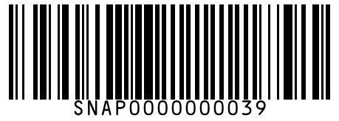
#40 | Aashirvaad Multigrains Atta 5 kg
Brand: Aashirvaad
Variant: 5.000 kg
SKU Code: SMSKU-000040
MRP: ₹355.00 | Sell: ₹335.00 | Discount: ₹20.00 flat | Final: ₹315.00
Available Qty: 10
Barcode: SNAP0000000040
 | 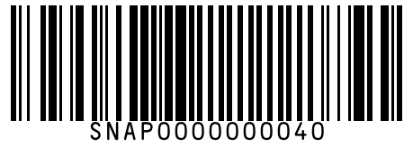
#41 | Pillsbury Chakki Fresh Atta 1 kg
Brand: Pillsbury
Variant: 1.000 kg
SKU Code: SMSKU-000041
MRP: ₹60.00 | Sell: ₹56.00 | Discount: ₹4.00 flat | Final: ₹52.00
Available Qty: 25
Barcode: SNAP0000000041
 | 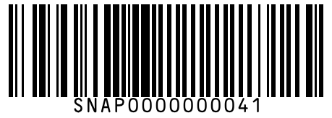
#42 | Pillsbury Chakki Fresh Atta 5 kg
Brand: Pillsbury
Variant: 5.000 kg
SKU Code: SMSKU-000042
MRP: ₹285.00 | Sell: ₹270.00 | Discount: ₹15.00 flat | Final: ₹255.00
Available Qty: 12
Barcode: SNAP0000000042
 | 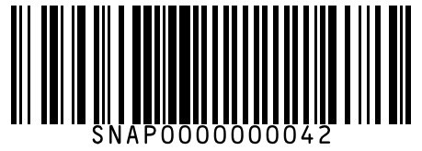
#43 | Fortune Chakki Atta 1 kg
Brand: Fortune
Variant: 1.000 kg
SKU Code: SMSKU-000043
MRP: ₹58.00 | Sell: ₹55.00 | Discount: ₹3.00 flat | Final: ₹52.00
Available Qty: 22
Barcode: SNAP0000000043
 | 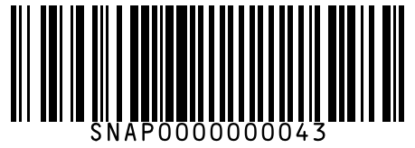
#44 | Fortune Chakki Atta 5 kg
Brand: Fortune
Variant: 5.000 kg
SKU Code: SMSKU-000044
MRP: ₹275.00 | Sell: ₹260.00 | Discount: ₹15.00 flat | Final: ₹245.00
Available Qty: 10
Barcode: SNAP0000000044
 | 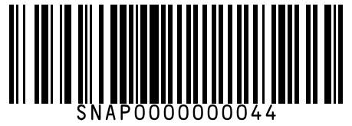
#45 | Rajdhani Besan (Gram Flour) 500 g
Brand: Rajdhani
Variant: 500.000 g
SKU Code: SMSKU-000045
MRP: ₹65.00 | Sell: ₹60.00 | Discount: ₹5.00 flat | Final: ₹55.00
Available Qty: 18
Barcode: SNAP0000000045
 | 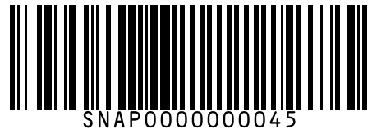
#46 | Rajdhani Besan (Gram Flour) 1 kg
Brand: Rajdhani
Variant: 1.000 kg
SKU Code: SMSKU-000046
MRP: ₹125.00 | Sell: ₹118.00 | Discount: ₹7.00 flat | Final: ₹111.00
Available Qty: 12
Barcode: SNAP0000000046
 | 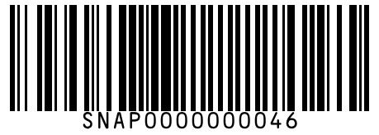
#47 | BB Royal Maida (All Purpose Flour) 500 g
Brand: BB Royal
Variant: 500.000 g
SKU Code: SMSKU-000047
MRP: ₹35.00 | Sell: ₹32.00 | Discount: ₹3.00 flat | Final: ₹29.00
Available Qty: 20
Barcode: SNAP0000000047
 | 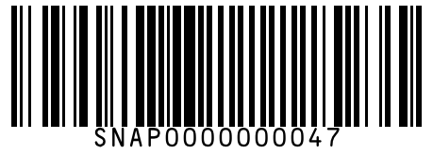
#48 | BB Royal Maida (All Purpose Flour) 1 kg
Brand: BB Royal
Variant: 1.000 kg
SKU Code: SMSKU-000048
MRP: ₹65.00 | Sell: ₹60.00 | Discount: ₹5.00 flat | Final: ₹55.00
Available Qty: 14
Barcode: SNAP0000000048
 | 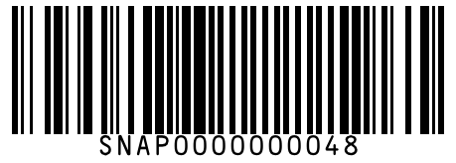
#49 | BB Royal Rava (Semolina) 500 g
Brand: BB Royal
Variant: 500.000 g
SKU Code: SMSKU-000049
MRP: ₹40.00 | Sell: ₹38.00 | Discount: ₹2.00 flat | Final: ₹36.00
Available Qty: 22
Barcode: SNAP0000000049
 | 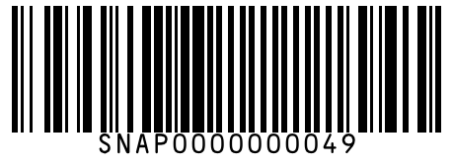
#50 | BB Royal Rava (Semolina) 1 kg
Brand: BB Royal
Variant: 1.000 kg
SKU Code: SMSKU-000050
MRP: ₹75.00 | Sell: ₹70.00 | Discount: ₹5.00 flat | Final: ₹65.00
Available Qty: 15
Barcode: SNAP0000000050
 | 
#51 | Fortune Sunlite Refined Sunflower Oil 1 L
Brand: Fortune
Variant: 1.000 L
SKU Code: SMSKU-000051
MRP: ₹160.00 | Sell: ₹150.00 | Discount: ₹10.00 flat | Final: ₹140.00
Available Qty: 25
Barcode: SNAP0000000051
 | 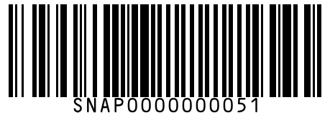
#52 | Fortune Sunlite Refined Sunflower Oil 2 L
Brand: Fortune
Variant: 2.000 L
SKU Code: SMSKU-000052
MRP: ₹310.00 | Sell: ₹295.00 | Discount: ₹15.00 flat | Final: ₹280.00
Available Qty: 12
Barcode: SNAP0000000052
 | 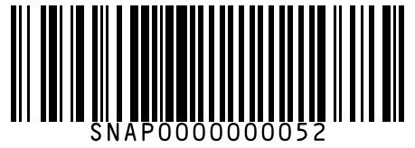
#53 | Fortune Sunlite Refined Sunflower Oil 5 L
Brand: Fortune
Variant: 5.000 L
SKU Code: SMSKU-000053
MRP: ₹745.00 | Sell: ₹710.00 | Discount: ₹35.00 flat | Final: ₹675.00
Available Qty: 6
Barcode: SNAP0000000053
 | 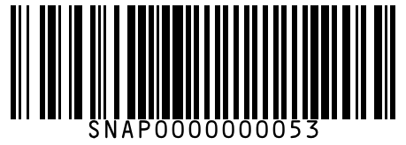
#54 | Saffola Gold Refined Oil 1 L
Brand: Saffola
Variant: 1.000 L
SKU Code: SMSKU-000054
MRP: ₹210.00 | Sell: ₹198.00 | Discount: ₹12.00 flat | Final: ₹186.00
Available Qty: 20
Barcode: SNAP0000000054
 | 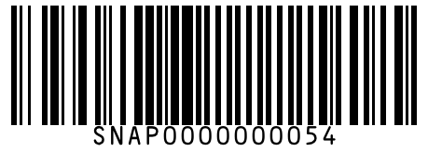
#55 | Saffola Gold Refined Oil 2 L
Brand: Saffola
Variant: 2.000 L
SKU Code: SMSKU-000055
MRP: ₹410.00 | Sell: ₹390.00 | Discount: ₹20.00 flat | Final: ₹370.00
Available Qty: 10
Barcode: SNAP0000000055
 | 
#56 | Saffola Gold Refined Oil 5 L
Brand: Saffola
Variant: 5.000 L
SKU Code: SMSKU-000056
MRP: ₹990.00 | Sell: ₹950.00 | Discount: ₹40.00 flat | Final: ₹910.00
Available Qty: 5
Barcode: SNAP0000000056
 | 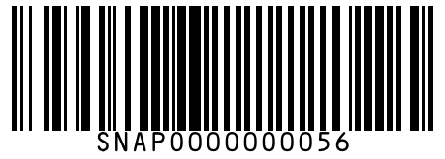
#57 | Sundrop Heart Lite Sunflower Oil 1 L
Brand: Sundrop
Variant: 1.000 L
SKU Code: SMSKU-000057
MRP: ₹175.00 | Sell: ₹165.00 | Discount: ₹10.00 flat | Final: ₹155.00
Available Qty: 18
Barcode: SNAP0000000057
 | 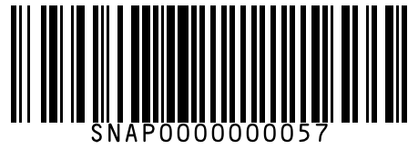
#58 | Sundrop Heart Lite Sunflower Oil 2 L
Brand: Sundrop
Variant: 2.000 L
SKU Code: SMSKU-000058
MRP: ₹340.00 | Sell: ₹320.00 | Discount: ₹20.00 flat | Final: ₹300.00
Available Qty: 8
Barcode: SNAP0000000058
 | 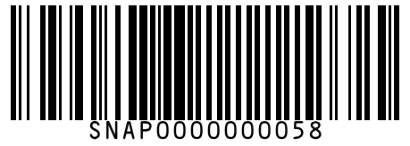
#59 | Nature Fresh Kachi Ghani Mustard Oil 1 L
Brand: Nature Fresh
Variant: 1.000 L
SKU Code: SMSKU-000059
MRP: ₹190.00 | Sell: ₹180.00 | Discount: ₹10.00 flat | Final: ₹170.00
Available Qty: 15
Barcode: SNAP0000000059
 | 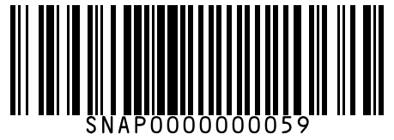
#60 | Nature Fresh Kachi Ghani Mustard Oil 5 L
Brand: Nature Fresh
Variant: 5.000 L
SKU Code: SMSKU-000060
MRP: ₹910.00 | Sell: ₹870.00 | Discount: ₹40.00 flat | Final: ₹830.00
Available Qty: 4
Barcode: SNAP0000000060
 | 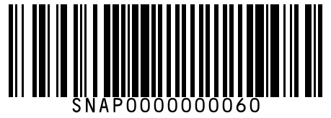
#61 | Dhara Refined Groundnut Oil 1 L
Brand: Dhara
Variant: 1.000 L
SKU Code: SMSKU-000061
MRP: ₹220.00 | Sell: ₹210.00 | Discount: ₹10.00 flat | Final: ₹200.00
Available Qty: 12
Barcode: SNAP0000000061
 | 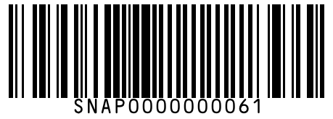
#62 | Dhara Refined Groundnut Oil 5 L
Brand: Dhara
Variant: 5.000 L
SKU Code: SMSKU-000062
MRP: ₹1050.00 | Sell: ₹1000.00 | Discount: ₹50.00 flat | Final: ₹950.00
Available Qty: 4
Barcode: SNAP0000000062
 | 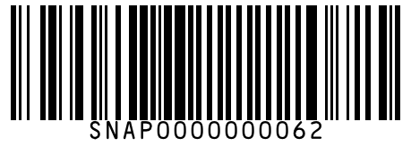
#63 | KLF Coconad Pure Coconut Oil 500 ml
Brand: KLF Coconad
Variant: 500.000 ml
SKU Code: SMSKU-000063
MRP: ₹130.00 | Sell: ₹122.00 | Discount: ₹8.00 flat | Final: ₹114.00
Available Qty: 20
Barcode: SNAP0000000063
 | 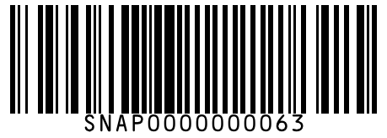
#64 | KLF Coconad Pure Coconut Oil 1 L
Brand: KLF Coconad
Variant: 1.000 L
SKU Code: SMSKU-000064
MRP: ₹250.00 | Sell: ₹238.00 | Discount: ₹12.00 flat | Final: ₹226.00
Available Qty: 10
Barcode: SNAP0000000064
 | 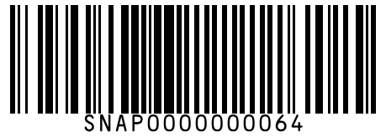
#65 | Figaro Olive Oil 250 ml
Brand: Figaro
Variant: 250.000 ml
SKU Code: SMSKU-000065
MRP: ₹320.00 | Sell: ₹305.00 | Discount: 4.69% | Final: ₹290.70
Available Qty: 8
Barcode: SNAP0000000065
 | 
#66 | Figaro Olive Oil 500 ml
Brand: Figaro
Variant: 500.000 ml
SKU Code: SMSKU-000066
MRP: ₹600.00 | Sell: ₹570.00 | Discount: ₹30.00 flat | Final: ₹540.00
Available Qty: 5
Barcode: SNAP0000000066
 | 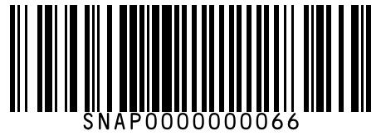
#67 | Fortune Rice Bran Health Oil 1 L
Brand: Fortune
Variant: 1.000 L
SKU Code: SMSKU-000067
MRP: ₹185.00 | Sell: ₹175.00 | Discount: ₹10.00 flat | Final: ₹165.00
Available Qty: 14
Barcode: SNAP0000000067
 | 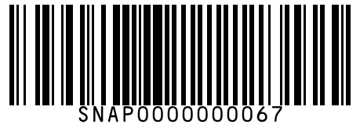
#68 | Fortune Rice Bran Health Oil 5 L
Brand: Fortune
Variant: 5.000 L
SKU Code: SMSKU-000068
MRP: ₹880.00 | Sell: ₹840.00 | Discount: ₹40.00 flat | Final: ₹800.00
Available Qty: 5
Barcode: SNAP0000000068
 | 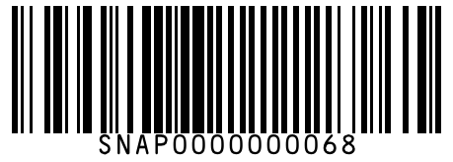
#69 | MDH Garam Masala 50 g
Brand: MDH
Variant: 50.000 g
SKU Code: SMSKU-000069
MRP: ₹58.00 | Sell: ₹55.00 | Discount: ₹3.00 flat | Final: ₹52.00
Available Qty: 30
Barcode: SNAP0000000069
 | 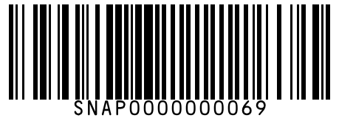
#70 | MDH Garam Masala 100 g
Brand: MDH
Variant: 100.000 g
SKU Code: SMSKU-000070
MRP: ₹110.00 | Sell: ₹105.00 | Discount: 4.55% | Final: ₹100.22
Available Qty: 20
Barcode: SNAP0000000070
 | 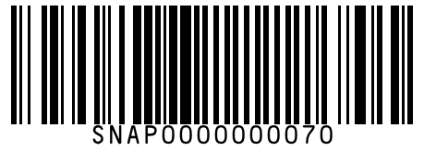
#71 | MDH Chana Masala 100 g
Brand: MDH
Variant: 100.000 g
SKU Code: SMSKU-000071
MRP: ₹70.00 | Sell: ₹65.00 | Discount: ₹5.00 flat | Final: ₹60.00
Available Qty: 22
Barcode: SNAP0000000071
 | 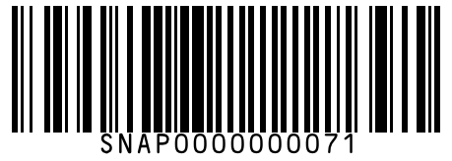
#72 | MDH Kitchen King Masala 100 g
Brand: MDH
Variant: 100.000 g
SKU Code: SMSKU-000072
MRP: ₹95.00 | Sell: ₹90.00 | Discount: ₹5.00 flat | Final: ₹85.00
Available Qty: 18
Barcode: SNAP0000000072
 | 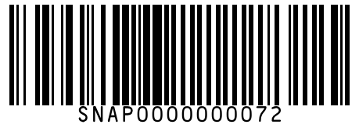
#73 | MDH Pav Bhaji Masala 100 g
Brand: MDH
Variant: 100.000 g
SKU Code: SMSKU-000073
MRP: ₹72.00 | Sell: ₹68.00 | Discount: ₹4.00 flat | Final: ₹64.00
Available Qty: 15
Barcode: SNAP0000000073
 | 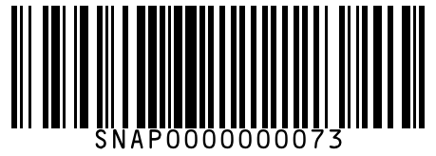
#74 | MDH Sambhar Masala 100 g
Brand: MDH
Variant: 100.000 g
SKU Code: SMSKU-000074
MRP: ₹68.00 | Sell: ₹64.00 | Discount: ₹4.00 flat | Final: ₹60.00
Available Qty: 20
Barcode: SNAP0000000074
 | 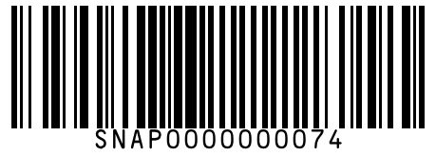
#75 | Everest Turmeric Powder 100 g
Brand: Everest
Variant: 100.000 g
SKU Code: SMSKU-000075
MRP: ₹42.00 | Sell: ₹40.00 | Discount: ₹2.00 flat | Final: ₹38.00
Available Qty: 35
Barcode: SNAP0000000075
 | 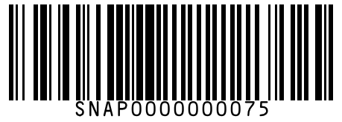
#76 | Everest Turmeric Powder 200 g
Brand: Everest
Variant: 200.000 g
SKU Code: SMSKU-000076
MRP: ₹80.00 | Sell: ₹75.00 | Discount: ₹5.00 flat | Final: ₹70.00
Available Qty: 20
Barcode: SNAP0000000076
 | 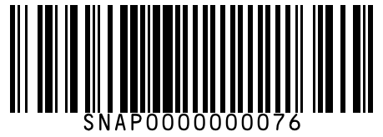
#77 | Everest Turmeric Powder 500 g
Brand: Everest
Variant: 500.000 g
SKU Code: SMSKU-000077
MRP: ₹190.00 | Sell: ₹180.00 | Discount: ₹10.00 flat | Final: ₹170.00
Available Qty: 10
Barcode: SNAP0000000077
 | 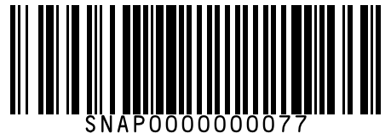
#78 | Everest Red Chilli Powder 100 g
Brand: Everest
Variant: 100.000 g
SKU Code: SMSKU-000078
MRP: ₹55.00 | Sell: ₹52.00 | Discount: ₹3.00 flat | Final: ₹49.00
Available Qty: 30
Barcode: SNAP0000000078
 | 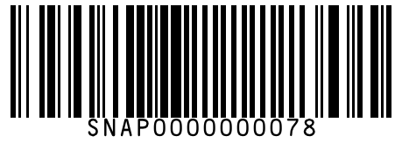
#79 | Everest Red Chilli Powder 200 g
Brand: Everest
Variant: 200.000 g
SKU Code: SMSKU-000079
MRP: ₹105.00 | Sell: ₹100.00 | Discount: ₹5.00 flat | Final: ₹95.00
Available Qty: 18
Barcode: SNAP0000000079
 | 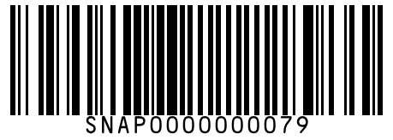
#80 | Everest Red Chilli Powder 500 g
Brand: Everest
Variant: 500.000 g
SKU Code: SMSKU-000080
MRP: ₹250.00 | Sell: ₹238.00 | Discount: ₹12.00 flat | Final: ₹226.00
Available Qty: 8
Barcode: SNAP0000000080
 | 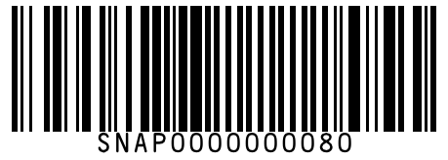
#81 | Everest Coriander Powder 100 g
Brand: Everest
Variant: 100.000 g
SKU Code: SMSKU-000081
MRP: ₹38.00 | Sell: ₹35.00 | Discount: ₹3.00 flat | Final: ₹32.00
Available Qty: 28
Barcode: SNAP0000000081
 | 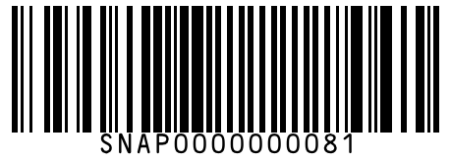
#82 | Everest Coriander Powder 200 g
Brand: Everest
Variant: 200.000 g
SKU Code: SMSKU-000082
MRP: ₹72.00 | Sell: ₹68.00 | Discount: ₹4.00 flat | Final: ₹64.00
Available Qty: 15
Barcode: SNAP0000000082
 | 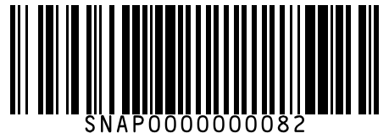
#83 | Everest Cumin Powder 100 g
Brand: Everest
Variant: 100.000 g
SKU Code: SMSKU-000083
MRP: ₹85.00 | Sell: ₹80.00 | Discount: ₹5.00 flat | Final: ₹75.00
Available Qty: 20
Barcode: SNAP0000000083
 | 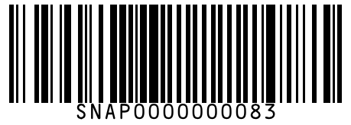
#84 | Everest Cumin Powder 200 g
Brand: Everest
Variant: 200.000 g
SKU Code: SMSKU-000084
MRP: ₹165.00 | Sell: ₹155.00 | Discount: ₹10.00 flat | Final: ₹145.00
Available Qty: 10
Barcode: SNAP0000000084
 | 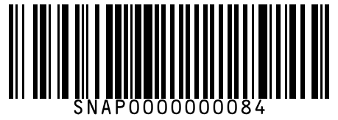
#85 | Catch Black Pepper Powder 50 g
Brand: Catch
Variant: 50.000 g
SKU Code: SMSKU-000085
MRP: ₹90.00 | Sell: ₹85.00 | Discount: ₹5.00 flat | Final: ₹80.00
Available Qty: 15
Barcode: SNAP0000000085
 | 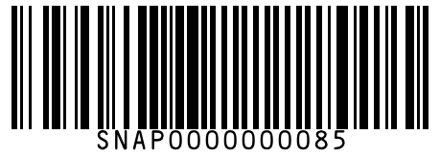
#86 | Catch Black Pepper Powder 100 g
Brand: Catch
Variant: 100.000 g
SKU Code: SMSKU-000086
MRP: ₹175.00 | Sell: ₹165.00 | Discount: ₹10.00 flat | Final: ₹155.00
Available Qty: 10
Barcode: SNAP0000000086
 | 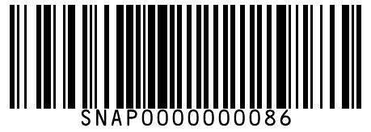
#87 | Catch Sprinklers Table Salt 200 g
Brand: Catch
Variant: 200.000 g
SKU Code: SMSKU-000087
MRP: ₹28.00 | Sell: ₹25.00 | Discount: ₹3.00 flat | Final: ₹22.00
Available Qty: 40
Barcode: SNAP0000000087
 | 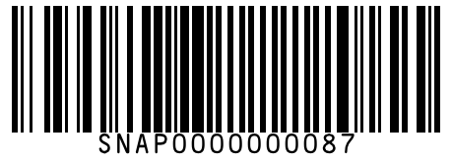
#88 | Tata Iodised Salt 1 kg
Brand: Tata
Variant: 1.000 kg
SKU Code: SMSKU-000088
MRP: ₹24.00 | Sell: ₹22.00 | Discount: ₹2.00 flat | Final: ₹20.00
Available Qty: 50
Barcode: SNAP0000000088
 | 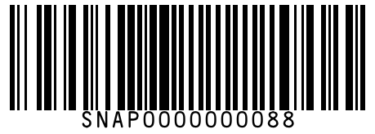
#89 | Sakthi Chicken Masala 50 g
Brand: Sakthi
Variant: 50.000 g
SKU Code: SMSKU-000089
MRP: ₹35.00 | Sell: ₹33.00 | Discount: ₹2.00 flat | Final: ₹31.00
Available Qty: 25
Barcode: SNAP0000000089
 | 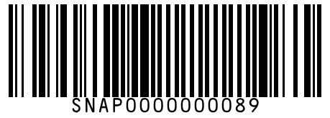
#90 | Sakthi Chicken Masala 100 g
Brand: Sakthi
Variant: 100.000 g
SKU Code: SMSKU-000090
MRP: ₹65.00 | Sell: ₹60.00 | Discount: ₹5.00 flat | Final: ₹55.00
Available Qty: 18
Barcode: SNAP0000000090
 | 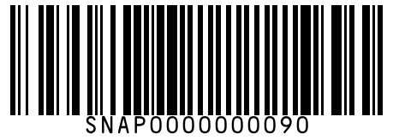
#91 | Sakthi Fish Curry Powder 50 g
Brand: Sakthi
Variant: 50.000 g
SKU Code: SMSKU-000091
MRP: ₹32.00 | Sell: ₹30.00 | Discount: ₹2.00 flat | Final: ₹28.00
Available Qty: 22
Barcode: SNAP0000000091
 | 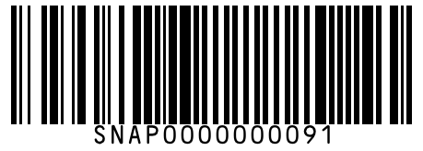
#92 | Sakthi Fish Curry Powder 100 g
Brand: Sakthi
Variant: 100.000 g
SKU Code: SMSKU-000092
MRP: ₹60.00 | Sell: ₹56.00 | Discount: ₹4.00 flat | Final: ₹52.00
Available Qty: 14
Barcode: SNAP0000000092
 | 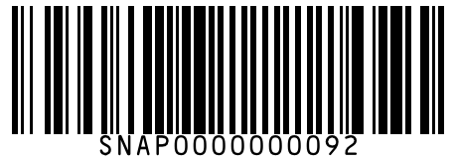
#93 | Eastern Biryani Masala 50 g
Brand: Eastern
Variant: 50.000 g
SKU Code: SMSKU-000093
MRP: ₹60.00 | Sell: ₹56.00 | Discount: ₹4.00 flat | Final: ₹52.00
Available Qty: 16
Barcode: SNAP0000000093
 | 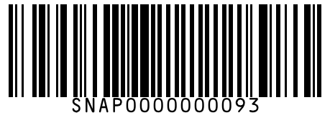
#94 | Eastern Rasam Powder 100 g
Brand: Eastern
Variant: 100.000 g
SKU Code: SMSKU-000094
MRP: ₹52.00 | Sell: ₹48.00 | Discount: ₹4.00 flat | Final: ₹44.00
Available Qty: 20
Barcode: SNAP0000000094
 | 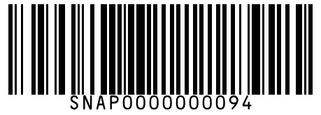
#95 | Tata Rock Salt 1 kg
Brand: Tata
Variant: 1.000 kg
SKU Code: SMSKU-000095
MRP: ₹35.00 | Sell: ₹32.00 | Discount: ₹3.00 flat | Final: ₹29.00
Available Qty: 30
Barcode: SNAP0000000095
 | 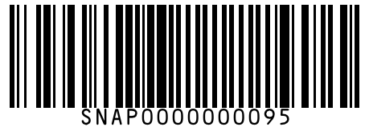
#96 | Nutrela Soya Chunks 200 g
Brand: Nutrela
Variant: 200.000 g
SKU Code: SMSKU-000096
MRP: ₹80.00 | Sell: ₹75.00 | Discount: ₹5.00 flat | Final: ₹70.00
Available Qty: 20
Barcode: SNAP0000000096
 | 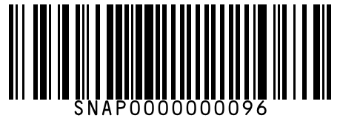
#97 | Nutrela Soya Chunks 500 g
Brand: Nutrela
Variant: 500.000 g
SKU Code: SMSKU-000097
MRP: ₹185.00 | Sell: ₹175.00 | Discount: ₹10.00 flat | Final: ₹165.00
Available Qty: 10
Barcode: SNAP0000000097
 | 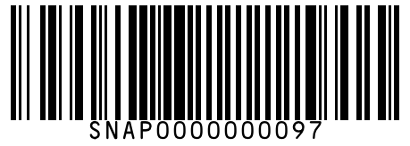
#98 | Maggi Coconut Milk 200 ml
Brand: Maggi
Variant: 200.000 ml
SKU Code: SMSKU-000098
MRP: ₹55.00 | Sell: ₹50.00 | Discount: ₹5.00 flat | Final: ₹45.00
Available Qty: 15
Barcode: SNAP0000000098
 | 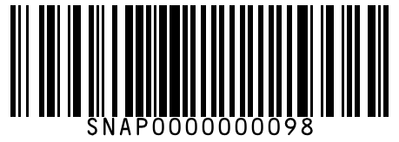
#99 | MTR Vermicelli 440 g
Brand: MTR
Variant: 440.000 g
SKU Code: SMSKU-000099
MRP: ₹48.00 | Sell: ₹45.00 | Discount: ₹3.00 flat | Final: ₹42.00
Available Qty: 18
Barcode: SNAP0000000099
 | 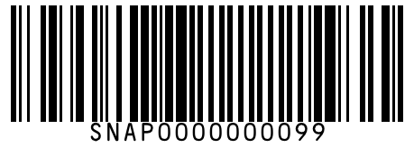
#100 | Bambino Vermicelli 850 g
Brand: Bambino
Variant: 850.000 g
SKU Code: SMSKU-000100
MRP: ₹65.00 | Sell: ₹60.00 | Discount: ₹5.00 flat | Final: ₹55.00
Available Qty: 12
Barcode: SNAP0000000100
 | 
#101 | Aachi Jaggery Powder 500 g
Brand: Aachi
Variant: 500.000 g
SKU Code: SMSKU-000101
MRP: ₹70.00 | Sell: ₹65.00 | Discount: ₹5.00 flat | Final: ₹60.00
Available Qty: 16
Barcode: SNAP0000000101
 | 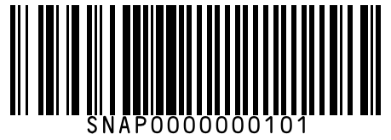
#102 | Manna Barnyard Millet 500 g
Brand: Manna
Variant: 500.000 g
SKU Code: SMSKU-000102
MRP: ₹120.00 | Sell: ₹112.00 | Discount: ₹8.00 flat | Final: ₹104.00
Available Qty: 10
Barcode: SNAP0000000102
 | 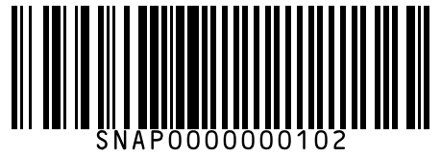
#103 | Manna Foxtail Millet 500 g
Brand: Manna
Variant: 500.000 g
SKU Code: SMSKU-000103
MRP: ₹115.00 | Sell: ₹108.00 | Discount: ₹7.00 flat | Final: ₹101.00
Available Qty: 12
Barcode: SNAP0000000103
 | 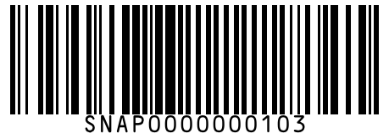
#104 | Manna Ragi Flour 500 g
Brand: Manna
Variant: 500.000 g
SKU Code: SMSKU-000104
MRP: ₹95.00 | Sell: ₹88.00 | Discount: ₹7.00 flat | Final: ₹81.00
Available Qty: 14
Barcode: SNAP0000000104
 | 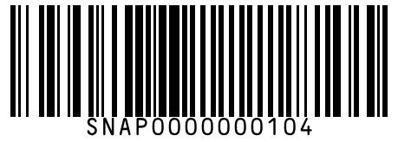
#105 | 24 Mantra Organic Jaggery 500 g
Brand: 24 Mantra Organic
Variant: 500.000 g
SKU Code: SMSKU-000105
MRP: ₹110.00 | Sell: ₹105.00 | Discount: 4.55% | Final: ₹100.22
Available Qty: 8
Barcode: SNAP0000000105
 | 
#106 | Sri Sri Tattva Poha (Flattened Rice) Thick 500 g
Brand: Sri Sri Tattva
Variant: 500.000 g
SKU Code: SMSKU-000106
MRP: ₹55.00 | Sell: ₹50.00 | Discount: ₹5.00 flat | Final: ₹45.00
Available Qty: 20
Barcode: SNAP0000000106
 | 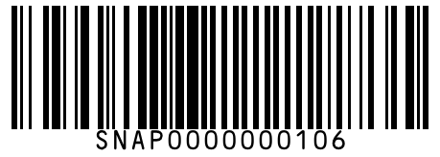
#107 | BB Royal Sugar Sulphurless 1 kg
Brand: BB Royal
Variant: 1.000 kg
SKU Code: SMSKU-000107
MRP: ₹48.00 | Sell: ₹45.00 | Discount: ₹3.00 flat | Final: ₹42.00
Available Qty: 35
Barcode: SNAP0000000107
 | 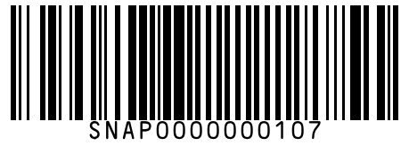
#108 | BB Royal Sugar Sulphurless 5 kg
Brand: BB Royal
Variant: 5.000 kg
SKU Code: SMSKU-000108
MRP: ₹230.00 | Sell: ₹220.00 | Discount: ₹10.00 flat | Final: ₹210.00
Available Qty: 12
Barcode: SNAP0000000108
 | 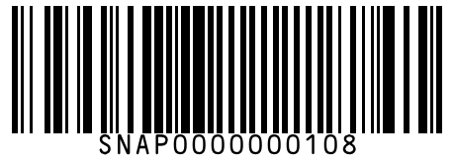
#109 | Aachi Tamarind Block 200 g
Brand: Aachi
Variant: 200.000 g
SKU Code: SMSKU-000109
MRP: ₹40.00 | Sell: ₹37.00 | Discount: ₹3.00 flat | Final: ₹34.00
Available Qty: 18
Barcode: SNAP0000000109
 | 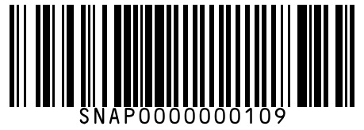
#110 | Aachi Tamarind Block 500 g
Brand: Aachi
Variant: 500.000 g
SKU Code: SMSKU-000110
MRP: ₹90.00 | Sell: ₹85.00 | Discount: ₹5.00 flat | Final: ₹80.00
Available Qty: 10
Barcode: SNAP0000000110
 | 
#111 | Eastern Papad – Cumin 200 g
Brand: Eastern
Variant: 200.000 g
SKU Code: SMSKU-000111
MRP: ₹65.00 | Sell: ₹60.00 | Discount: ₹5.00 flat | Final: ₹55.00
Available Qty: 15
Barcode: SNAP0000000111
 | 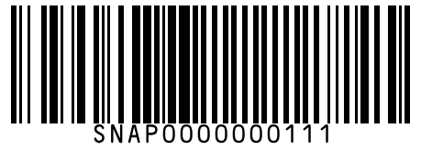
#112 | Lay's Classic Salted Chips 28 g
Brand: Lay's
Variant: 28.000 g
SKU Code: SMSKU-000112
MRP: ₹20.00 | Sell: ₹20.00 | Discount: None | Final: ₹20.00
Available Qty: 40
Barcode: SNAP0000000112
 | 
#113 | Lay's Classic Salted Chips 52 g
Brand: Lay's
Variant: 52.000 g
SKU Code: SMSKU-000113
MRP: ₹30.00 | Sell: ₹30.00 | Discount: None | Final: ₹30.00
Available Qty: 30
Barcode: SNAP0000000113
 | 
#114 | Lay's Classic Salted Chips 90 g
Brand: Lay's
Variant: 90.000 g
SKU Code: SMSKU-000114
MRP: ₹50.00 | Sell: ₹50.00 | Discount: None | Final: ₹50.00
Available Qty: 20
Barcode: SNAP0000000114
 | 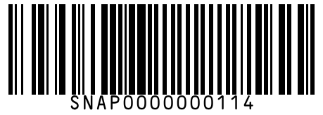
#115 | Lay's Classic Salted Chips 180 g
Brand: Lay's
Variant: 180.000 g
SKU Code: SMSKU-000115
MRP: ₹99.00 | Sell: ₹95.00 | Discount: ₹4.00 flat | Final: ₹91.00
Available Qty: 10
Barcode: SNAP0000000115
 | 
#116 | Lay's Magic Masala Chips 28 g
Brand: Lay's
Variant: 28.000 g
SKU Code: SMSKU-000116
MRP: ₹20.00 | Sell: ₹20.00 | Discount: None | Final: ₹20.00
Available Qty: 40
Barcode: SNAP0000000116
 | 
#117 | Lay's Magic Masala Chips 52 g
Brand: Lay's
Variant: 52.000 g
SKU Code: SMSKU-000117
MRP: ₹30.00 | Sell: ₹30.00 | Discount: None | Final: ₹30.00
Available Qty: 30
Barcode: SNAP0000000117
 | 
#118 | Lay's Magic Masala Chips 90 g
Brand: Lay's
Variant: 90.000 g
SKU Code: SMSKU-000118
MRP: ₹50.00 | Sell: ₹50.00 | Discount: None | Final: ₹50.00
Available Qty: 18
Barcode: SNAP0000000118
 | 
#119 | Lay's American Style Cream & Onion 52 g
Brand: Lay's
Variant: 52.000 g
SKU Code: SMSKU-000119
MRP: ₹30.00 | Sell: ₹30.00 | Discount: None | Final: ₹30.00
Available Qty: 28
Barcode: SNAP0000000119
 | 
#120 | Lay's American Style Cream & Onion 90 g
Brand: Lay's
Variant: 90.000 g
SKU Code: SMSKU-000120
MRP: ₹50.00 | Sell: ₹50.00 | Discount: None | Final: ₹50.00
Available Qty: 15
Barcode: SNAP0000000120
 | 
#121 | Kurkure Masala Munch 30 g
Brand: Kurkure
Variant: 30.000 g
SKU Code: SMSKU-000121
MRP: ₹10.00 | Sell: ₹10.00 | Discount: None | Final: ₹10.00
Available Qty: 45
Barcode: SNAP0000000121
 | 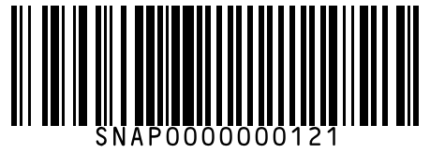
#122 | Kurkure Masala Munch 75 g
Brand: Kurkure
Variant: 75.000 g
SKU Code: SMSKU-000122
MRP: ₹20.00 | Sell: ₹20.00 | Discount: None | Final: ₹20.00
Available Qty: 30
Barcode: SNAP0000000122
 | 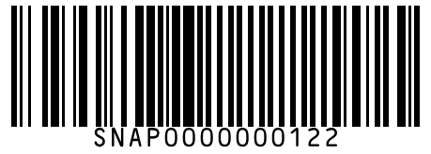
#123 | Kurkure Masala Munch 115 g
Brand: Kurkure
Variant: 115.000 g
SKU Code: SMSKU-000123
MRP: ₹30.00 | Sell: ₹30.00 | Discount: None | Final: ₹30.00
Available Qty: 22
Barcode: SNAP0000000123
 | 
#124 | Kurkure Puffcorn Yummy Cheese 32 g
Brand: Kurkure
Variant: 32.000 g
SKU Code: SMSKU-000124
MRP: ₹10.00 | Sell: ₹10.00 | Discount: None | Final: ₹10.00
Available Qty: 35
Barcode: SNAP0000000124
 | 
#125 | Kurkure Puffcorn Yummy Cheese 68 g
Brand: Kurkure
Variant: 68.000 g
SKU Code: SMSKU-000125
MRP: ₹20.00 | Sell: ₹20.00 | Discount: None | Final: ₹20.00
Available Qty: 20
Barcode: SNAP0000000125
 | 
#126 | Bingo Mad Angles Achari Masti 36 g
Brand: Bingo
Variant: 36.000 g
SKU Code: SMSKU-000126
MRP: ₹10.00 | Sell: ₹10.00 | Discount: None | Final: ₹10.00
Available Qty: 35
Barcode: SNAP0000000126
 | 
#127 | Bingo Mad Angles Achari Masti 72 g
Brand: Bingo
Variant: 72.000 g
SKU Code: SMSKU-000127
MRP: ₹20.00 | Sell: ₹20.00 | Discount: None | Final: ₹20.00
Available Qty: 22
Barcode: SNAP0000000127
 | 
#128 | Bingo Tedhe Medhe Masala Tadka 35 g
Brand: Bingo
Variant: 35.000 g
SKU Code: SMSKU-000128
MRP: ₹10.00 | Sell: ₹10.00 | Discount: None | Final: ₹10.00
Available Qty: 32
Barcode: SNAP0000000128
 | 
#129 | Bingo Tedhe Medhe Masala Tadka 66 g
Brand: Bingo
Variant: 66.000 g
SKU Code: SMSKU-000129
MRP: ₹20.00 | Sell: ₹20.00 | Discount: None | Final: ₹20.00
Available Qty: 20
Barcode: SNAP0000000129
 | 
#130 | Haldiram's Aloo Bhujia 200 g
Brand: Haldiram's
Variant: 200.000 g
SKU Code: SMSKU-000130
MRP: ₹80.00 | Sell: ₹75.00 | Discount: ₹5.00 flat | Final: ₹70.00
Available Qty: 18
Barcode: SNAP0000000130
 | 
#131 | Haldiram's Aloo Bhujia 400 g
Brand: Haldiram's
Variant: 400.000 g
SKU Code: SMSKU-000131
MRP: ₹155.00 | Sell: ₹145.00 | Discount: ₹10.00 flat | Final: ₹135.00
Available Qty: 10
Barcode: SNAP0000000131
 | 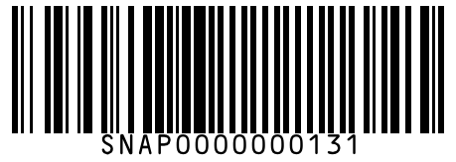
#132 | Haldiram's Moong Dal 200 g
Brand: Haldiram's
Variant: 200.000 g
SKU Code: SMSKU-000132
MRP: ₹75.00 | Sell: ₹70.00 | Discount: ₹5.00 flat | Final: ₹65.00
Available Qty: 16
Barcode: SNAP0000000132
 | 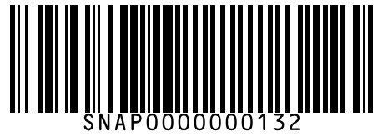
#133 | Haldiram's Moong Dal 400 g
Brand: Haldiram's
Variant: 400.000 g
SKU Code: SMSKU-000133
MRP: ₹145.00 | Sell: ₹135.00 | Discount: ₹10.00 flat | Final: ₹125.00
Available Qty: 8
Barcode: SNAP0000000133
 | 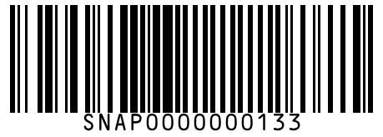
#134 | Haldiram's Namkeen Mixture 200 g
Brand: Haldiram's
Variant: 200.000 g
SKU Code: SMSKU-000134
MRP: ₹72.00 | Sell: ₹68.00 | Discount: ₹4.00 flat | Final: ₹64.00
Available Qty: 15
Barcode: SNAP0000000134
 | 
#135 | Haldiram's Namkeen Mixture 400 g
Brand: Haldiram's
Variant: 400.000 g
SKU Code: SMSKU-000135
MRP: ₹140.00 | Sell: ₹132.00 | Discount: ₹8.00 flat | Final: ₹124.00
Available Qty: 8
Barcode: SNAP0000000135
 | 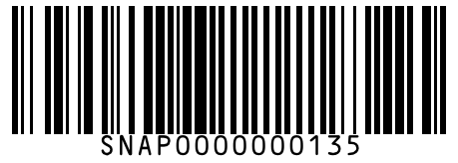
#136 | Pringles Original Salted Crisps 107 g
Brand: Pringles
Variant: 107.000 g
SKU Code: SMSKU-000136
MRP: ₹149.00 | Sell: ₹140.00 | Discount: ₹9.00 flat | Final: ₹131.00
Available Qty: 12
Barcode: SNAP0000000136
 | 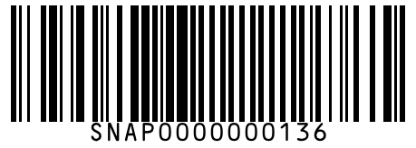
#137 | Pringles Sour Cream & Onion 107 g
Brand: Pringles
Variant: 107.000 g
SKU Code: SMSKU-000137
MRP: ₹149.00 | Sell: ₹140.00 | Discount: ₹9.00 flat | Final: ₹131.00
Available Qty: 10
Barcode: SNAP0000000137
 | 
#138 | Too Yumm Veggie Stix Herbs & Sundried Tomato 30 g
Brand: Too Yumm
Variant: 30.000 g
SKU Code: SMSKU-000138
MRP: ₹20.00 | Sell: ₹20.00 | Discount: None | Final: ₹20.00
Available Qty: 18
Barcode: SNAP0000000138
 | 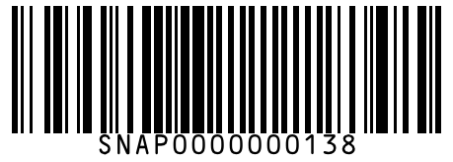
#139 | Parle Parle-G Gold Biscuits 100 g
Brand: Parle
Variant: 100.000 g
SKU Code: SMSKU-000139
MRP: ₹20.00 | Sell: ₹20.00 | Discount: None | Final: ₹20.00
Available Qty: 50
Barcode: SNAP0000000139
 | 
#140 | Parle Parle-G Gold Biscuits 250 g
Brand: Parle
Variant: 250.000 g
SKU Code: SMSKU-000140
MRP: ₹40.00 | Sell: ₹40.00 | Discount: None | Final: ₹40.00
Available Qty: 30
Barcode: SNAP0000000140
 | 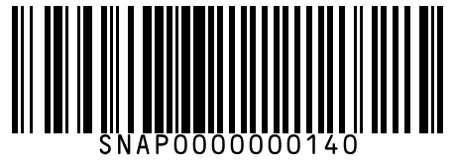
#141 | Parle Monaco Salted Biscuits 75 g
Brand: Parle
Variant: 75.000 g
SKU Code: SMSKU-000141
MRP: ₹20.00 | Sell: ₹20.00 | Discount: None | Final: ₹20.00
Available Qty: 35
Barcode: SNAP0000000141
 | 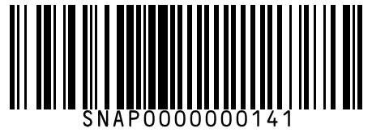
#142 | Parle Monaco Salted Biscuits 200 g
Brand: Parle
Variant: 200.000 g
SKU Code: SMSKU-000142
MRP: ₹45.00 | Sell: ₹45.00 | Discount: None | Final: ₹45.00
Available Qty: 20
Barcode: SNAP0000000142
 | 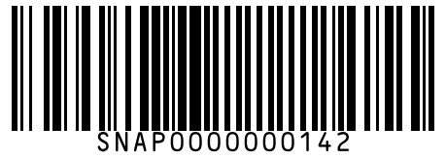
#143 | Britannia Good Day Cashew Cookies 75 g
Brand: Britannia
Variant: 75.000 g
SKU Code: SMSKU-000143
MRP: ₹25.00 | Sell: ₹25.00 | Discount: None | Final: ₹25.00
Available Qty: 35
Barcode: SNAP0000000143
 | 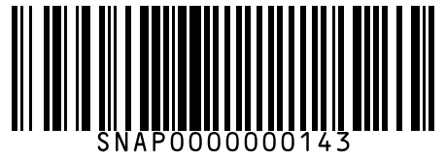
#144 | Britannia Good Day Cashew Cookies 200 g
Brand: Britannia
Variant: 200.000 g
SKU Code: SMSKU-000144
MRP: ₹55.00 | Sell: ₹52.00 | Discount: ₹3.00 flat | Final: ₹49.00
Available Qty: 18
Barcode: SNAP0000000144
 | 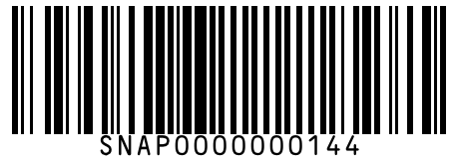
#145 | Britannia Marie Gold Biscuits 100 g
Brand: Britannia
Variant: 100.000 g
SKU Code: SMSKU-000145
MRP: ₹22.00 | Sell: ₹22.00 | Discount: None | Final: ₹22.00
Available Qty: 40
Barcode: SNAP0000000145
 | 
#146 | Britannia Marie Gold Biscuits 250 g
Brand: Britannia
Variant: 250.000 g
SKU Code: SMSKU-000146
MRP: ₹48.00 | Sell: ₹45.00 | Discount: ₹3.00 flat | Final: ₹42.00
Available Qty: 22
Barcode: SNAP0000000146
 | 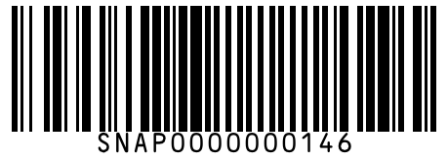
#147 | Britannia Jim Jam Cream Biscuits 100 g
Brand: Britannia
Variant: 100.000 g
SKU Code: SMSKU-000147
MRP: ₹30.00 | Sell: ₹30.00 | Discount: None | Final: ₹30.00
Available Qty: 28
Barcode: SNAP0000000147
 | 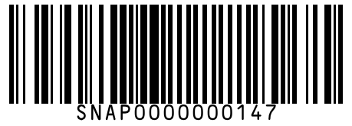
#148 | Britannia Jim Jam Cream Biscuits 150 g
Brand: Britannia
Variant: 150.000 g
SKU Code: SMSKU-000148
MRP: ₹40.00 | Sell: ₹38.00 | Discount: ₹2.00 flat | Final: ₹36.00
Available Qty: 18
Barcode: SNAP0000000148
 | 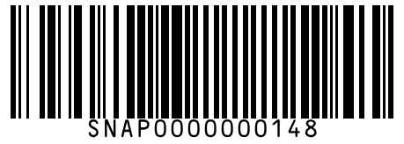
#149 | Britannia Bourbon Chocolate Cream 100 g
Brand: Britannia
Variant: 100.000 g
SKU Code: SMSKU-000149
MRP: ₹30.00 | Sell: ₹30.00 | Discount: None | Final: ₹30.00
Available Qty: 25
Barcode: SNAP0000000149
 | 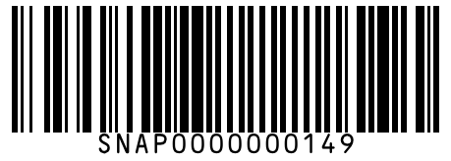
#150 | Britannia Bourbon Chocolate Cream 150 g
Brand: Britannia
Variant: 150.000 g
SKU Code: SMSKU-000150
MRP: ₹42.00 | Sell: ₹40.00 | Discount: ₹2.00 flat | Final: ₹38.00
Available Qty: 15
Barcode: SNAP0000000150
 | 
#151 | Sunfeast Dark Fantasy Choco Fills 75 g
Brand: Sunfeast
Variant: 75.000 g
SKU Code: SMSKU-000151
MRP: ₹40.00 | Sell: ₹38.00 | Discount: ₹2.00 flat | Final: ₹36.00
Available Qty: 22
Barcode: SNAP0000000151
 | 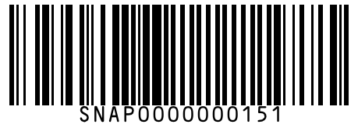
#152 | Sunfeast Dark Fantasy Choco Fills 150 g
Brand: Sunfeast
Variant: 150.000 g
SKU Code: SMSKU-000152
MRP: ₹75.00 | Sell: ₹70.00 | Discount: ₹5.00 flat | Final: ₹65.00
Available Qty: 14
Barcode: SNAP0000000152
 | 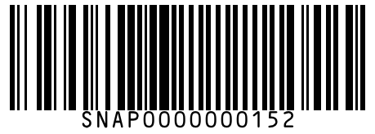
#153 | Sunfeast Mom's Magic Cashew & Almond 200 g
Brand: Sunfeast
Variant: 200.000 g
SKU Code: SMSKU-000153
MRP: ₹50.00 | Sell: ₹48.00 | Discount: ₹2.00 flat | Final: ₹46.00
Available Qty: 18
Barcode: SNAP0000000153
 | 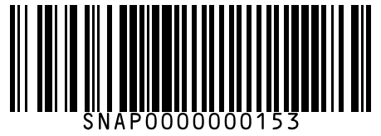
#154 | McVitie's Digestive Biscuits Wholewheat 100 g
Brand: McVitie's
Variant: 100.000 g
SKU Code: SMSKU-000154
MRP: ₹45.00 | Sell: ₹42.00 | Discount: ₹3.00 flat | Final: ₹39.00
Available Qty: 14
Barcode: SNAP0000000154
 | 
#155 | McVitie's Digestive Biscuits Wholewheat 250 g
Brand: McVitie's
Variant: 250.000 g
SKU Code: SMSKU-000155
MRP: ₹99.00 | Sell: ₹92.00 | Discount: ₹7.00 flat | Final: ₹85.00
Available Qty: 8
Barcode: SNAP0000000155
 | 
#156 | Unibic Choco Chip Cookies 150 g
Brand: Unibic
Variant: 150.000 g
SKU Code: SMSKU-000156
MRP: ₹60.00 | Sell: ₹56.00 | Discount: ₹4.00 flat | Final: ₹52.00
Available Qty: 16
Barcode: SNAP0000000156
 | 
#157 | Oreo Original Cream Biscuits 120 g
Brand: Oreo
Variant: 120.000 g
SKU Code: SMSKU-000157
MRP: ₹30.00 | Sell: ₹30.00 | Discount: None | Final: ₹30.00
Available Qty: 25
Barcode: SNAP0000000157
 | 
#158 | Oreo Original Cream Biscuits 300 g
Brand: Oreo
Variant: 300.000 g
SKU Code: SMSKU-000158
MRP: ₹65.00 | Sell: ₹60.00 | Discount: ₹5.00 flat | Final: ₹55.00
Available Qty: 12
Barcode: SNAP0000000158
 | 
#159 | Cadbury Dairy Milk Chocolate 25 g
Brand: Cadbury
Variant: 25.000 g
SKU Code: SMSKU-000159
MRP: ₹40.00 | Sell: ₹40.00 | Discount: None | Final: ₹40.00
Available Qty: 50
Barcode: SNAP0000000159
 | 
#160 | Cadbury Dairy Milk Chocolate 55 g
Brand: Cadbury
Variant: 55.000 g
SKU Code: SMSKU-000160
MRP: ₹80.00 | Sell: ₹80.00 | Discount: None | Final: ₹80.00
Available Qty: 30
Barcode: SNAP0000000160
 | 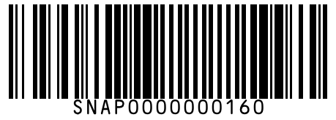
#161 | Cadbury Dairy Milk Chocolate 110 g
Brand: Cadbury
Variant: 110.000 g
SKU Code: SMSKU-000161
MRP: ₹150.00 | Sell: ₹145.00 | Discount: ₹5.00 flat | Final: ₹140.00
Available Qty: 15
Barcode: SNAP0000000161
 | 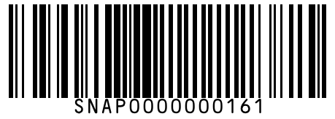
#162 | Cadbury Dairy Milk Silk 60 g
Brand: Cadbury
Variant: 60.000 g
SKU Code: SMSKU-000162
MRP: ₹99.00 | Sell: ₹95.00 | Discount: ₹4.00 flat | Final: ₹91.00
Available Qty: 25
Barcode: SNAP0000000162
 | 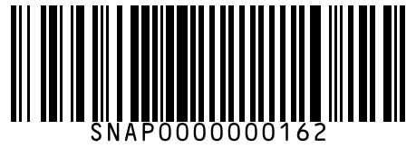
#163 | Cadbury Dairy Milk Silk 150 g
Brand: Cadbury
Variant: 150.000 g
SKU Code: SMSKU-000163
MRP: ₹200.00 | Sell: ₹190.00 | Discount: ₹10.00 flat | Final: ₹180.00
Available Qty: 12
Barcode: SNAP0000000163
 | 
#164 | Cadbury 5 Star Chocolate Bar 25 g
Brand: Cadbury
Variant: 25.000 g
SKU Code: SMSKU-000164
MRP: ₹20.00 | Sell: ₹20.00 | Discount: None | Final: ₹20.00
Available Qty: 40
Barcode: SNAP0000000164
 | 
#165 | Cadbury 5 Star Chocolate Bar 44 g
Brand: Cadbury
Variant: 44.000 g
SKU Code: SMSKU-000165
MRP: ₹40.00 | Sell: ₹40.00 | Discount: None | Final: ₹40.00
Available Qty: 25
Barcode: SNAP0000000165
 | 
#166 | Cadbury Gems Chocolate 18 g
Brand: Cadbury
Variant: 18.000 g
SKU Code: SMSKU-000166
MRP: ₹20.00 | Sell: ₹20.00 | Discount: None | Final: ₹20.00
Available Qty: 40
Barcode: SNAP0000000166
 | 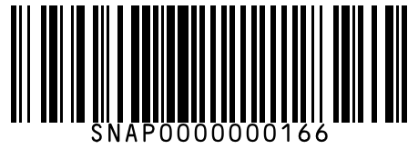
#167 | Cadbury Perk Wafer Chocolate 22 g
Brand: Cadbury
Variant: 22.000 g
SKU Code: SMSKU-000167
MRP: ₹15.00 | Sell: ₹15.00 | Discount: None | Final: ₹15.00
Available Qty: 35
Barcode: SNAP0000000167
 | 
#168 | Cadbury Celebrations Rich Dry Fruit Collection 135 g
Brand: Cadbury
Variant: 135.000 g
SKU Code: SMSKU-000168
MRP: ₹230.00 | Sell: ₹220.00 | Discount: ₹10.00 flat | Final: ₹210.00
Available Qty: 8
Barcode: SNAP0000000168
 | 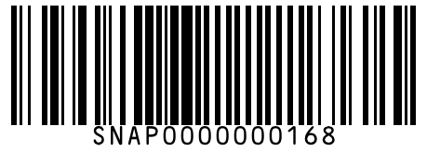
#169 | Nestle KitKat Wafer 18 g
Brand: Nestle
Variant: 18.000 g
SKU Code: SMSKU-000169
MRP: ₹20.00 | Sell: ₹20.00 | Discount: None | Final: ₹20.00
Available Qty: 40
Barcode: SNAP0000000169
 | 
#170 | Nestle KitKat Wafer 37 g
Brand: Nestle
Variant: 37.000 g
SKU Code: SMSKU-000170
MRP: ₹40.00 | Sell: ₹40.00 | Discount: None | Final: ₹40.00
Available Qty: 25
Barcode: SNAP0000000170
 | 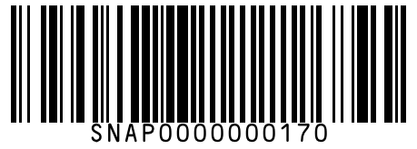
#171 | Nestle Munch Chocolate 18 g
Brand: Nestle
Variant: 18.000 g
SKU Code: SMSKU-000171
MRP: ₹10.00 | Sell: ₹10.00 | Discount: None | Final: ₹10.00
Available Qty: 50
Barcode: SNAP0000000171
 | 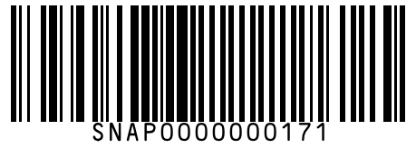
#172 | Nestle Munch Chocolate 42 g
Brand: Nestle
Variant: 42.000 g
SKU Code: SMSKU-000172
MRP: ₹20.00 | Sell: ₹20.00 | Discount: None | Final: ₹20.00
Available Qty: 30
Barcode: SNAP0000000172
 | 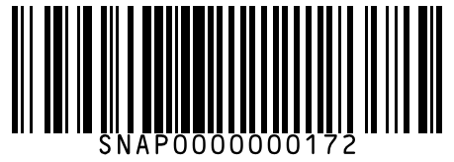
#173 | Ferrero Rocher Chocolate 200 g
Brand: Ferrero
Variant: 200.000 g
SKU Code: SMSKU-000173
MRP: ₹575.00 | Sell: ₹550.00 | Discount: ₹25.00 flat | Final: ₹525.00
Available Qty: 6
Barcode: SNAP0000000173
 | 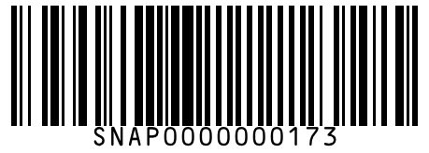
#174 | Amul Dark Chocolate 55% Cocoa 150 g
Brand: Amul
Variant: 150.000 g
SKU Code: SMSKU-000174
MRP: ₹175.00 | Sell: ₹165.00 | Discount: ₹10.00 flat | Final: ₹155.00
Available Qty: 10
Barcode: SNAP0000000174
 | 
#175 | Snickers Chocolate Bar 45 g
Brand: Snickers
Variant: 45.000 g
SKU Code: SMSKU-000175
MRP: ₹50.00 | Sell: ₹50.00 | Discount: None | Final: ₹50.00
Available Qty: 22
Barcode: SNAP0000000175
 | 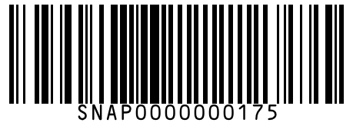
#176 | Mentos Mint Rolls 37 g
Brand: Mentos
Variant: 37.000 g
SKU Code: SMSKU-000176
MRP: ₹20.00 | Sell: ₹20.00 | Discount: None | Final: ₹20.00
Available Qty: 30
Barcode: SNAP0000000176
 | 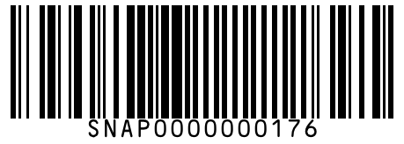
#177 | Pulse Kachcha Aam Candy 50 pcs
Brand: Pulse
Variant: 50.000 pcs
SKU Code: SMSKU-000177
MRP: ₹50.00 | Sell: ₹50.00 | Discount: None | Final: ₹50.00
Available Qty: 20
Barcode: SNAP0000000177
 | 
#178 | Coca-Cola Classic 250 ml
Brand: Coca-Cola
Variant: 250.000 ml
SKU Code: SMSKU-000178
MRP: ₹20.00 | Sell: ₹20.00 | Discount: None | Final: ₹20.00
Available Qty: 50
Barcode: SNAP0000000178
 | 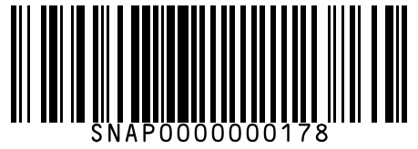
#179 | Coca-Cola Classic 500 ml
Brand: Coca-Cola
Variant: 500.000 ml
SKU Code: SMSKU-000179
MRP: ₹40.00 | Sell: ₹40.00 | Discount: None | Final: ₹40.00
Available Qty: 35
Barcode: SNAP0000000179
 | 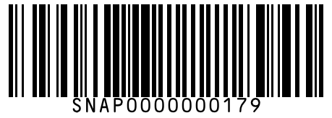
#180 | Coca-Cola Classic 750 ml
Brand: Coca-Cola
Variant: 750.000 ml
SKU Code: SMSKU-000180
MRP: ₹45.00 | Sell: ₹45.00 | Discount: None | Final: ₹45.00
Available Qty: 20
Barcode: SNAP0000000180
 | 
#181 | Coca-Cola Classic 1.25 L
Brand: Coca-Cola
Variant: 1.250 L
SKU Code: SMSKU-000181
MRP: ₹75.00 | Sell: ₹72.00 | Discount: ₹3.00 flat | Final: ₹69.00
Available Qty: 12
Barcode: SNAP0000000181
 | 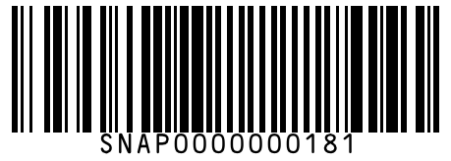
#182 | Coca-Cola Classic 2 L
Brand: Coca-Cola
Variant: 2.000 L
SKU Code: SMSKU-000182
MRP: ₹95.00 | Sell: ₹90.00 | Discount: ₹5.00 flat | Final: ₹85.00
Available Qty: 8
Barcode: SNAP0000000182
 | 
#183 | Pepsi Cola 250 ml
Brand: Pepsi
Variant: 250.000 ml
SKU Code: SMSKU-000183
MRP: ₹20.00 | Sell: ₹20.00 | Discount: None | Final: ₹20.00
Available Qty: 45
Barcode: SNAP0000000183
 | 
#184 | Pepsi Cola 500 ml
Brand: Pepsi
Variant: 500.000 ml
SKU Code: SMSKU-000184
MRP: ₹40.00 | Sell: ₹40.00 | Discount: None | Final: ₹40.00
Available Qty: 30
Barcode: SNAP0000000184
 | 
#185 | Pepsi Cola 2 L
Brand: Pepsi
Variant: 2.000 L
SKU Code: SMSKU-000185
MRP: ₹95.00 | Sell: ₹90.00 | Discount: ₹5.00 flat | Final: ₹85.00
Available Qty: 8
Barcode: SNAP0000000185
 | 
#186 | Sprite Lemon Lime 250 ml
Brand: Sprite
Variant: 250.000 ml
SKU Code: SMSKU-000186
MRP: ₹20.00 | Sell: ₹20.00 | Discount: None | Final: ₹20.00
Available Qty: 40
Barcode: SNAP0000000186
 | 
#187 | Sprite Lemon Lime 500 ml
Brand: Sprite
Variant: 500.000 ml
SKU Code: SMSKU-000187
MRP: ₹40.00 | Sell: ₹40.00 | Discount: None | Final: ₹40.00
Available Qty: 28
Barcode: SNAP0000000187
 | 
#188 | Sprite Lemon Lime 2 L
Brand: Sprite
Variant: 2.000 L
SKU Code: SMSKU-000188
MRP: ₹95.00 | Sell: ₹90.00 | Discount: ₹5.00 flat | Final: ₹85.00
Available Qty: 7
Barcode: SNAP0000000188
 | 
#189 | Thums Up Cola 250 ml
Brand: Thums Up
Variant: 250.000 ml
SKU Code: SMSKU-000189
MRP: ₹20.00 | Sell: ₹20.00 | Discount: None | Final: ₹20.00
Available Qty: 38
Barcode: SNAP0000000189
 | 
#190 | Thums Up Cola 500 ml
Brand: Thums Up
Variant: 500.000 ml
SKU Code: SMSKU-000190
MRP: ₹40.00 | Sell: ₹40.00 | Discount: None | Final: ₹40.00
Available Qty: 24
Barcode: SNAP0000000190
 | 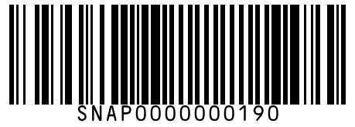
#191 | Thums Up Cola 2 L
Brand: Thums Up
Variant: 2.000 L
SKU Code: SMSKU-000191
MRP: ₹95.00 | Sell: ₹90.00 | Discount: ₹5.00 flat | Final: ₹85.00
Available Qty: 6
Barcode: SNAP0000000191
 | 
#192 | Fanta Orange 250 ml
Brand: Fanta
Variant: 250.000 ml
SKU Code: SMSKU-000192
MRP: ₹20.00 | Sell: ₹20.00 | Discount: None | Final: ₹20.00
Available Qty: 30
Barcode: SNAP0000000192
 | 
#193 | Fanta Orange 500 ml
Brand: Fanta
Variant: 500.000 ml
SKU Code: SMSKU-000193
MRP: ₹40.00 | Sell: ₹40.00 | Discount: None | Final: ₹40.00
Available Qty: 20
Barcode: SNAP0000000193
 | 
#194 | Limca Lemon 250 ml
Brand: Limca
Variant: 250.000 ml
SKU Code: SMSKU-000194
MRP: ₹20.00 | Sell: ₹20.00 | Discount: None | Final: ₹20.00
Available Qty: 28
Barcode: SNAP0000000194
 | 
#195 | Limca Lemon 500 ml
Brand: Limca
Variant: 500.000 ml
SKU Code: SMSKU-000195
MRP: ₹40.00 | Sell: ₹40.00 | Discount: None | Final: ₹40.00
Available Qty: 18
Barcode: SNAP0000000195
 | 
#196 | Real Mixed Fruit Juice 200 ml
Brand: Real
Variant: 200.000 ml
SKU Code: SMSKU-000196
MRP: ₹30.00 | Sell: ₹28.00 | Discount: ₹2.00 flat | Final: ₹26.00
Available Qty: 25
Barcode: SNAP0000000196
 | 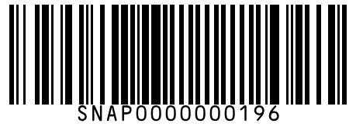
#197 | Real Mixed Fruit Juice 1 L
Brand: Real
Variant: 1.000 L
SKU Code: SMSKU-000197
MRP: ₹115.00 | Sell: ₹108.00 | Discount: ₹7.00 flat | Final: ₹101.00
Available Qty: 12
Barcode: SNAP0000000197
 | 
#198 | Real Mango Juice 200 ml
Brand: Real
Variant: 200.000 ml
SKU Code: SMSKU-000198
MRP: ₹30.00 | Sell: ₹28.00 | Discount: ₹2.00 flat | Final: ₹26.00
Available Qty: 30
Barcode: SNAP0000000198
 | 
#199 | Real Mango Juice 1 L
Brand: Real
Variant: 1.000 L
SKU Code: SMSKU-000199
MRP: ₹115.00 | Sell: ₹108.00 | Discount: ₹7.00 flat | Final: ₹101.00
Available Qty: 14
Barcode: SNAP0000000199
 | 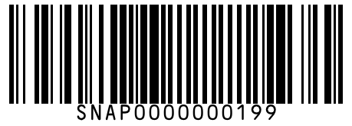
#200 | Real Orange Juice 200 ml
Brand: Real
Variant: 200.000 ml
SKU Code: SMSKU-000200
MRP: ₹30.00 | Sell: ₹28.00 | Discount: ₹2.00 flat | Final: ₹26.00
Available Qty: 22
Barcode: SNAP0000000200
 | 
#201 | Real Orange Juice 1 L
Brand: Real
Variant: 1.000 L
SKU Code: SMSKU-000201
MRP: ₹115.00 | Sell: ₹108.00 | Discount: ₹7.00 flat | Final: ₹101.00
Available Qty: 10
Barcode: SNAP0000000201
 | 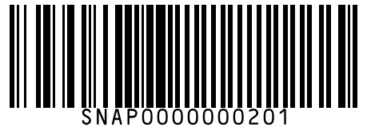
#202 | Tropicana Mango Delight 200 ml
Brand: Tropicana
Variant: 200.000 ml
SKU Code: SMSKU-000202
MRP: ₹25.00 | Sell: ₹25.00 | Discount: None | Final: ₹25.00
Available Qty: 28
Barcode: SNAP0000000202
 | 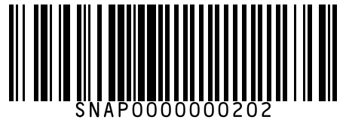
#203 | Tropicana Mango Delight 1 L
Brand: Tropicana
Variant: 1.000 L
SKU Code: SMSKU-000203
MRP: ₹110.00 | Sell: ₹105.00 | Discount: ₹5.00 flat | Final: ₹100.00
Available Qty: 12
Barcode: SNAP0000000203
 | 
#204 | Tropicana Apple Juice 200 ml
Brand: Tropicana
Variant: 200.000 ml
SKU Code: SMSKU-000204
MRP: ₹30.00 | Sell: ₹28.00 | Discount: ₹2.00 flat | Final: ₹26.00
Available Qty: 20
Barcode: SNAP0000000204
 | 
#205 | Tropicana Apple Juice 1 L
Brand: Tropicana
Variant: 1.000 L
SKU Code: SMSKU-000205
MRP: ₹120.00 | Sell: ₹115.00 | Discount: ₹5.00 flat | Final: ₹110.00
Available Qty: 8
Barcode: SNAP0000000205
 | 
#206 | Paper Boat Aam Panna 200 ml
Brand: Paper Boat
Variant: 200.000 ml
SKU Code: SMSKU-000206
MRP: ₹30.00 | Sell: ₹28.00 | Discount: ₹2.00 flat | Final: ₹26.00
Available Qty: 18
Barcode: SNAP0000000206
 | 
#207 | Paper Boat Jaljeera 200 ml
Brand: Paper Boat
Variant: 200.000 ml
SKU Code: SMSKU-000207
MRP: ₹30.00 | Sell: ₹28.00 | Discount: ₹2.00 flat | Final: ₹26.00
Available Qty: 16
Barcode: SNAP0000000207
 | 
#208 | Paper Boat Kokum 200 ml
Brand: Paper Boat
Variant: 200.000 ml
SKU Code: SMSKU-000208
MRP: ₹30.00 | Sell: ₹28.00 | Discount: ₹2.00 flat | Final: ₹26.00
Available Qty: 14
Barcode: SNAP0000000208
 | 
#209 | Frooti Mango Drink 150 ml
Brand: Frooti
Variant: 150.000 ml
SKU Code: SMSKU-000209
MRP: ₹10.00 | Sell: ₹10.00 | Discount: None | Final: ₹10.00
Available Qty: 50
Barcode: SNAP0000000209
 | 
#210 | Frooti Mango Drink 250 ml
Brand: Frooti
Variant: 250.000 ml
SKU Code: SMSKU-000210
MRP: ₹15.00 | Sell: ₹15.00 | Discount: None | Final: ₹15.00
Available Qty: 35
Barcode: SNAP0000000210
 | 
#211 | Frooti Mango Drink 600 ml
Brand: Frooti
Variant: 600.000 ml
SKU Code: SMSKU-000211
MRP: ₹30.00 | Sell: ₹30.00 | Discount: None | Final: ₹30.00
Available Qty: 20
Barcode: SNAP0000000211
 | 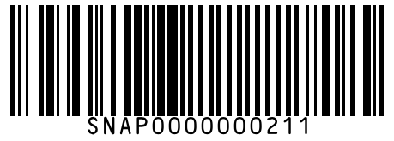
#212 | Frooti Mango Drink 1.2 L
Brand: Frooti
Variant: 1.200 L
SKU Code: SMSKU-000212
MRP: ₹55.00 | Sell: ₹52.00 | Discount: ₹3.00 flat | Final: ₹49.00
Available Qty: 10
Barcode: SNAP0000000212
 | 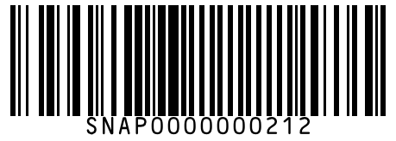
#213 | Maaza Mango Drink 250 ml
Brand: Maaza
Variant: 250.000 ml
SKU Code: SMSKU-000213
MRP: ₹20.00 | Sell: ₹20.00 | Discount: None | Final: ₹20.00
Available Qty: 30
Barcode: SNAP0000000213
 | 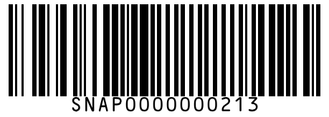
#214 | Maaza Mango Drink 600 ml
Brand: Maaza
Variant: 600.000 ml
SKU Code: SMSKU-000214
MRP: ₹35.00 | Sell: ₹35.00 | Discount: None | Final: ₹35.00
Available Qty: 18
Barcode: SNAP0000000214
 | 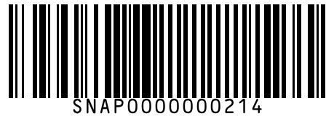
#215 | B Natural Mixed Fruit Juice 1 L
Brand: B Natural
Variant: 1.000 L
SKU Code: SMSKU-000215
MRP: ₹105.00 | Sell: ₹99.00 | Discount: ₹6.00 flat | Final: ₹93.00
Available Qty: 10
Barcode: SNAP0000000215
 | 
#216 | Tata Tea Gold Leaf Tea 100 g
Brand: Tata Tea
Variant: 100.000 g
SKU Code: SMSKU-000216
MRP: ₹50.00 | Sell: ₹47.00 | Discount: ₹3.00 flat | Final: ₹44.00
Available Qty: 30
Barcode: SNAP0000000216
 | 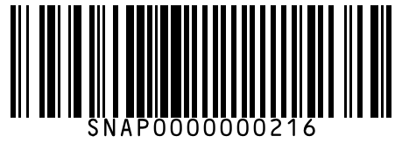
#217 | Tata Tea Gold Leaf Tea 250 g
Brand: Tata Tea
Variant: 250.000 g
SKU Code: SMSKU-000217
MRP: ₹120.00 | Sell: ₹115.00 | Discount: ₹5.00 flat | Final: ₹110.00
Available Qty: 20
Barcode: SNAP0000000217
 | 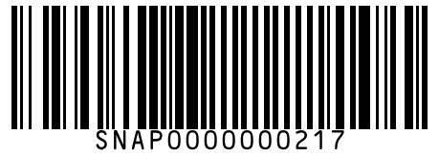
#218 | Tata Tea Gold Leaf Tea 500 g
Brand: Tata Tea
Variant: 500.000 g
SKU Code: SMSKU-000218
MRP: ₹235.00 | Sell: ₹225.00 | Discount: ₹10.00 flat | Final: ₹215.00
Available Qty: 12
Barcode: SNAP0000000218
 | 
#219 | Tata Tea Premium Leaf Tea 250 g
Brand: Tata Tea
Variant: 250.000 g
SKU Code: SMSKU-000219
MRP: ₹105.00 | Sell: ₹100.00 | Discount: ₹5.00 flat | Final: ₹95.00
Available Qty: 18
Barcode: SNAP0000000219
 | 
#220 | Tata Tea Premium Leaf Tea 500 g
Brand: Tata Tea
Variant: 500.000 g
SKU Code: SMSKU-000220
MRP: ₹205.00 | Sell: ₹195.00 | Discount: ₹10.00 flat | Final: ₹185.00
Available Qty: 10
Barcode: SNAP0000000220
 | 
#221 | Red Label Natural Care Tea 250 g
Brand: Red Label
Variant: 250.000 g
SKU Code: SMSKU-000221
MRP: ₹135.00 | Sell: ₹128.00 | Discount: ₹7.00 flat | Final: ₹121.00
Available Qty: 16
Barcode: SNAP0000000221
 | 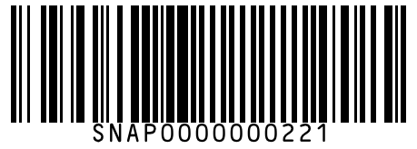
#222 | Red Label Natural Care Tea 500 g
Brand: Red Label
Variant: 500.000 g
SKU Code: SMSKU-000222
MRP: ₹260.00 | Sell: ₹248.00 | Discount: ₹12.00 flat | Final: ₹236.00
Available Qty: 8
Barcode: SNAP0000000222
 | 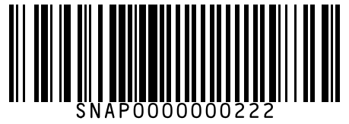
#223 | Taj Mahal Rich & Aromatic Tea Bags 25 pcs
Brand: Taj Mahal
Variant: 25.000 pcs
SKU Code: SMSKU-000223
MRP: ₹120.00 | Sell: ₹112.00 | Discount: ₹8.00 flat | Final: ₹104.00
Available Qty: 14
Barcode: SNAP0000000223
 | 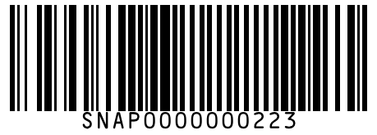
#224 | Taj Mahal Rich & Aromatic Tea Bags 100 pcs
Brand: Taj Mahal
Variant: 100.000 pcs
SKU Code: SMSKU-000224
MRP: ₹420.00 | Sell: ₹399.00 | Discount: ₹21.00 flat | Final: ₹378.00
Available Qty: 6
Barcode: SNAP0000000224
 | 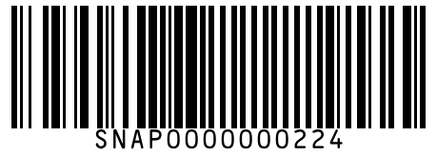
#225 | Lipton Green Tea Pure & Light 25 pcs
Brand: Lipton
Variant: 25.000 pcs
SKU Code: SMSKU-000225
MRP: ₹145.00 | Sell: ₹138.00 | Discount: ₹7.00 flat | Final: ₹131.00
Available Qty: 12
Barcode: SNAP0000000225
 | 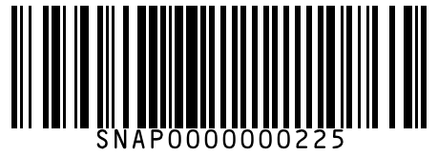
#226 | Lipton Green Tea Pure & Light 100 pcs
Brand: Lipton
Variant: 100.000 pcs
SKU Code: SMSKU-000226
MRP: ₹470.00 | Sell: ₹450.00 | Discount: ₹20.00 flat | Final: ₹430.00
Available Qty: 6
Barcode: SNAP0000000226
 | 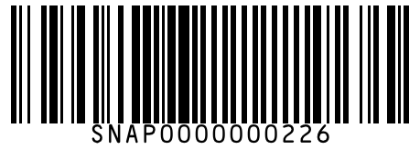
#227 | Girnar Masala Chai Tea Bags 10 pcs
Brand: Girnar
Variant: 10.000 pcs
SKU Code: SMSKU-000227
MRP: ₹85.00 | Sell: ₹80.00 | Discount: ₹5.00 flat | Final: ₹75.00
Available Qty: 10
Barcode: SNAP0000000227
 | 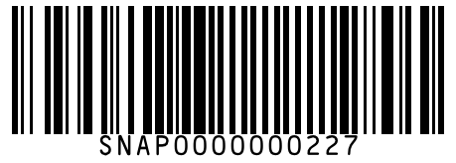
#228 | Nescafe Classic Instant Coffee 50 g
Brand: Nescafe
Variant: 50.000 g
SKU Code: SMSKU-000228
MRP: ₹155.00 | Sell: ₹148.00 | Discount: ₹7.00 flat | Final: ₹141.00
Available Qty: 18
Barcode: SNAP0000000228
 | 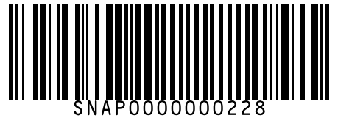
#229 | Nescafe Classic Instant Coffee 100 g
Brand: Nescafe
Variant: 100.000 g
SKU Code: SMSKU-000229
MRP: ₹295.00 | Sell: ₹280.00 | Discount: ₹15.00 flat | Final: ₹265.00
Available Qty: 10
Barcode: SNAP0000000229
 | 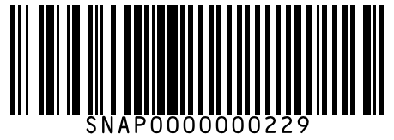
#230 | Nescafe Sunrise Rich Instant Coffee 50 g
Brand: Nescafe
Variant: 50.000 g
SKU Code: SMSKU-000230
MRP: ₹105.00 | Sell: ₹100.00 | Discount: ₹5.00 flat | Final: ₹95.00
Available Qty: 15
Barcode: SNAP0000000230
 | 
#231 | Nescafe Sunrise Rich Instant Coffee 100 g
Brand: Nescafe
Variant: 100.000 g
SKU Code: SMSKU-000231
MRP: ₹200.00 | Sell: ₹190.00 | Discount: ₹10.00 flat | Final: ₹180.00
Available Qty: 8
Barcode: SNAP0000000231
 | 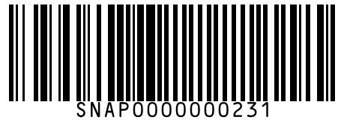
#232 | Bru Instant Coffee 50 g
Brand: Bru
Variant: 50.000 g
SKU Code: SMSKU-000232
MRP: ₹115.00 | Sell: ₹110.00 | Discount: ₹5.00 flat | Final: ₹105.00
Available Qty: 16
Barcode: SNAP0000000232
 | 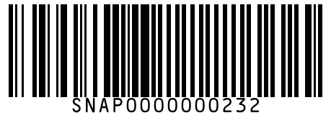
#233 | Bru Instant Coffee 100 g
Brand: Bru
Variant: 100.000 g
SKU Code: SMSKU-000233
MRP: ₹220.00 | Sell: ₹210.00 | Discount: ₹10.00 flat | Final: ₹200.00
Available Qty: 10
Barcode: SNAP0000000233
 | 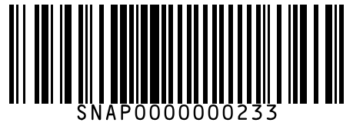
#234 | Bru Gold Freeze Dried Coffee 50 g
Brand: Bru
Variant: 50.000 g
SKU Code: SMSKU-000234
MRP: ₹230.00 | Sell: ₹220.00 | Discount: ₹10.00 flat | Final: ₹210.00
Available Qty: 8
Barcode: SNAP0000000234
 | 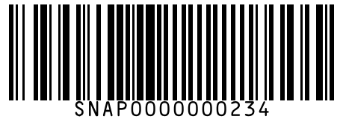
#235 | Continental XTRA Instant South Blend Coffee 50 g
Brand: Continental
Variant: 50.000 g
SKU Code: SMSKU-000235
MRP: ₹95.00 | Sell: ₹90.00 | Discount: ₹5.00 flat | Final: ₹85.00
Available Qty: 12
Barcode: SNAP0000000235
 | 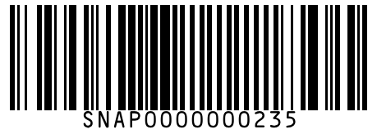
#236 | Continental XTRA Instant South Blend Coffee 100 g
Brand: Continental
Variant: 100.000 g
SKU Code: SMSKU-000236
MRP: ₹180.00 | Sell: ₹170.00 | Discount: ₹10.00 flat | Final: ₹160.00
Available Qty: 6
Barcode: SNAP0000000236
 | 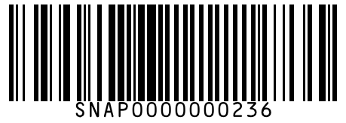
#237 | Horlicks Classic Malt 200 g
Brand: Horlicks
Variant: 200.000 g
SKU Code: SMSKU-000237
MRP: ₹145.00 | Sell: ₹138.00 | Discount: ₹7.00 flat | Final: ₹131.00
Available Qty: 16
Barcode: SNAP0000000237
 | 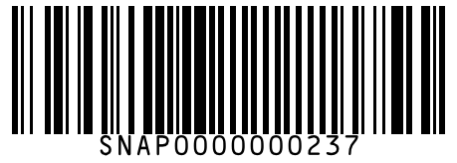
#238 | Horlicks Classic Malt 500 g
Brand: Horlicks
Variant: 500.000 g
SKU Code: SMSKU-000238
MRP: ₹325.00 | Sell: ₹310.00 | Discount: ₹15.00 flat | Final: ₹295.00
Available Qty: 10
Barcode: SNAP0000000238
 | 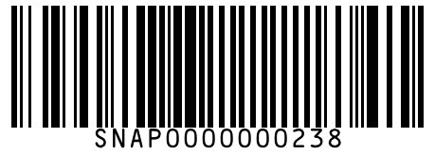
#239 | Horlicks Classic Malt 1 kg
Brand: Horlicks
Variant: 1.000 kg
SKU Code: SMSKU-000239
MRP: ₹600.00 | Sell: ₹570.00 | Discount: ₹30.00 flat | Final: ₹540.00
Available Qty: 5
Barcode: SNAP0000000239
 | 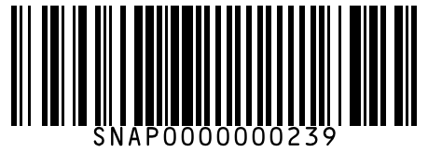
#240 | Bournvita Chocolate Health Drink 200 g
Brand: Bournvita
Variant: 200.000 g
SKU Code: SMSKU-000240
MRP: ₹125.00 | Sell: ₹118.00 | Discount: ₹7.00 flat | Final: ₹111.00
Available Qty: 18
Barcode: SNAP0000000240
 | 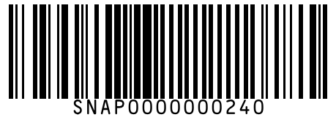
#241 | Bournvita Chocolate Health Drink 500 g
Brand: Bournvita
Variant: 500.000 g
SKU Code: SMSKU-000241
MRP: ₹275.00 | Sell: ₹260.00 | Discount: ₹15.00 flat | Final: ₹245.00
Available Qty: 10
Barcode: SNAP0000000241
 | 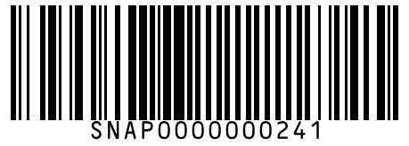
#242 | Bournvita Chocolate Health Drink 1 kg
Brand: Bournvita
Variant: 1.000 kg
SKU Code: SMSKU-000242
MRP: ₹520.00 | Sell: ₹495.00 | Discount: ₹25.00 flat | Final: ₹470.00
Available Qty: 5
Barcode: SNAP0000000242
 | 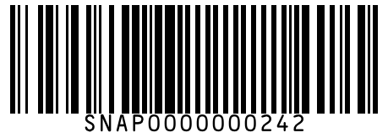
#243 | Complan Classic Chocolate Nutrition Drink 200 g
Brand: Complan
Variant: 200.000 g
SKU Code: SMSKU-000243
MRP: ₹155.00 | Sell: ₹148.00 | Discount: ₹7.00 flat | Final: ₹141.00
Available Qty: 12
Barcode: SNAP0000000243
 | 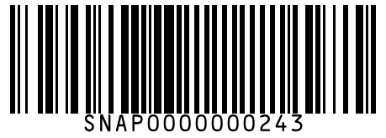
#244 | Complan Classic Chocolate Nutrition Drink 500 g
Brand: Complan
Variant: 500.000 g
SKU Code: SMSKU-000244
MRP: ₹355.00 | Sell: ₹340.00 | Discount: ₹15.00 flat | Final: ₹325.00
Available Qty: 6
Barcode: SNAP0000000244
 | 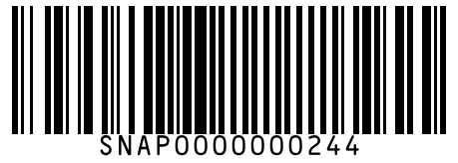
#245 | Protinex Original Health Supplement 250 g
Brand: Protinex
Variant: 250.000 g
SKU Code: SMSKU-000245
MRP: ₹350.00 | Sell: ₹330.00 | Discount: ₹20.00 flat | Final: ₹310.00
Available Qty: 8
Barcode: SNAP0000000245
 | 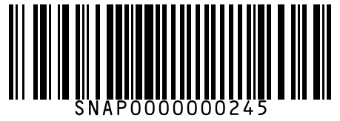
#246 | Boost Chocolate Energy Drink 200 g
Brand: Boost
Variant: 200.000 g
SKU Code: SMSKU-000246
MRP: ₹130.00 | Sell: ₹125.00 | Discount: ₹5.00 flat | Final: ₹120.00
Available Qty: 14
Barcode: SNAP0000000246
 | 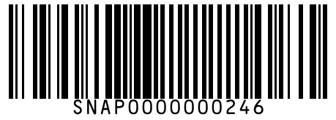
#247 | Boost Chocolate Energy Drink 500 g
Brand: Boost
Variant: 500.000 g
SKU Code: SMSKU-000247
MRP: ₹290.00 | Sell: ₹275.00 | Discount: ₹15.00 flat | Final: ₹260.00
Available Qty: 8
Barcode: SNAP0000000247
 | 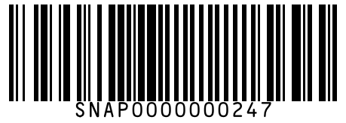
#248 | Amul Taaza Toned Milk 500 ml
Brand: Amul
Variant: 500.000 ml
SKU Code: SMSKU-000248
MRP: ₹28.00 | Sell: ₹28.00 | Discount: None | Final: ₹28.00
Available Qty: 40
Barcode: SNAP0000000248
 | 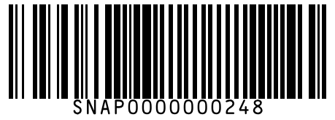
#249 | Amul Taaza Toned Milk 1 L
Brand: Amul
Variant: 1.000 L
SKU Code: SMSKU-000249
MRP: ₹54.00 | Sell: ₹54.00 | Discount: None | Final: ₹54.00
Available Qty: 30
Barcode: SNAP0000000249
 | 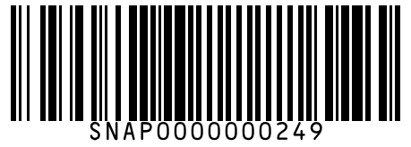
#250 | Amul Gold Full Cream Milk 500 ml
Brand: Amul
Variant: 500.000 ml
SKU Code: SMSKU-000250
MRP: ₹34.00 | Sell: ₹34.00 | Discount: None | Final: ₹34.00
Available Qty: 35
Barcode: SNAP0000000250
 | 
#251 | Amul Gold Full Cream Milk 1 L
Brand: Amul
Variant: 1.000 L
SKU Code: SMSKU-000251
MRP: ₹66.00 | Sell: ₹66.00 | Discount: None | Final: ₹66.00
Available Qty: 25
Barcode: SNAP0000000251
 | 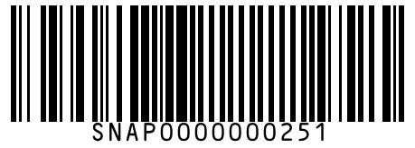
#252 | Arokya Toned Milk 500 ml
Brand: Arokya
Variant: 500.000 ml
SKU Code: SMSKU-000252
MRP: ₹26.00 | Sell: ₹26.00 | Discount: None | Final: ₹26.00
Available Qty: 40
Barcode: SNAP0000000252
 | 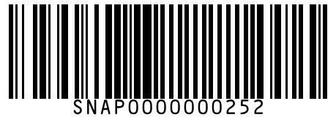
#253 | Arokya Toned Milk 1 L
Brand: Arokya
Variant: 1.000 L
SKU Code: SMSKU-000253
MRP: ₹50.00 | Sell: ₹50.00 | Discount: None | Final: ₹50.00
Available Qty: 30
Barcode: SNAP0000000253
 | 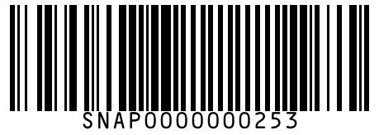
#254 | Nandini Homogenised Toned Milk 500 ml
Brand: Nandini
Variant: 500.000 ml
SKU Code: SMSKU-000254
MRP: ₹25.00 | Sell: ₹25.00 | Discount: None | Final: ₹25.00
Available Qty: 30
Barcode: SNAP0000000254
 | 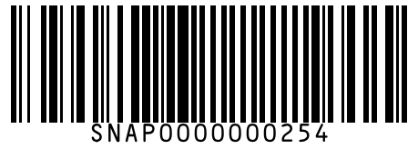
#255 | Nandini Homogenised Toned Milk 1 L
Brand: Nandini
Variant: 1.000 L
SKU Code: SMSKU-000255
MRP: ₹48.00 | Sell: ₹48.00 | Discount: None | Final: ₹48.00
Available Qty: 20
Barcode: SNAP0000000255
 | 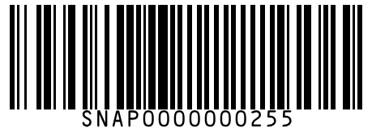
#256 | Amul Slim N Trim Double Toned Milk 500 ml
Brand: Amul
Variant: 500.000 ml
SKU Code: SMSKU-000256
MRP: ₹26.00 | Sell: ₹26.00 | Discount: None | Final: ₹26.00
Available Qty: 22
Barcode: SNAP0000000256
 | 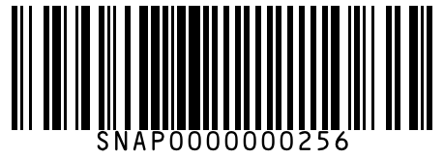
#257 | Amul Masti Dahi (Curd) 200 g
Brand: Amul
Variant: 200.000 g
SKU Code: SMSKU-000257
MRP: ₹30.00 | Sell: ₹30.00 | Discount: None | Final: ₹30.00
Available Qty: 30
Barcode: SNAP0000000257
 | 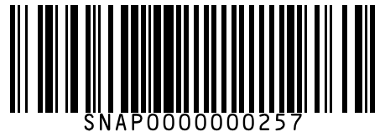
#258 | Amul Masti Dahi (Curd) 400 g
Brand: Amul
Variant: 400.000 g
SKU Code: SMSKU-000258
MRP: ₹55.00 | Sell: ₹55.00 | Discount: None | Final: ₹55.00
Available Qty: 22
Barcode: SNAP0000000258
 | 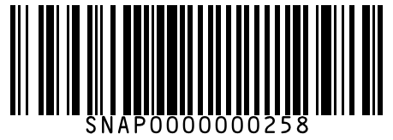
#259 | Amul Malai Paneer 200 g
Brand: Amul
Variant: 200.000 g
SKU Code: SMSKU-000259
MRP: ₹90.00 | Sell: ₹85.00 | Discount: ₹5.00 flat | Final: ₹80.00
Available Qty: 18
Barcode: SNAP0000000259
 | 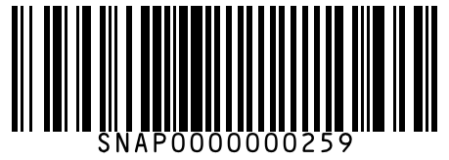
#260 | Amul Malai Paneer 500 g
Brand: Amul
Variant: 500.000 g
SKU Code: SMSKU-000260
MRP: ₹210.00 | Sell: ₹200.00 | Discount: ₹10.00 flat | Final: ₹190.00
Available Qty: 10
Barcode: SNAP0000000260
 | 
#261 | Mother Dairy Classic Curd 400 g
Brand: Mother Dairy
Variant: 400.000 g
SKU Code: SMSKU-000261
MRP: ₹50.00 | Sell: ₹50.00 | Discount: None | Final: ₹50.00
Available Qty: 25
Barcode: SNAP0000000261
 | 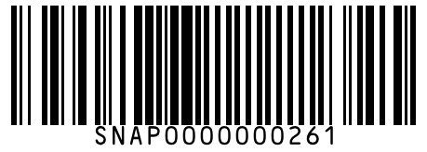
#262 | Nestle a+ Probiotic Dahi 200 g
Brand: Nestle
Variant: 200.000 g
SKU Code: SMSKU-000262
MRP: ₹35.00 | Sell: ₹35.00 | Discount: None | Final: ₹35.00
Available Qty: 20
Barcode: SNAP0000000262
 | 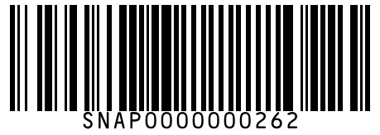
#263 | Nestle a+ Probiotic Dahi 400 g
Brand: Nestle
Variant: 400.000 g
SKU Code: SMSKU-000263
MRP: ₹60.00 | Sell: ₹58.00 | Discount: ₹2.00 flat | Final: ₹56.00
Available Qty: 15
Barcode: SNAP0000000263
 | 
#264 | Chitale Full Cream Paneer 200 g
Brand: Chitale
Variant: 200.000 g
SKU Code: SMSKU-000264
MRP: ₹95.00 | Sell: ₹90.00 | Discount: ₹5.00 flat | Final: ₹85.00
Available Qty: 12
Barcode: SNAP0000000264
 | 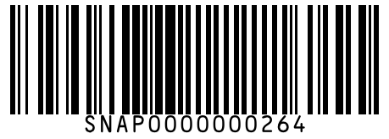
#265 | Amul Pasteurised Butter 100 g
Brand: Amul
Variant: 100.000 g
SKU Code: SMSKU-000265
MRP: ₹56.00 | Sell: ₹54.00 | Discount: ₹2.00 flat | Final: ₹52.00
Available Qty: 25
Barcode: SNAP0000000265
 | 
#266 | Amul Pasteurised Butter 500 g
Brand: Amul
Variant: 500.000 g
SKU Code: SMSKU-000266
MRP: ₹270.00 | Sell: ₹260.00 | Discount: ₹10.00 flat | Final: ₹250.00
Available Qty: 12
Barcode: SNAP0000000266
 | 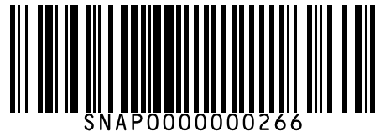
#267 | Amul Pure Ghee 200 ml
Brand: Amul
Variant: 200.000 ml
SKU Code: SMSKU-000267
MRP: ₹120.00 | Sell: ₹115.00 | Discount: ₹5.00 flat | Final: ₹110.00
Available Qty: 20
Barcode: SNAP0000000267
 | 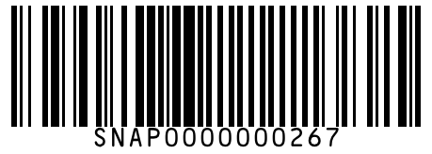
#268 | Amul Pure Ghee 500 ml
Brand: Amul
Variant: 500.000 ml
SKU Code: SMSKU-000268
MRP: ₹290.00 | Sell: ₹278.00 | Discount: ₹12.00 flat | Final: ₹266.00
Available Qty: 10
Barcode: SNAP0000000268
 | 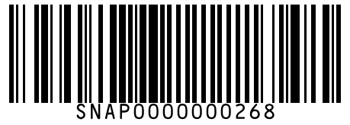
#269 | Amul Pure Ghee 1 L
Brand: Amul
Variant: 1.000 L
SKU Code: SMSKU-000269
MRP: ₹570.00 | Sell: ₹550.00 | Discount: ₹20.00 flat | Final: ₹530.00
Available Qty: 5
Barcode: SNAP0000000269
 | 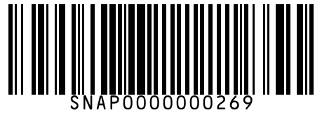
#270 | Nandini Table Butter 100 g
Brand: Nandini
Variant: 100.000 g
SKU Code: SMSKU-000270
MRP: ₹50.00 | Sell: ₹48.00 | Discount: ₹2.00 flat | Final: ₹46.00
Available Qty: 18
Barcode: SNAP0000000270
 | 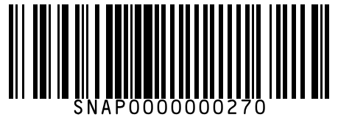
#271 | Patanjali Cow Ghee 500 ml
Brand: Patanjali
Variant: 500.000 ml
SKU Code: SMSKU-000271
MRP: ₹310.00 | Sell: ₹295.00 | Discount: ₹15.00 flat | Final: ₹280.00
Available Qty: 8
Barcode: SNAP0000000271
 | 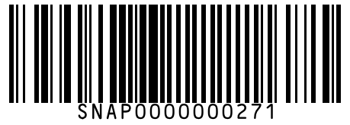
#272 | Amul Processed Cheese Block 200 g
Brand: Amul
Variant: 200.000 g
SKU Code: SMSKU-000272
MRP: ₹105.00 | Sell: ₹100.00 | Discount: ₹5.00 flat | Final: ₹95.00
Available Qty: 18
Barcode: SNAP0000000272
 | 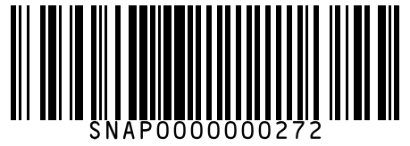
#273 | Amul Cheese Slices 100 g
Brand: Amul
Variant: 100.000 g
SKU Code: SMSKU-000273
MRP: ₹75.00 | Sell: ₹72.00 | Discount: ₹3.00 flat | Final: ₹69.00
Available Qty: 15
Barcode: SNAP0000000273
 | 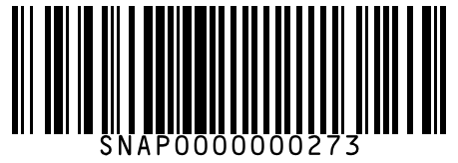
#274 | Britannia Cheese Cubes 200 g
Brand: Britannia
Variant: 200.000 g
SKU Code: SMSKU-000274
MRP: ₹110.00 | Sell: ₹105.00 | Discount: ₹5.00 flat | Final: ₹100.00
Available Qty: 12
Barcode: SNAP0000000274
 | 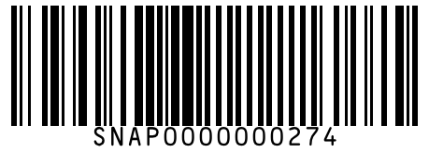
#275 | Amul Mozzarella Cheese Pizza 200 g
Brand: Amul
Variant: 200.000 g
SKU Code: SMSKU-000275
MRP: ₹145.00 | Sell: ₹138.00 | Discount: ₹7.00 flat | Final: ₹131.00
Available Qty: 8
Barcode: SNAP0000000275
 | 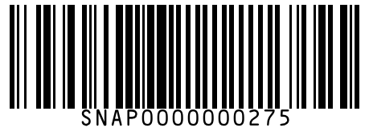
#276 | Amul Vanilla Magic Ice Cream 750 ml
Brand: Amul
Variant: 750.000 ml
SKU Code: SMSKU-000276
MRP: ₹175.00 | Sell: ₹165.00 | Discount: ₹10.00 flat | Final: ₹155.00
Available Qty: 10
Barcode: SNAP0000000276
 | 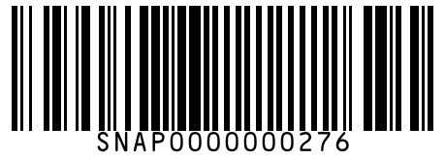
#277 | Amul Chocolate Ice Cream Tub 750 ml
Brand: Amul
Variant: 750.000 ml
SKU Code: SMSKU-000277
MRP: ₹190.00 | Sell: ₹180.00 | Discount: ₹10.00 flat | Final: ₹170.00
Available Qty: 8
Barcode: SNAP0000000277
 | 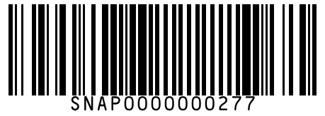
#278 | Kwality Wall's Cornetto Butterscotch Cone 110 ml
Brand: Kwality Wall's
Variant: 110.000 ml
SKU Code: SMSKU-000278
MRP: ₹50.00 | Sell: ₹50.00 | Discount: None | Final: ₹50.00
Available Qty: 20
Barcode: SNAP0000000278
 | 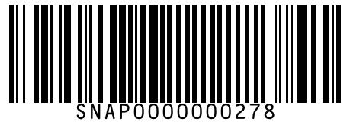
#279 | Kwality Wall's Feast Chocolate Stick Bar 65 ml
Brand: Kwality Wall's
Variant: 65.000 ml
SKU Code: SMSKU-000279
MRP: ₹30.00 | Sell: ₹30.00 | Discount: None | Final: ₹30.00
Available Qty: 25
Barcode: SNAP0000000279
 | 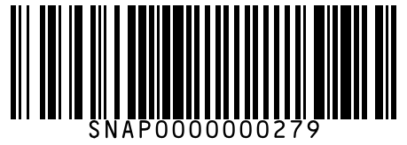
#280 | Baskin Robbins Pralines & Cream Tub 450 ml
Brand: Baskin Robbins
Variant: 450.000 ml
SKU Code: SMSKU-000280
MRP: ₹350.00 | Sell: ₹335.00 | Discount: ₹15.00 flat | Final: ₹320.00
Available Qty: 5
Barcode: SNAP0000000280
 | 
#281 | Arun Triple Sundae Cup 100 ml
Brand: Arun
Variant: 100.000 ml
SKU Code: SMSKU-000281
MRP: ₹30.00 | Sell: ₹30.00 | Discount: None | Final: ₹30.00
Available Qty: 22
Barcode: SNAP0000000281
 | 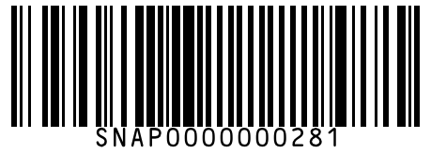
#282 | McCain French Fries 420 g
Brand: McCain
Variant: 420.000 g
SKU Code: SMSKU-000282
MRP: ₹175.00 | Sell: ₹168.00 | Discount: ₹7.00 flat | Final: ₹161.00
Available Qty: 12
Barcode: SNAP0000000282
 | 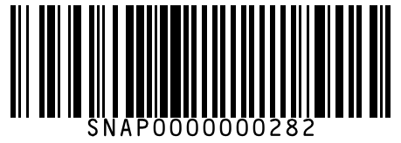
#283 | McCain French Fries 750 g
Brand: McCain
Variant: 750.000 g
SKU Code: SMSKU-000283
MRP: ₹310.00 | Sell: ₹295.00 | Discount: ₹15.00 flat | Final: ₹280.00
Available Qty: 6
Barcode: SNAP0000000283
 | 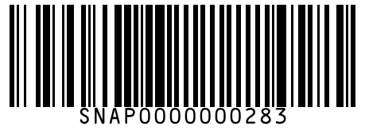
#284 | McCain Smiles Potato Shapes 415 g
Brand: McCain
Variant: 415.000 g
SKU Code: SMSKU-000284
MRP: ₹185.00 | Sell: ₹175.00 | Discount: ₹10.00 flat | Final: ₹165.00
Available Qty: 10
Barcode: SNAP0000000284
 | 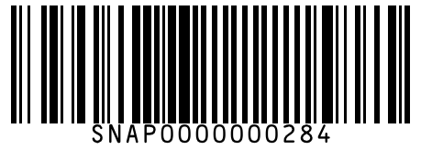
#285 | Safal Frozen Green Peas 500 g
Brand: Safal
Variant: 500.000 g
SKU Code: SMSKU-000285
MRP: ₹120.00 | Sell: ₹112.00 | Discount: ₹8.00 flat | Final: ₹104.00
Available Qty: 14
Barcode: SNAP0000000285
 | 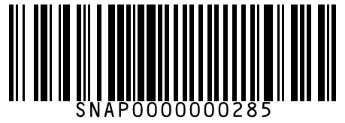
#286 | Safal Frozen Green Peas 1 kg
Brand: Safal
Variant: 1.000 kg
SKU Code: SMSKU-000286
MRP: ₹230.00 | Sell: ₹218.00 | Discount: ₹12.00 flat | Final: ₹206.00
Available Qty: 6
Barcode: SNAP0000000286
 | 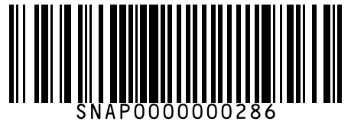
#287 | Safal Frozen Mixed Vegetables 500 g
Brand: Safal
Variant: 500.000 g
SKU Code: SMSKU-000287
MRP: ₹130.00 | Sell: ₹122.00 | Discount: ₹8.00 flat | Final: ₹114.00
Available Qty: 10
Barcode: SNAP0000000287
 | 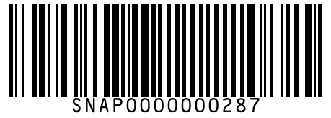
#288 | ITC Master Chef Frozen Aloo Tikki 320 g
Brand: ITC Master Chef
Variant: 320.000 g
SKU Code: SMSKU-000288
MRP: ₹140.00 | Sell: ₹132.00 | Discount: ₹8.00 flat | Final: ₹124.00
Available Qty: 10
Barcode: SNAP0000000288
 | 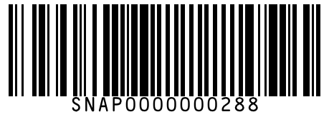
#289 | ITC Master Chef Frozen Veg Seekh Kebab 300 g
Brand: ITC Master Chef
Variant: 300.000 g
SKU Code: SMSKU-000289
MRP: ₹165.00 | Sell: ₹155.00 | Discount: ₹10.00 flat | Final: ₹145.00
Available Qty: 8
Barcode: SNAP0000000289
 | 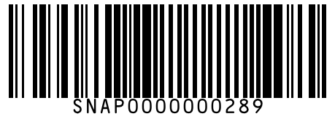
#290 | Sumeru Frozen Sweet Corn 500 g
Brand: Sumeru
Variant: 500.000 g
SKU Code: SMSKU-000290
MRP: ₹125.00 | Sell: ₹118.00 | Discount: ₹7.00 flat | Final: ₹111.00
Available Qty: 10
Barcode: SNAP0000000290
 | 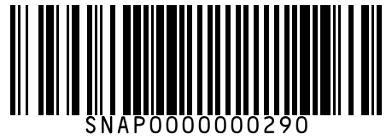
#291 | Godrej Yummiez Veg Spring Roll 320 g
Brand: Godrej Yummiez
Variant: 320.000 g
SKU Code: SMSKU-000291
MRP: ₹160.00 | Sell: ₹150.00 | Discount: ₹10.00 flat | Final: ₹140.00
Available Qty: 8
Barcode: SNAP0000000291
 | 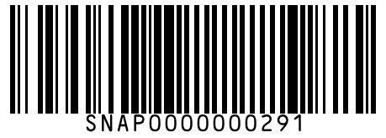
#292 | Maggi 2-Minute Masala Noodles 70 g
Brand: Maggi
Variant: 70.000 g
SKU Code: SMSKU-000292
MRP: ₹14.00 | Sell: ₹14.00 | Discount: None | Final: ₹14.00
Available Qty: 60
Barcode: SNAP0000000292
 | 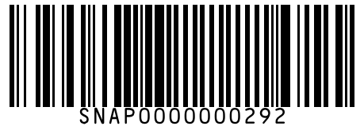
#293 | Maggi 2-Minute Masala Noodles 280 g
Brand: Maggi
Variant: 280.000 g
SKU Code: SMSKU-000293
MRP: ₹52.00 | Sell: ₹50.00 | Discount: ₹2.00 flat | Final: ₹48.00
Available Qty: 30
Barcode: SNAP0000000293
 | 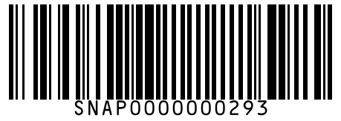
#294 | Maggi 2-Minute Masala Noodles 560 g
Brand: Maggi
Variant: 560.000 g
SKU Code: SMSKU-000294
MRP: ₹99.00 | Sell: ₹95.00 | Discount: ₹4.00 flat | Final: ₹91.00
Available Qty: 15
Barcode: SNAP0000000294
 | 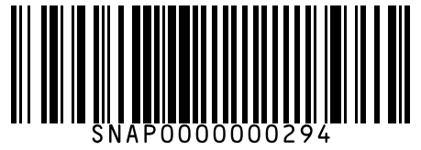
#295 | Maggi Atta Noodles 320 g
Brand: Maggi
Variant: 320.000 g
SKU Code: SMSKU-000295
MRP: ₹72.00 | Sell: ₹68.00 | Discount: ₹4.00 flat | Final: ₹64.00
Available Qty: 12
Barcode: SNAP0000000295
 | 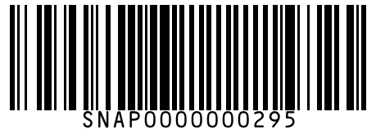
#296 | Yippee Magic Masala Noodles 70 g
Brand: Yippee
Variant: 70.000 g
SKU Code: SMSKU-000296
MRP: ₹14.00 | Sell: ₹14.00 | Discount: None | Final: ₹14.00
Available Qty: 45
Barcode: SNAP0000000296
 | 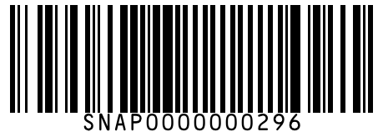
#297 | Yippee Magic Masala Noodles 280 g
Brand: Yippee
Variant: 280.000 g
SKU Code: SMSKU-000297
MRP: ₹48.00 | Sell: ₹45.00 | Discount: ₹3.00 flat | Final: ₹42.00
Available Qty: 20
Barcode: SNAP0000000297
 | 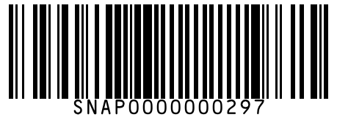
#298 | Top Ramen Curry Noodles 280 g
Brand: Top Ramen
Variant: 280.000 g
SKU Code: SMSKU-000298
MRP: ₹55.00 | Sell: ₹52.00 | Discount: ₹3.00 flat | Final: ₹49.00
Available Qty: 15
Barcode: SNAP0000000298
 | 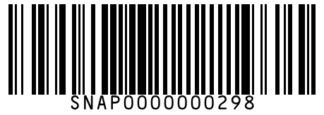
#299 | Knorr Classic Mixed Veg Soup 44 g
Brand: Knorr
Variant: 44.000 g
SKU Code: SMSKU-000299
MRP: ₹48.00 | Sell: ₹45.00 | Discount: ₹3.00 flat | Final: ₹42.00
Available Qty: 20
Barcode: SNAP0000000299
 | 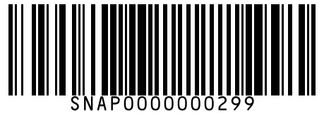
#300 | Knorr Hot & Sour Veg Soup 44 g
Brand: Knorr
Variant: 44.000 g
SKU Code: SMSKU-000300
MRP: ₹48.00 | Sell: ₹45.00 | Discount: ₹3.00 flat | Final: ₹42.00
Available Qty: 18
Barcode: SNAP0000000300
 | 
#301 | Knorr Tomato Soup 53 g
Brand: Knorr
Variant: 53.000 g
SKU Code: SMSKU-000301
MRP: ₹55.00 | Sell: ₹52.00 | Discount: ₹3.00 flat | Final: ₹49.00
Available Qty: 16
Barcode: SNAP0000000301
 | 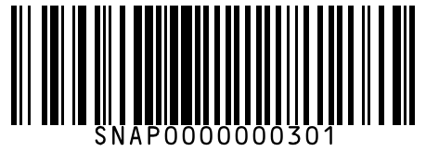
#302 | MTR Ready to Eat Rajma Masala 300 g
Brand: MTR
Variant: 300.000 g
SKU Code: SMSKU-000302
MRP: ₹99.00 | Sell: ₹92.00 | Discount: ₹7.00 flat | Final: ₹85.00
Available Qty: 10
Barcode: SNAP0000000302
 | 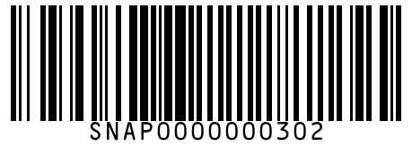
#303 | MTR Ready to Eat Palak Paneer 300 g
Brand: MTR
Variant: 300.000 g
SKU Code: SMSKU-000303
MRP: ₹110.00 | Sell: ₹102.00 | Discount: ₹8.00 flat | Final: ₹94.00
Available Qty: 8
Barcode: SNAP0000000303
 | 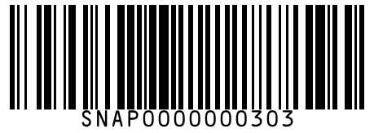
#304 | MTR Ready to Eat Dal Makhani 300 g
Brand: MTR
Variant: 300.000 g
SKU Code: SMSKU-000304
MRP: ₹99.00 | Sell: ₹92.00 | Discount: ₹7.00 flat | Final: ₹85.00
Available Qty: 10
Barcode: SNAP0000000304
 | 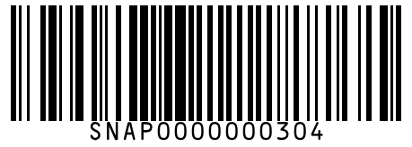
#305 | Maggi Pazzta Cheesy Tomato Twist 64 g
Brand: Maggi
Variant: 64.000 g
SKU Code: SMSKU-000305
MRP: ₹40.00 | Sell: ₹38.00 | Discount: ₹2.00 flat | Final: ₹36.00
Available Qty: 15
Barcode: SNAP0000000305
 | 
#306 | Ching's Secret Schezwan Instant Noodles 60 g
Brand: Ching's Secret
Variant: 60.000 g
SKU Code: SMSKU-000306
MRP: ₹20.00 | Sell: ₹20.00 | Discount: None | Final: ₹20.00
Available Qty: 20
Barcode: SNAP0000000306
 | 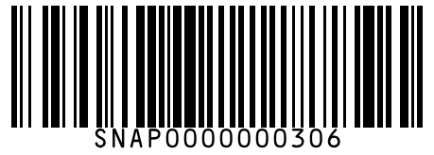
#307 | Kellogg's Corn Flakes Original 250 g
Brand: Kellogg's
Variant: 250.000 g
SKU Code: SMSKU-000307
MRP: ₹115.00 | Sell: ₹110.00 | Discount: ₹5.00 flat | Final: ₹105.00
Available Qty: 16
Barcode: SNAP0000000307
 | 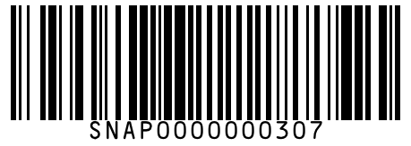
#308 | Kellogg's Corn Flakes Original 475 g
Brand: Kellogg's
Variant: 475.000 g
SKU Code: SMSKU-000308
MRP: ₹210.00 | Sell: ₹200.00 | Discount: ₹10.00 flat | Final: ₹190.00
Available Qty: 8
Barcode: SNAP0000000308
 | 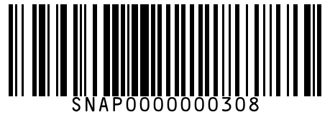
#309 | Kellogg's Chocos Chocolate Cereal 250 g
Brand: Kellogg's
Variant: 250.000 g
SKU Code: SMSKU-000309
MRP: ₹150.00 | Sell: ₹142.00 | Discount: ₹8.00 flat | Final: ₹134.00
Available Qty: 14
Barcode: SNAP0000000309
 | 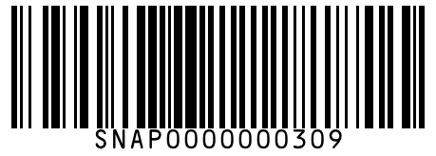
#310 | Kellogg's Chocos Chocolate Cereal 700 g
Brand: Kellogg's
Variant: 700.000 g
SKU Code: SMSKU-000310
MRP: ₹395.00 | Sell: ₹375.00 | Discount: ₹20.00 flat | Final: ₹355.00
Available Qty: 6
Barcode: SNAP0000000310
 | 
#311 | Kellogg's Muesli Fruit & Nut 500 g
Brand: Kellogg's
Variant: 500.000 g
SKU Code: SMSKU-000311
MRP: ₹340.00 | Sell: ₹320.00 | Discount: ₹20.00 flat | Final: ₹300.00
Available Qty: 8
Barcode: SNAP0000000311
 | 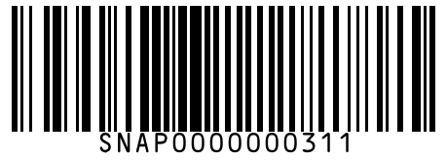
#312 | Quaker Oats 400 g
Brand: Quaker
Variant: 400.000 g
SKU Code: SMSKU-000312
MRP: ₹120.00 | Sell: ₹115.00 | Discount: ₹5.00 flat | Final: ₹110.00
Available Qty: 18
Barcode: SNAP0000000312
 | 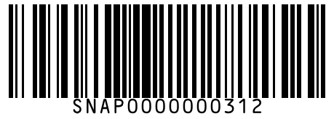
#313 | Quaker Oats 1 kg
Brand: Quaker
Variant: 1.000 kg
SKU Code: SMSKU-000313
MRP: ₹270.00 | Sell: ₹255.00 | Discount: ₹15.00 flat | Final: ₹240.00
Available Qty: 10
Barcode: SNAP0000000313
 | 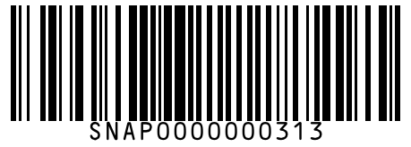
#314 | Saffola Masala Oats Classic Masala 39 g
Brand: Saffola
Variant: 39.000 g
SKU Code: SMSKU-000314
MRP: ₹25.00 | Sell: ₹25.00 | Discount: None | Final: ₹25.00
Available Qty: 22
Barcode: SNAP0000000314
 | 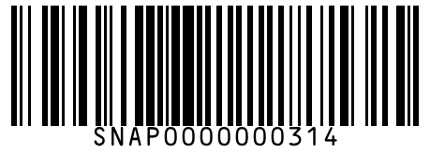
#315 | Saffola Masala Oats Classic Masala 500 g
Brand: Saffola
Variant: 500.000 g
SKU Code: SMSKU-000315
MRP: ₹190.00 | Sell: ₹180.00 | Discount: ₹10.00 flat | Final: ₹170.00
Available Qty: 10
Barcode: SNAP0000000315
 | 
#316 | Bagrry's Muesli with Cranberries 500 g
Brand: Bagrry's
Variant: 500.000 g
SKU Code: SMSKU-000316
MRP: ₹350.00 | Sell: ₹335.00 | Discount: ₹15.00 flat | Final: ₹320.00
Available Qty: 8
Barcode: SNAP0000000316
 | 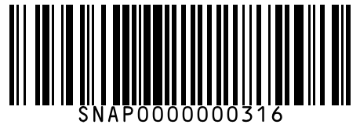
#317 | Yoga Bar Muesli Dark Chocolate 400 g
Brand: Yoga Bar
Variant: 400.000 g
SKU Code: SMSKU-000317
MRP: ₹325.00 | Sell: ₹310.00 | Discount: ₹15.00 flat | Final: ₹295.00
Available Qty: 6
Barcode: SNAP0000000317
 | 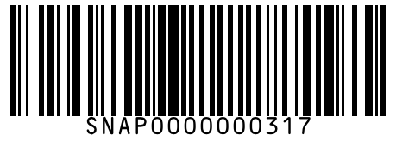
#318 | True Elements Granola Honey Crunch 450 g
Brand: True Elements
Variant: 450.000 g
SKU Code: SMSKU-000318
MRP: ₹380.00 | Sell: ₹360.00 | Discount: ₹20.00 flat | Final: ₹340.00
Available Qty: 5
Barcode: SNAP0000000318
 | 
#319 | Kissan Fresh Tomato Ketchup 200 g
Brand: Kissan
Variant: 200.000 g
SKU Code: SMSKU-000319
MRP: ₹52.00 | Sell: ₹50.00 | Discount: ₹2.00 flat | Final: ₹48.00
Available Qty: 22
Barcode: SNAP0000000319
 | 
#320 | Kissan Fresh Tomato Ketchup 500 g
Brand: Kissan
Variant: 500.000 g
SKU Code: SMSKU-000320
MRP: ₹115.00 | Sell: ₹110.00 | Discount: ₹5.00 flat | Final: ₹105.00
Available Qty: 14
Barcode: SNAP0000000320
 | 
#321 | Kissan Fresh Tomato Ketchup 1 kg
Brand: Kissan
Variant: 1.000 kg
SKU Code: SMSKU-000321
MRP: ₹210.00 | Sell: ₹200.00 | Discount: ₹10.00 flat | Final: ₹190.00
Available Qty: 8
Barcode: SNAP0000000321
 | 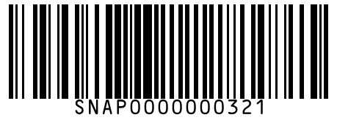
#322 | Maggi Rich Tomato Ketchup 200 g
Brand: Maggi
Variant: 200.000 g
SKU Code: SMSKU-000322
MRP: ₹48.00 | Sell: ₹45.00 | Discount: ₹3.00 flat | Final: ₹42.00
Available Qty: 20
Barcode: SNAP0000000322
 | 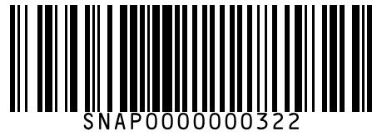
#323 | Maggi Rich Tomato Ketchup 500 g
Brand: Maggi
Variant: 500.000 g
SKU Code: SMSKU-000323
MRP: ₹110.00 | Sell: ₹105.00 | Discount: ₹5.00 flat | Final: ₹100.00
Available Qty: 12
Barcode: SNAP0000000323
 | 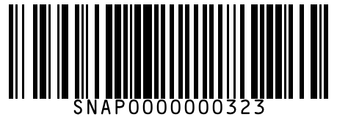
#324 | Ching's Secret Green Chilli Sauce 200 g
Brand: Ching's Secret
Variant: 200.000 g
SKU Code: SMSKU-000324
MRP: ₹55.00 | Sell: ₹52.00 | Discount: ₹3.00 flat | Final: ₹49.00
Available Qty: 16
Barcode: SNAP0000000324
 | 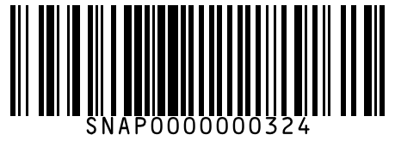
#325 | Ching's Secret Schezwan Chutney 250 g
Brand: Ching's Secret
Variant: 250.000 g
SKU Code: SMSKU-000325
MRP: ₹98.00 | Sell: ₹92.00 | Discount: ₹6.00 flat | Final: ₹86.00
Available Qty: 12
Barcode: SNAP0000000325
 | 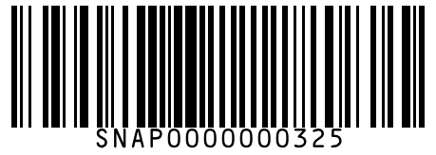
#326 | Veeba Tandoori Mayo 250 g
Brand: Veeba
Variant: 250.000 g
SKU Code: SMSKU-000326
MRP: ₹89.00 | Sell: ₹85.00 | Discount: ₹4.00 flat | Final: ₹81.00
Available Qty: 10
Barcode: SNAP0000000326
 | 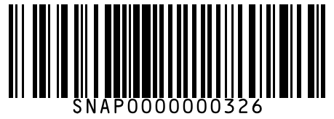
#327 | Veeba Chipotle Southwest Dressing 300 g
Brand: Veeba
Variant: 300.000 g
SKU Code: SMSKU-000327
MRP: ₹120.00 | Sell: ₹115.00 | Discount: ₹5.00 flat | Final: ₹110.00
Available Qty: 8
Barcode: SNAP0000000327
 | 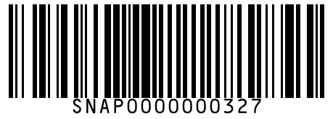
#328 | Priya Mango Pickle 300 g
Brand: Priya
Variant: 300.000 g
SKU Code: SMSKU-000328
MRP: ₹85.00 | Sell: ₹80.00 | Discount: ₹5.00 flat | Final: ₹75.00
Available Qty: 14
Barcode: SNAP0000000328
 | 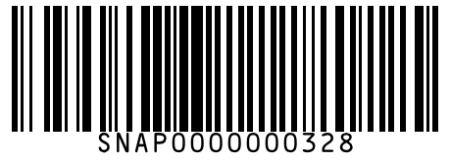
#329 | Priya Mango Pickle 500 g
Brand: Priya
Variant: 500.000 g
SKU Code: SMSKU-000329
MRP: ₹130.00 | Sell: ₹122.00 | Discount: ₹8.00 flat | Final: ₹114.00
Available Qty: 8
Barcode: SNAP0000000329
 | 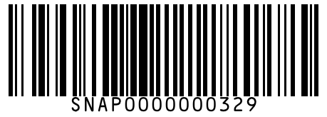
#330 | Mother's Recipe Lime Pickle 300 g
Brand: Mother's Recipe
Variant: 300.000 g
SKU Code: SMSKU-000330
MRP: ₹90.00 | Sell: ₹85.00 | Discount: ₹5.00 flat | Final: ₹80.00
Available Qty: 12
Barcode: SNAP0000000330
 | 
#331 | Mother's Recipe Mixed Pickle 300 g
Brand: Mother's Recipe
Variant: 300.000 g
SKU Code: SMSKU-000331
MRP: ₹90.00 | Sell: ₹85.00 | Discount: ₹5.00 flat | Final: ₹80.00
Available Qty: 10
Barcode: SNAP0000000331
 | 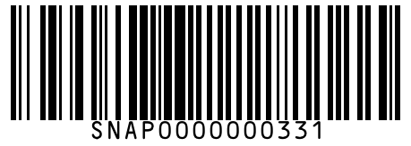
#332 | Kissan Mixed Fruit Jam 200 g
Brand: Kissan
Variant: 200.000 g
SKU Code: SMSKU-000332
MRP: ₹80.00 | Sell: ₹75.00 | Discount: ₹5.00 flat | Final: ₹70.00
Available Qty: 18
Barcode: SNAP0000000332
 | 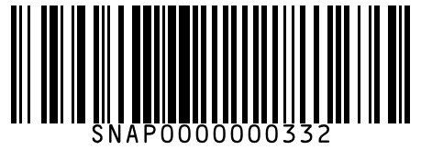
#333 | Kissan Mixed Fruit Jam 500 g
Brand: Kissan
Variant: 500.000 g
SKU Code: SMSKU-000333
MRP: ₹170.00 | Sell: ₹162.00 | Discount: ₹8.00 flat | Final: ₹154.00
Available Qty: 10
Barcode: SNAP0000000333
 | 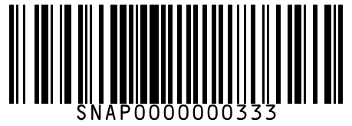
#334 | Kissan Pineapple Jam 200 g
Brand: Kissan
Variant: 200.000 g
SKU Code: SMSKU-000334
MRP: ₹80.00 | Sell: ₹75.00 | Discount: ₹5.00 flat | Final: ₹70.00
Available Qty: 14
Barcode: SNAP0000000334
 | 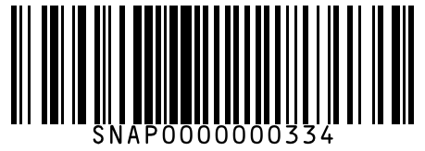
#335 | Sundrop Peanut Butter Creamy 200 g
Brand: Sundrop
Variant: 200.000 g
SKU Code: SMSKU-000335
MRP: ₹130.00 | Sell: ₹122.00 | Discount: ₹8.00 flat | Final: ₹114.00
Available Qty: 10
Barcode: SNAP0000000335
 | 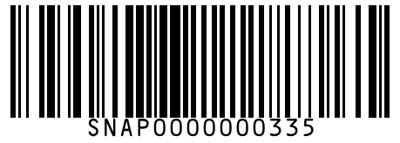
#336 | Sundrop Peanut Butter Creamy 462 g
Brand: Sundrop
Variant: 462.000 g
SKU Code: SMSKU-000336
MRP: ₹275.00 | Sell: ₹260.00 | Discount: ₹15.00 flat | Final: ₹245.00
Available Qty: 5
Barcode: SNAP0000000336
 | 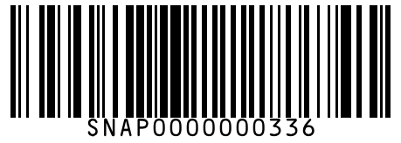
#337 | Nutella Hazelnut Cocoa Spread 350 g
Brand: Nutella
Variant: 350.000 g
SKU Code: SMSKU-000337
MRP: ₹450.00 | Sell: ₹425.00 | Discount: ₹25.00 flat | Final: ₹400.00
Available Qty: 6
Barcode: SNAP0000000337
 | 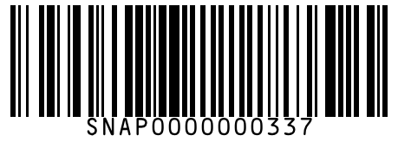
#338 | Head & Shoulders Anti-Dandruff Smooth & Silky Shampoo 72 ml
Brand: Head & Shoulders
Variant: 72.000 ml
SKU Code: SMSKU-000338
MRP: ₹85.00 | Sell: ₹80.00 | Discount: ₹5.00 flat | Final: ₹75.00
Available Qty: 20
Barcode: SNAP0000000338
 | 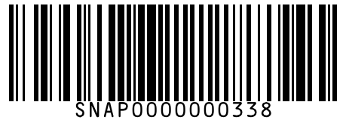
#339 | Head & Shoulders Anti-Dandruff Smooth & Silky Shampoo 180 ml
Brand: Head & Shoulders
Variant: 180.000 ml
SKU Code: SMSKU-000339
MRP: ₹190.00 | Sell: ₹180.00 | Discount: ₹10.00 flat | Final: ₹170.00
Available Qty: 14
Barcode: SNAP0000000339
 | 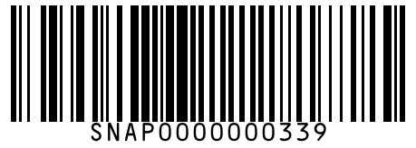
#340 | Head & Shoulders Anti-Dandruff Smooth & Silky Shampoo 340 ml
Brand: Head & Shoulders
Variant: 340.000 ml
SKU Code: SMSKU-000340
MRP: ₹350.00 | Sell: ₹330.00 | Discount: ₹20.00 flat | Final: ₹310.00
Available Qty: 8
Barcode: SNAP0000000340
 | 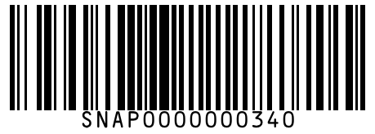
#341 | Dove Hair Fall Rescue Shampoo 80 ml
Brand: Dove
Variant: 80.000 ml
SKU Code: SMSKU-000341
MRP: ₹75.00 | Sell: ₹70.00 | Discount: ₹5.00 flat | Final: ₹65.00
Available Qty: 18
Barcode: SNAP0000000341
 | 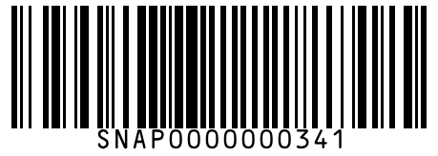
#342 | Dove Hair Fall Rescue Shampoo 180 ml
Brand: Dove
Variant: 180.000 ml
SKU Code: SMSKU-000342
MRP: ₹178.00 | Sell: ₹168.00 | Discount: ₹10.00 flat | Final: ₹158.00
Available Qty: 12
Barcode: SNAP0000000342
 | 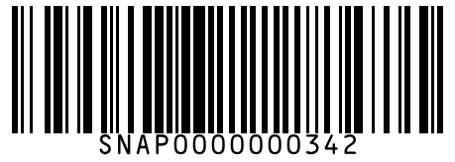
#343 | Dove Hair Fall Rescue Shampoo 340 ml
Brand: Dove
Variant: 340.000 ml
SKU Code: SMSKU-000343
MRP: ₹330.00 | Sell: ₹315.00 | Discount: ₹15.00 flat | Final: ₹300.00
Available Qty: 7
Barcode: SNAP0000000343
 | 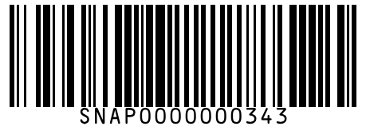
#344 | Dove Intense Repair Conditioner 80 ml
Brand: Dove
Variant: 80.000 ml
SKU Code: SMSKU-000344
MRP: ₹82.00 | Sell: ₹78.00 | Discount: ₹4.00 flat | Final: ₹74.00
Available Qty: 14
Barcode: SNAP0000000344
 | 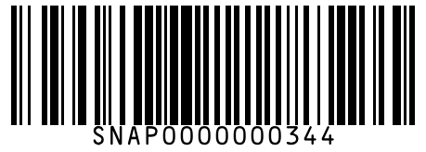
#345 | Dove Intense Repair Conditioner 175 ml
Brand: Dove
Variant: 175.000 ml
SKU Code: SMSKU-000345
MRP: ₹189.00 | Sell: ₹180.00 | Discount: ₹9.00 flat | Final: ₹171.00
Available Qty: 8
Barcode: SNAP0000000345
 | 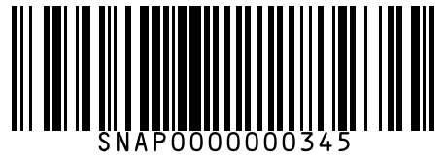
#346 | Pantene Hair Fall Control Shampoo 72 ml
Brand: Pantene
Variant: 72.000 ml
SKU Code: SMSKU-000346
MRP: ₹75.00 | Sell: ₹72.00 | Discount: ₹3.00 flat | Final: ₹69.00
Available Qty: 16
Barcode: SNAP0000000346
 | 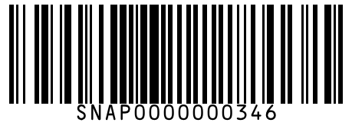
#347 | Pantene Hair Fall Control Shampoo 180 ml
Brand: Pantene
Variant: 180.000 ml
SKU Code: SMSKU-000347
MRP: ₹185.00 | Sell: ₹175.00 | Discount: ₹10.00 flat | Final: ₹165.00
Available Qty: 10
Barcode: SNAP0000000347
 | 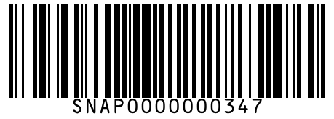
#348 | Pantene Hair Fall Control Shampoo 340 ml
Brand: Pantene
Variant: 340.000 ml
SKU Code: SMSKU-000348
MRP: ₹340.00 | Sell: ₹325.00 | Discount: ₹15.00 flat | Final: ₹310.00
Available Qty: 6
Barcode: SNAP0000000348
 | 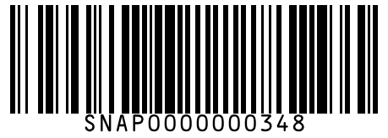
#349 | Clinic Plus Strong & Long Shampoo 80 ml
Brand: Clinic Plus
Variant: 80.000 ml
SKU Code: SMSKU-000349
MRP: ₹52.00 | Sell: ₹50.00 | Discount: ₹2.00 flat | Final: ₹48.00
Available Qty: 22
Barcode: SNAP0000000349
 | 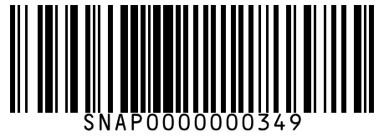
#350 | Clinic Plus Strong & Long Shampoo 175 ml
Brand: Clinic Plus
Variant: 175.000 ml
SKU Code: SMSKU-000350
MRP: ₹108.00 | Sell: ₹102.00 | Discount: ₹6.00 flat | Final: ₹96.00
Available Qty: 14
Barcode: SNAP0000000350
 | 
#351 | Clinic Plus Strong & Long Shampoo 340 ml
Brand: Clinic Plus
Variant: 340.000 ml
SKU Code: SMSKU-000351
MRP: ₹198.00 | Sell: ₹188.00 | Discount: ₹10.00 flat | Final: ₹178.00
Available Qty: 8
Barcode: SNAP0000000351
 | 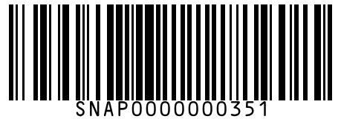
#352 | Sunsilk Lusciously Thick & Long Shampoo 80 ml
Brand: Sunsilk
Variant: 80.000 ml
SKU Code: SMSKU-000352
MRP: ₹55.00 | Sell: ₹52.00 | Discount: ₹3.00 flat | Final: ₹49.00
Available Qty: 20
Barcode: SNAP0000000352
 | 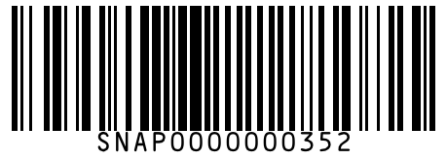
#353 | Sunsilk Lusciously Thick & Long Shampoo 180 ml
Brand: Sunsilk
Variant: 180.000 ml
SKU Code: SMSKU-000353
MRP: ₹115.00 | Sell: ₹108.00 | Discount: ₹7.00 flat | Final: ₹101.00
Available Qty: 12
Barcode: SNAP0000000353
 | 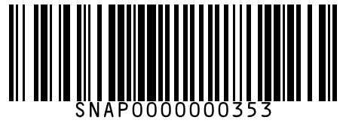
#354 | Sunsilk Lusciously Thick & Long Shampoo 340 ml
Brand: Sunsilk
Variant: 340.000 ml
SKU Code: SMSKU-000354
MRP: ₹210.00 | Sell: ₹200.00 | Discount: ₹10.00 flat | Final: ₹190.00
Available Qty: 7
Barcode: SNAP0000000354
 | 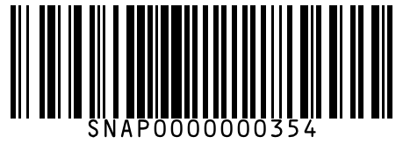
#355 | TRESemme Keratin Smooth Shampoo 185 ml
Brand: TRESemme
Variant: 185.000 ml
SKU Code: SMSKU-000355
MRP: ₹240.00 | Sell: ₹228.00 | Discount: ₹12.00 flat | Final: ₹216.00
Available Qty: 10
Barcode: SNAP0000000355
 | 
#356 | TRESemme Keratin Smooth Shampoo 580 ml
Brand: TRESemme
Variant: 580.000 ml
SKU Code: SMSKU-000356
MRP: ₹680.00 | Sell: ₹650.00 | Discount: ₹30.00 flat | Final: ₹620.00
Available Qty: 4
Barcode: SNAP0000000356
 | 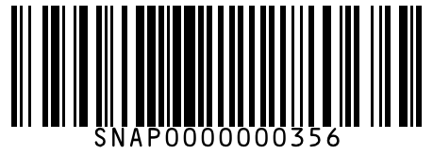
#357 | Parachute Advansed Coconut Hair Oil 90 ml
Brand: Parachute
Variant: 90.000 ml
SKU Code: SMSKU-000357
MRP: ₹52.00 | Sell: ₹50.00 | Discount: ₹2.00 flat | Final: ₹48.00
Available Qty: 25
Barcode: SNAP0000000357
 | 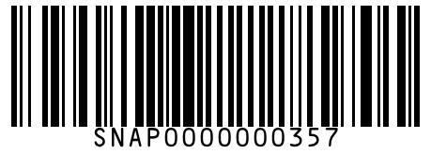
#358 | Parachute Advansed Coconut Hair Oil 175 ml
Brand: Parachute
Variant: 175.000 ml
SKU Code: SMSKU-000358
MRP: ₹99.00 | Sell: ₹95.00 | Discount: ₹4.00 flat | Final: ₹91.00
Available Qty: 15
Barcode: SNAP0000000358
 | 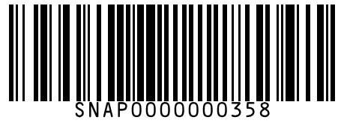
#359 | Parachute Advansed Coconut Hair Oil 300 ml
Brand: Parachute
Variant: 300.000 ml
SKU Code: SMSKU-000359
MRP: ₹165.00 | Sell: ₹158.00 | Discount: ₹7.00 flat | Final: ₹151.00
Available Qty: 10
Barcode: SNAP0000000359
 | 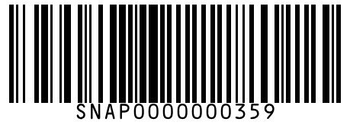
#360 | Bajaj Almond Drops Almond Hair Oil 100 ml
Brand: Bajaj Almond Drops
Variant: 100.000 ml
SKU Code: SMSKU-000360
MRP: ₹85.00 | Sell: ₹80.00 | Discount: ₹5.00 flat | Final: ₹75.00
Available Qty: 18
Barcode: SNAP0000000360
 | 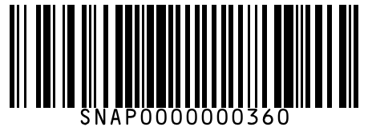
#361 | Bajaj Almond Drops Almond Hair Oil 200 ml
Brand: Bajaj Almond Drops
Variant: 200.000 ml
SKU Code: SMSKU-000361
MRP: ₹155.00 | Sell: ₹148.00 | Discount: ₹7.00 flat | Final: ₹141.00
Available Qty: 10
Barcode: SNAP0000000361
 | 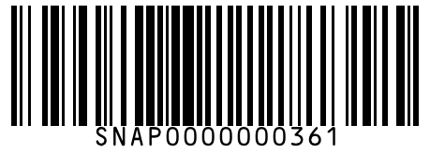
#362 | Indulekha Bringha Hair Oil 100 ml
Brand: Indulekha
Variant: 100.000 ml
SKU Code: SMSKU-000362
MRP: ₹420.00 | Sell: ₹400.00 | Discount: ₹20.00 flat | Final: ₹380.00
Available Qty: 6
Barcode: SNAP0000000362
 | 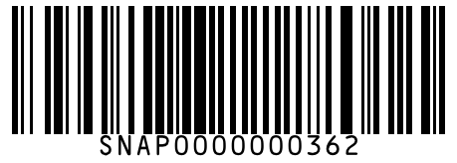
#363 | Dove Cream Beauty Bar Soap 75 g
Brand: Dove
Variant: 75.000 g
SKU Code: SMSKU-000363
MRP: ₹52.00 | Sell: ₹50.00 | Discount: ₹2.00 flat | Final: ₹48.00
Available Qty: 30
Barcode: SNAP0000000363
 | 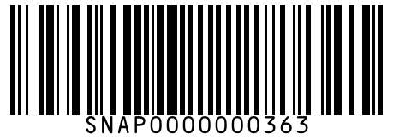
#364 | Dove Cream Beauty Bar Soap 100 g
Brand: Dove
Variant: 100.000 g
SKU Code: SMSKU-000364
MRP: ₹65.00 | Sell: ₹62.00 | Discount: ₹3.00 flat | Final: ₹59.00
Available Qty: 22
Barcode: SNAP0000000364
 | 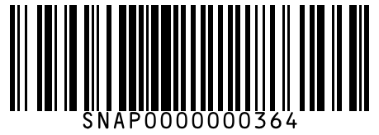
#365 | Lux Soft Touch Bar Soap 75 g
Brand: Lux
Variant: 75.000 g
SKU Code: SMSKU-000365
MRP: ₹38.00 | Sell: ₹36.00 | Discount: ₹2.00 flat | Final: ₹34.00
Available Qty: 28
Barcode: SNAP0000000365
 | 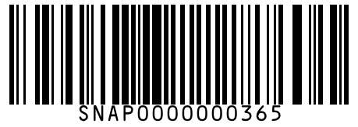
#366 | Lux Soft Touch Bar Soap 150 g
Brand: Lux
Variant: 150.000 g
SKU Code: SMSKU-000366
MRP: ₹72.00 | Sell: ₹68.00 | Discount: ₹4.00 flat | Final: ₹64.00
Available Qty: 18
Barcode: SNAP0000000366
 | 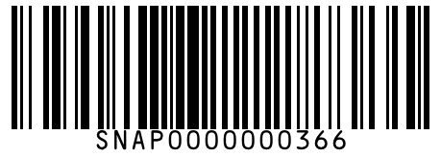
#367 | Dettol Original Germ Protection Soap 75 g
Brand: Dettol
Variant: 75.000 g
SKU Code: SMSKU-000367
MRP: ₹38.00 | Sell: ₹36.00 | Discount: ₹2.00 flat | Final: ₹34.00
Available Qty: 30
Barcode: SNAP0000000367
 | 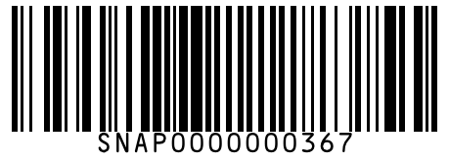
#368 | Dettol Original Germ Protection Soap 125 g
Brand: Dettol
Variant: 125.000 g
SKU Code: SMSKU-000368
MRP: ₹58.00 | Sell: ₹55.00 | Discount: ₹3.00 flat | Final: ₹52.00
Available Qty: 20
Barcode: SNAP0000000368
 | 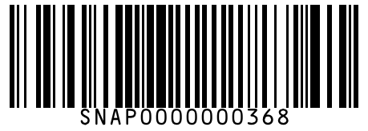
#369 | Lifebuoy Total 10 Germ Protection Soap 100 g
Brand: Lifebuoy
Variant: 100.000 g
SKU Code: SMSKU-000369
MRP: ₹35.00 | Sell: ₹33.00 | Discount: ₹2.00 flat | Final: ₹31.00
Available Qty: 30
Barcode: SNAP0000000369
 | 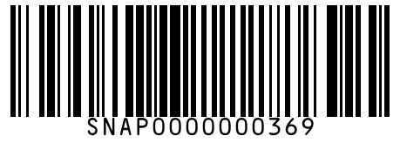
#370 | Lifebuoy Total 10 Germ Protection Soap 150 g
Brand: Lifebuoy
Variant: 150.000 g
SKU Code: SMSKU-000370
MRP: ₹50.00 | Sell: ₹48.00 | Discount: ₹2.00 flat | Final: ₹46.00
Available Qty: 20
Barcode: SNAP0000000370
 | 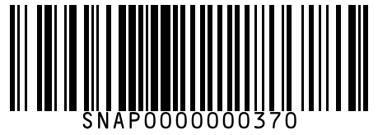
#371 | Dove Deeply Nourishing Body Wash 250 ml
Brand: Dove
Variant: 250.000 ml
SKU Code: SMSKU-000371
MRP: ₹210.00 | Sell: ₹200.00 | Discount: ₹10.00 flat | Final: ₹190.00
Available Qty: 12
Barcode: SNAP0000000371
 | 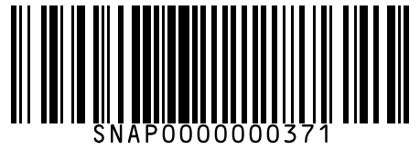
#372 | Dove Deeply Nourishing Body Wash 500 ml
Brand: Dove
Variant: 500.000 ml
SKU Code: SMSKU-000372
MRP: ₹395.00 | Sell: ₹375.00 | Discount: ₹20.00 flat | Final: ₹355.00
Available Qty: 6
Barcode: SNAP0000000372
 | 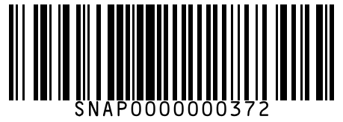
#373 | Nivea Creme Soft Shower Gel 250 ml
Brand: Nivea
Variant: 250.000 ml
SKU Code: SMSKU-000373
MRP: ₹225.00 | Sell: ₹215.00 | Discount: ₹10.00 flat | Final: ₹205.00
Available Qty: 10
Barcode: SNAP0000000373
 | 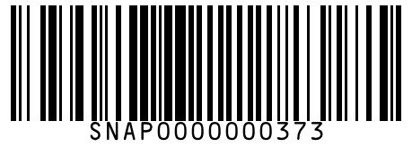
#374 | Nivea Creme Soft Shower Gel 500 ml
Brand: Nivea
Variant: 500.000 ml
SKU Code: SMSKU-000374
MRP: ₹410.00 | Sell: ₹390.00 | Discount: ₹20.00 flat | Final: ₹370.00
Available Qty: 5
Barcode: SNAP0000000374
 | 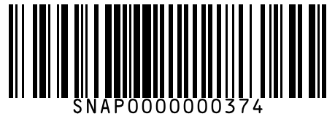
#375 | Himalaya Neem Face Wash 50 ml
Brand: Himalaya
Variant: 50.000 ml
SKU Code: SMSKU-000375
MRP: ₹70.00 | Sell: ₹65.00 | Discount: ₹5.00 flat | Final: ₹60.00
Available Qty: 18
Barcode: SNAP0000000375
 | 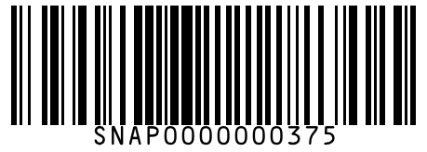
#376 | Himalaya Neem Face Wash 100 ml
Brand: Himalaya
Variant: 100.000 ml
SKU Code: SMSKU-000376
MRP: ₹130.00 | Sell: ₹122.00 | Discount: ₹8.00 flat | Final: ₹114.00
Available Qty: 12
Barcode: SNAP0000000376
 | 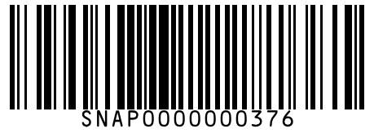
#377 | Himalaya Neem Face Wash 150 ml
Brand: Himalaya
Variant: 150.000 ml
SKU Code: SMSKU-000377
MRP: ₹185.00 | Sell: ₹175.00 | Discount: ₹10.00 flat | Final: ₹165.00
Available Qty: 7
Barcode: SNAP0000000377
 | 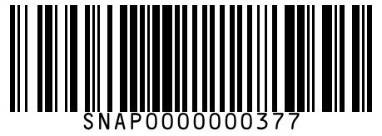
#378 | Nivea Soft Moisturising Cream 50 ml
Brand: Nivea
Variant: 50.000 ml
SKU Code: SMSKU-000378
MRP: ₹140.00 | Sell: ₹132.00 | Discount: ₹8.00 flat | Final: ₹124.00
Available Qty: 14
Barcode: SNAP0000000378
 | 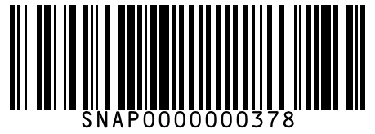
#379 | Nivea Soft Moisturising Cream 100 ml
Brand: Nivea
Variant: 100.000 ml
SKU Code: SMSKU-000379
MRP: ₹250.00 | Sell: ₹238.00 | Discount: ₹12.00 flat | Final: ₹226.00
Available Qty: 8
Barcode: SNAP0000000379
 | 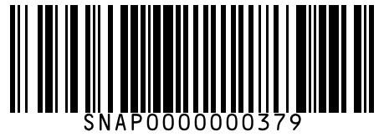
#380 | Vaseline Intensive Care Deep Moisture Body Lotion 200 ml
Brand: Vaseline
Variant: 200.000 ml
SKU Code: SMSKU-000380
MRP: ₹195.00 | Sell: ₹185.00 | Discount: ₹10.00 flat | Final: ₹175.00
Available Qty: 10
Barcode: SNAP0000000380
 | 
#381 | Vaseline Intensive Care Deep Moisture Body Lotion 400 ml
Brand: Vaseline
Variant: 400.000 ml
SKU Code: SMSKU-000381
MRP: ₹365.00 | Sell: ₹350.00 | Discount: ₹15.00 flat | Final: ₹335.00
Available Qty: 5
Barcode: SNAP0000000381
 | 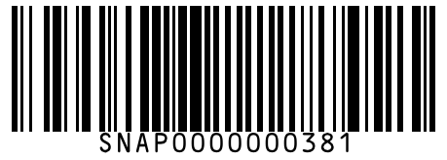
#382 | Ponds White Beauty Sun Protection SPF 15 Cream 35 g
Brand: Ponds
Variant: 35.000 g
SKU Code: SMSKU-000382
MRP: ₹125.00 | Sell: ₹118.00 | Discount: ₹7.00 flat | Final: ₹111.00
Available Qty: 12
Barcode: SNAP0000000382
 | 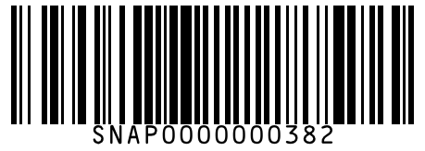
#383 | Dettol Original Liquid Handwash 200 ml
Brand: Dettol
Variant: 200.000 ml
SKU Code: SMSKU-000383
MRP: ₹85.00 | Sell: ₹80.00 | Discount: ₹5.00 flat | Final: ₹75.00
Available Qty: 20
Barcode: SNAP0000000383
 | 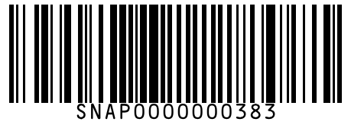
#384 | Dettol Original Liquid Handwash 750 ml
Brand: Dettol
Variant: 750.000 ml
SKU Code: SMSKU-000384
MRP: ₹175.00 | Sell: ₹165.00 | Discount: ₹10.00 flat | Final: ₹155.00
Available Qty: 10
Barcode: SNAP0000000384
 | 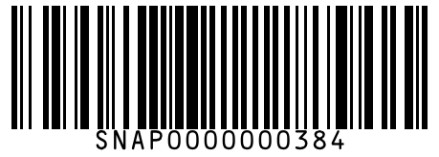
#385 | Colgate Strong Teeth Toothpaste 100 g
Brand: Colgate
Variant: 100.000 g
SKU Code: SMSKU-000385
MRP: ₹56.00 | Sell: ₹52.00 | Discount: ₹4.00 flat | Final: ₹48.00
Available Qty: 30
Barcode: SNAP0000000385
 | 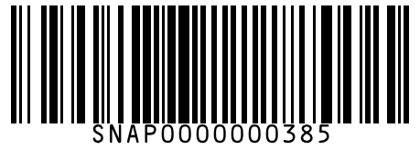
#386 | Colgate Strong Teeth Toothpaste 200 g
Brand: Colgate
Variant: 200.000 g
SKU Code: SMSKU-000386
MRP: ₹104.00 | Sell: ₹98.00 | Discount: ₹6.00 flat | Final: ₹92.00
Available Qty: 18
Barcode: SNAP0000000386
 | 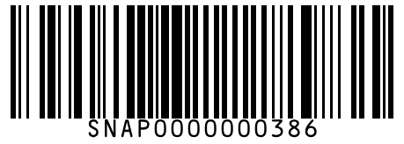
#387 | Colgate MaxFresh Blue Gel Toothpaste 80 g
Brand: Colgate
Variant: 80.000 g
SKU Code: SMSKU-000387
MRP: ₹65.00 | Sell: ₹60.00 | Discount: ₹5.00 flat | Final: ₹55.00
Available Qty: 22
Barcode: SNAP0000000387
 | 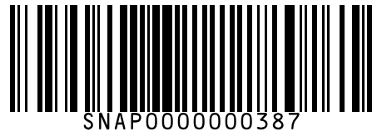
#388 | Colgate MaxFresh Blue Gel Toothpaste 150 g
Brand: Colgate
Variant: 150.000 g
SKU Code: SMSKU-000388
MRP: ₹115.00 | Sell: ₹108.00 | Discount: ₹7.00 flat | Final: ₹101.00
Available Qty: 14
Barcode: SNAP0000000388
 | 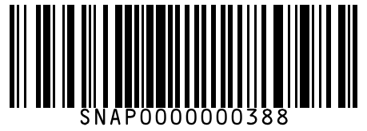
#389 | Colgate Total Charcoal Deep Clean Toothpaste 120 g
Brand: Colgate
Variant: 120.000 g
SKU Code: SMSKU-000389
MRP: ₹120.00 | Sell: ₹115.00 | Discount: ₹5.00 flat | Final: ₹110.00
Available Qty: 16
Barcode: SNAP0000000389
 | 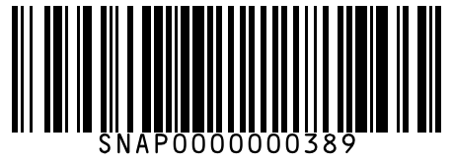
#390 | Pepsodent Germi Check Toothpaste 100 g
Brand: Pepsodent
Variant: 100.000 g
SKU Code: SMSKU-000390
MRP: ₹48.00 | Sell: ₹45.00 | Discount: ₹3.00 flat | Final: ₹42.00
Available Qty: 25
Barcode: SNAP0000000390
 | 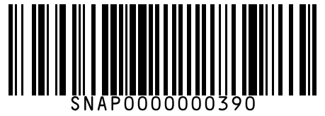
#391 | Pepsodent Germi Check Toothpaste 200 g
Brand: Pepsodent
Variant: 200.000 g
SKU Code: SMSKU-000391
MRP: ₹90.00 | Sell: ₹85.00 | Discount: ₹5.00 flat | Final: ₹80.00
Available Qty: 15
Barcode: SNAP0000000391
 | 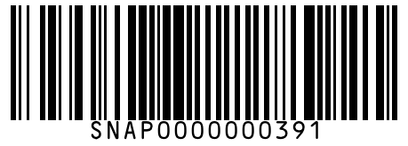
#392 | Sensodyne Sensitive Toothpaste Fresh Gel 75 g
Brand: Sensodyne
Variant: 75.000 g
SKU Code: SMSKU-000392
MRP: ₹185.00 | Sell: ₹175.00 | Discount: ₹10.00 flat | Final: ₹165.00
Available Qty: 10
Barcode: SNAP0000000392
 | 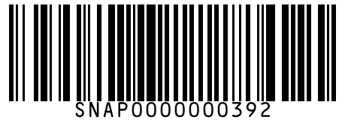
#393 | Sensodyne Sensitive Toothpaste Fresh Gel 150 g
Brand: Sensodyne
Variant: 150.000 g
SKU Code: SMSKU-000393
MRP: ₹345.00 | Sell: ₹330.00 | Discount: ₹15.00 flat | Final: ₹315.00
Available Qty: 5
Barcode: SNAP0000000393
 | 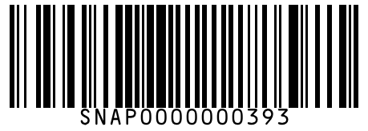
#394 | Closeup Ever Fresh Red Hot Gel 80 g
Brand: Closeup
Variant: 80.000 g
SKU Code: SMSKU-000394
MRP: ₹52.00 | Sell: ₹50.00 | Discount: ₹2.00 flat | Final: ₹48.00
Available Qty: 20
Barcode: SNAP0000000394
 | 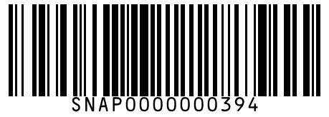
#395 | Closeup Ever Fresh Red Hot Gel 150 g
Brand: Closeup
Variant: 150.000 g
SKU Code: SMSKU-000395
MRP: ₹95.00 | Sell: ₹90.00 | Discount: ₹5.00 flat | Final: ₹85.00
Available Qty: 12
Barcode: SNAP0000000395
 | 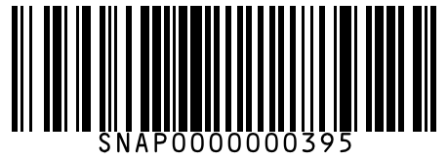
#396 | Oral-B Criss Cross Toothbrush Medium 1 pc
Brand: Oral-B
Variant: 1.000 pc
SKU Code: SMSKU-000396
MRP: ₹42.00 | Sell: ₹40.00 | Discount: ₹2.00 flat | Final: ₹38.00
Available Qty: 30
Barcode: SNAP0000000396
 | 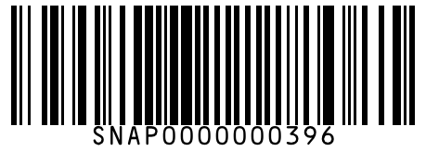
#397 | Oral-B Criss Cross Toothbrush Medium 4 pcs
Brand: Oral-B
Variant: 4.000 pcs
SKU Code: SMSKU-000397
MRP: ₹155.00 | Sell: ₹148.00 | Discount: ₹7.00 flat | Final: ₹141.00
Available Qty: 12
Barcode: SNAP0000000397
 | 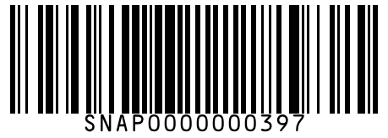
#398 | Colgate Slim Soft Toothbrush 1 pc
Brand: Colgate
Variant: 1.000 pc
SKU Code: SMSKU-000398
MRP: ₹55.00 | Sell: ₹52.00 | Discount: ₹3.00 flat | Final: ₹49.00
Available Qty: 25
Barcode: SNAP0000000398
 | 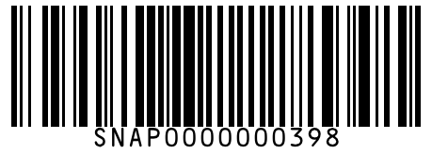
#399 | Listerine Cool Mint Mouthwash 250 ml
Brand: Listerine
Variant: 250.000 ml
SKU Code: SMSKU-000399
MRP: ₹115.00 | Sell: ₹110.00 | Discount: ₹5.00 flat | Final: ₹105.00
Available Qty: 14
Barcode: SNAP0000000399
 | 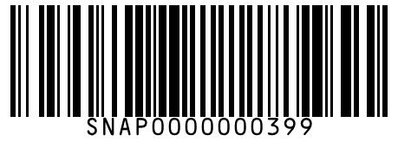
#400 | Listerine Cool Mint Mouthwash 500 ml
Brand: Listerine
Variant: 500.000 ml
SKU Code: SMSKU-000400
MRP: ₹210.00 | Sell: ₹200.00 | Discount: ₹10.00 flat | Final: ₹190.00
Available Qty: 6
Barcode: SNAP0000000400
 | 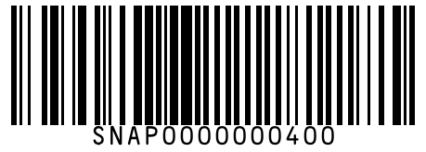
#401 | Johnson's Baby Baby Shampoo No More Tears 100 ml
Brand: Johnson's Baby
Variant: 100.000 ml
SKU Code: SMSKU-000401
MRP: ₹100.00 | Sell: ₹95.00 | Discount: ₹5.00 flat | Final: ₹90.00
Available Qty: 18
Barcode: SNAP0000000401
 | 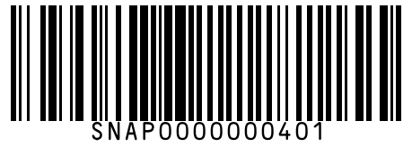
#402 | Johnson's Baby Baby Shampoo No More Tears 200 ml
Brand: Johnson's Baby
Variant: 200.000 ml
SKU Code: SMSKU-000402
MRP: ₹185.00 | Sell: ₹175.00 | Discount: ₹10.00 flat | Final: ₹165.00
Available Qty: 10
Barcode: SNAP0000000402
 | 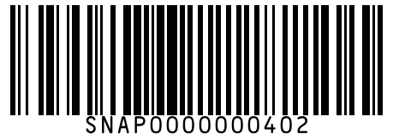
#403 | Johnson's Baby Baby Powder 100 g
Brand: Johnson's Baby
Variant: 100.000 g
SKU Code: SMSKU-000403
MRP: ₹65.00 | Sell: ₹62.00 | Discount: ₹3.00 flat | Final: ₹59.00
Available Qty: 20
Barcode: SNAP0000000403
 | 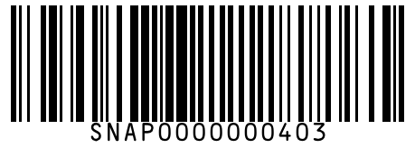
#404 | Johnson's Baby Baby Powder 200 g
Brand: Johnson's Baby
Variant: 200.000 g
SKU Code: SMSKU-000404
MRP: ₹120.00 | Sell: ₹115.00 | Discount: ₹5.00 flat | Final: ₹110.00
Available Qty: 14
Barcode: SNAP0000000404
 | 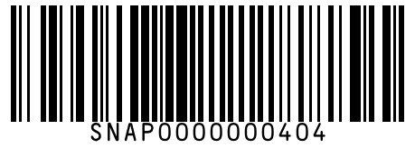
#405 | Johnson's Baby Baby Oil 100 ml
Brand: Johnson's Baby
Variant: 100.000 ml
SKU Code: SMSKU-000405
MRP: ₹95.00 | Sell: ₹90.00 | Discount: ₹5.00 flat | Final: ₹85.00
Available Qty: 16
Barcode: SNAP0000000405
 | 
#406 | Johnson's Baby Baby Oil 200 ml
Brand: Johnson's Baby
Variant: 200.000 ml
SKU Code: SMSKU-000406
MRP: ₹175.00 | Sell: ₹168.00 | Discount: ₹7.00 flat | Final: ₹161.00
Available Qty: 10
Barcode: SNAP0000000406
 | 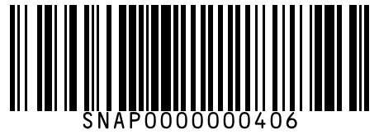
#407 | Himalaya Gentle Baby Wash 100 ml
Brand: Himalaya
Variant: 100.000 ml
SKU Code: SMSKU-000407
MRP: ₹110.00 | Sell: ₹105.00 | Discount: ₹5.00 flat | Final: ₹100.00
Available Qty: 14
Barcode: SNAP0000000407
 | 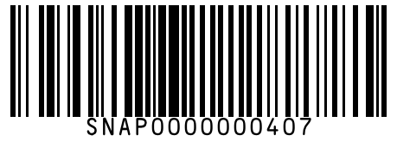
#408 | Himalaya Gentle Baby Wash 200 ml
Brand: Himalaya
Variant: 200.000 ml
SKU Code: SMSKU-000408
MRP: ₹195.00 | Sell: ₹185.00 | Discount: ₹10.00 flat | Final: ₹175.00
Available Qty: 8
Barcode: SNAP0000000408
 | 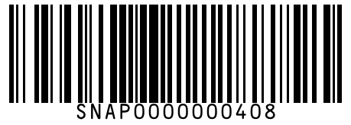
#409 | Himalaya Baby Diaper Rash Cream 50 g
Brand: Himalaya
Variant: 50.000 g
SKU Code: SMSKU-000409
MRP: ₹145.00 | Sell: ₹138.00 | Discount: ₹7.00 flat | Final: ₹131.00
Available Qty: 10
Barcode: SNAP0000000409
 | 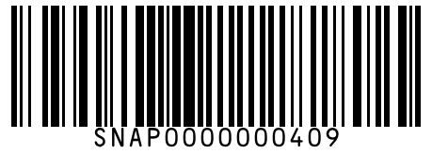
#410 | Pampers Active Baby Diapers (M) 66 pcs 66 pcs
Brand: Pampers
Variant: 66.000 pcs
SKU Code: SMSKU-000410
MRP: ₹999.00 | Sell: ₹940.00 | Discount: ₹59.00 flat | Final: ₹881.00
Available Qty: 8
Barcode: SNAP0000000410
 | 
#411 | Pampers Active Baby Diapers (L) 50 pcs 50 pcs
Brand: Pampers
Variant: 50.000 pcs
SKU Code: SMSKU-000411
MRP: ₹999.00 | Sell: ₹940.00 | Discount: ₹59.00 flat | Final: ₹881.00
Available Qty: 6
Barcode: SNAP0000000411
 | 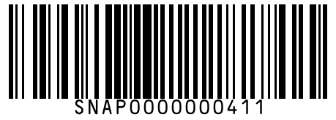
#412 | MamyPoko Pants Extra Absorb (M) 56 pcs 56 pcs
Brand: MamyPoko
Variant: 56.000 pcs
SKU Code: SMSKU-000412
MRP: ₹949.00 | Sell: ₹899.00 | Discount: ₹50.00 flat | Final: ₹849.00
Available Qty: 7
Barcode: SNAP0000000412
 | 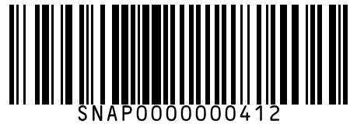
#413 | MamyPoko Pants Extra Absorb (L) 46 pcs 46 pcs
Brand: MamyPoko
Variant: 46.000 pcs
SKU Code: SMSKU-000413
MRP: ₹949.00 | Sell: ₹899.00 | Discount: ₹50.00 flat | Final: ₹849.00
Available Qty: 5
Barcode: SNAP0000000413
 | 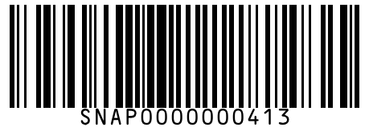
#414 | Cerelac Wheat Rice Mixed Fruit Baby Food 300 g
Brand: Cerelac
Variant: 300.000 g
SKU Code: SMSKU-000414
MRP: ₹265.00 | Sell: ₹250.00 | Discount: ₹15.00 flat | Final: ₹235.00
Available Qty: 10
Barcode: SNAP0000000414
 | 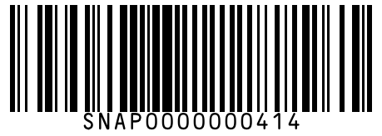
#415 | Cerelac Wheat Apple Cherry Baby Food 300 g
Brand: Cerelac
Variant: 300.000 g
SKU Code: SMSKU-000415
MRP: ₹265.00 | Sell: ₹250.00 | Discount: ₹15.00 flat | Final: ₹235.00
Available Qty: 8
Barcode: SNAP0000000415
 | 
#416 | Vim Dishwash Liquid Gel Lemon 250 ml
Brand: Vim
Variant: 250.000 ml
SKU Code: SMSKU-000416
MRP: ₹52.00 | Sell: ₹50.00 | Discount: ₹2.00 flat | Final: ₹48.00
Available Qty: 25
Barcode: SNAP0000000416
 | 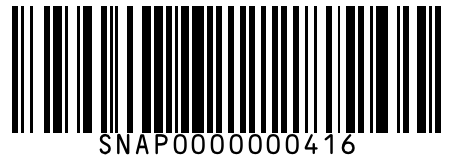
#417 | Vim Dishwash Liquid Gel Lemon 500 ml
Brand: Vim
Variant: 500.000 ml
SKU Code: SMSKU-000417
MRP: ₹99.00 | Sell: ₹95.00 | Discount: ₹4.00 flat | Final: ₹91.00
Available Qty: 15
Barcode: SNAP0000000417
 | 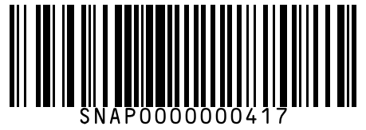
#418 | Vim Dishwash Liquid Gel Lemon 750 ml
Brand: Vim
Variant: 750.000 ml
SKU Code: SMSKU-000418
MRP: ₹145.00 | Sell: ₹138.00 | Discount: ₹7.00 flat | Final: ₹131.00
Available Qty: 8
Barcode: SNAP0000000418
 | 
#419 | Vim Dishwash Bar Lemon 200 g
Brand: Vim
Variant: 200.000 g
SKU Code: SMSKU-000419
MRP: ₹20.00 | Sell: ₹20.00 | Discount: None | Final: ₹20.00
Available Qty: 40
Barcode: SNAP0000000419
 | 
#420 | Vim Dishwash Bar Lemon 600 g
Brand: Vim
Variant: 600.000 g
SKU Code: SMSKU-000420
MRP: ₹50.00 | Sell: ₹48.00 | Discount: ₹2.00 flat | Final: ₹46.00
Available Qty: 25
Barcode: SNAP0000000420
 | 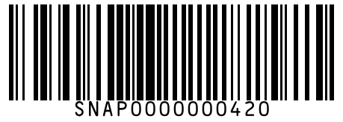
#421 | Prill Dishwash Liquid Lime 250 ml
Brand: Prill
Variant: 250.000 ml
SKU Code: SMSKU-000421
MRP: ₹48.00 | Sell: ₹46.00 | Discount: ₹2.00 flat | Final: ₹44.00
Available Qty: 20
Barcode: SNAP0000000421
 | 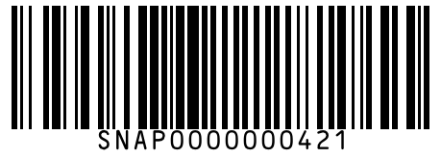
#422 | Prill Dishwash Liquid Lime 500 ml
Brand: Prill
Variant: 500.000 ml
SKU Code: SMSKU-000422
MRP: ₹90.00 | Sell: ₹85.00 | Discount: ₹5.00 flat | Final: ₹80.00
Available Qty: 12
Barcode: SNAP0000000422
 | 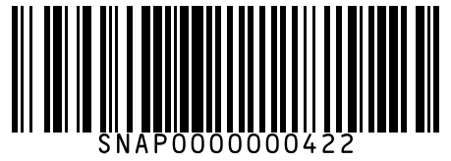
#423 | Surf Excel Easy Wash Detergent Powder 500 g
Brand: Surf Excel
Variant: 500.000 g
SKU Code: SMSKU-000423
MRP: ₹55.00 | Sell: ₹52.00 | Discount: ₹3.00 flat | Final: ₹49.00
Available Qty: 25
Barcode: SNAP0000000423
 | 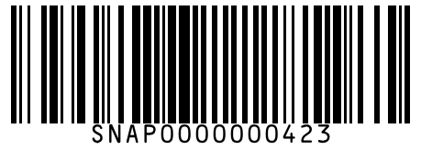
#424 | Surf Excel Easy Wash Detergent Powder 1 kg
Brand: Surf Excel
Variant: 1.000 kg
SKU Code: SMSKU-000424
MRP: ₹105.00 | Sell: ₹100.00 | Discount: ₹5.00 flat | Final: ₹95.00
Available Qty: 18
Barcode: SNAP0000000424
 | 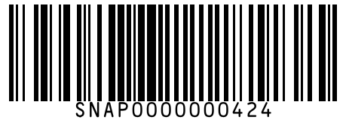
#425 | Surf Excel Easy Wash Detergent Powder 2 kg
Brand: Surf Excel
Variant: 2.000 kg
SKU Code: SMSKU-000425
MRP: ₹200.00 | Sell: ₹190.00 | Discount: ₹10.00 flat | Final: ₹180.00
Available Qty: 10
Barcode: SNAP0000000425
 | 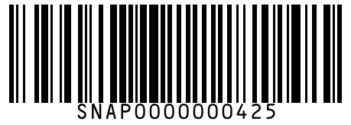
#426 | Surf Excel Matic Top Load Detergent Powder 500 g
Brand: Surf Excel
Variant: 500.000 g
SKU Code: SMSKU-000426
MRP: ₹130.00 | Sell: ₹125.00 | Discount: ₹5.00 flat | Final: ₹120.00
Available Qty: 15
Barcode: SNAP0000000426
 | 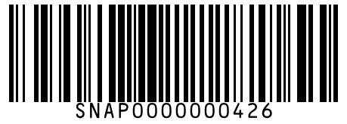
#427 | Surf Excel Matic Top Load Detergent Powder 1 kg
Brand: Surf Excel
Variant: 1.000 kg
SKU Code: SMSKU-000427
MRP: ₹250.00 | Sell: ₹238.00 | Discount: ₹12.00 flat | Final: ₹226.00
Available Qty: 8
Barcode: SNAP0000000427
 | 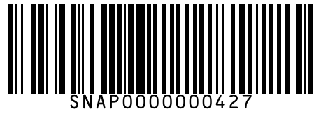
#428 | Surf Excel Matic Top Load Detergent Powder 2 kg
Brand: Surf Excel
Variant: 2.000 kg
SKU Code: SMSKU-000428
MRP: ₹480.00 | Sell: ₹460.00 | Discount: ₹20.00 flat | Final: ₹440.00
Available Qty: 4
Barcode: SNAP0000000428
 | 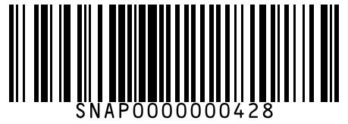
#429 | Surf Excel Liquid Detergent Front Load 500 ml
Brand: Surf Excel
Variant: 500.000 ml
SKU Code: SMSKU-000429
MRP: ₹165.00 | Sell: ₹158.00 | Discount: ₹7.00 flat | Final: ₹151.00
Available Qty: 10
Barcode: SNAP0000000429
 | 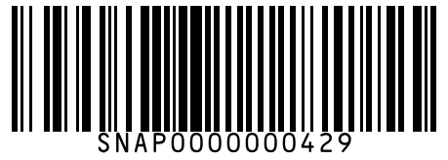
#430 | Surf Excel Liquid Detergent Front Load 1 L
Brand: Surf Excel
Variant: 1.000 L
SKU Code: SMSKU-000430
MRP: ₹310.00 | Sell: ₹295.00 | Discount: ₹15.00 flat | Final: ₹280.00
Available Qty: 5
Barcode: SNAP0000000430
 | 
#431 | Ariel Matic Front Load Detergent 500 g
Brand: Ariel
Variant: 500.000 g
SKU Code: SMSKU-000431
MRP: ₹145.00 | Sell: ₹138.00 | Discount: ₹7.00 flat | Final: ₹131.00
Available Qty: 12
Barcode: SNAP0000000431
 | 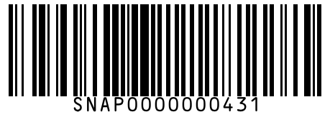
#432 | Ariel Matic Front Load Detergent 1 kg
Brand: Ariel
Variant: 1.000 kg
SKU Code: SMSKU-000432
MRP: ₹275.00 | Sell: ₹262.00 | Discount: ₹13.00 flat | Final: ₹249.00
Available Qty: 7
Barcode: SNAP0000000432
 | 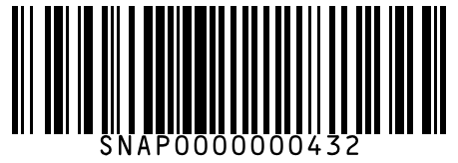
#433 | Ariel Matic Front Load Detergent 2 kg
Brand: Ariel
Variant: 2.000 kg
SKU Code: SMSKU-000433
MRP: ₹530.00 | Sell: ₹505.00 | Discount: ₹25.00 flat | Final: ₹480.00
Available Qty: 3
Barcode: SNAP0000000433
 | 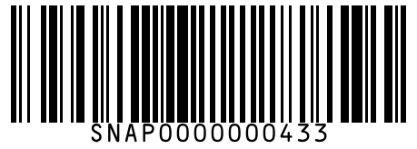
#434 | Tide Plus Double Power Detergent 500 g
Brand: Tide
Variant: 500.000 g
SKU Code: SMSKU-000434
MRP: ₹48.00 | Sell: ₹45.00 | Discount: ₹3.00 flat | Final: ₹42.00
Available Qty: 28
Barcode: SNAP0000000434
 | 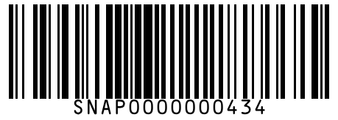
#435 | Tide Plus Double Power Detergent 1 kg
Brand: Tide
Variant: 1.000 kg
SKU Code: SMSKU-000435
MRP: ₹90.00 | Sell: ₹85.00 | Discount: ₹5.00 flat | Final: ₹80.00
Available Qty: 18
Barcode: SNAP0000000435
 | 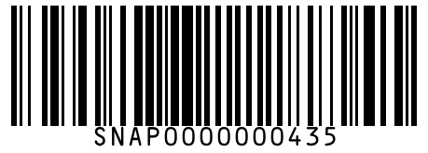
#436 | Tide Plus Double Power Detergent 2 kg
Brand: Tide
Variant: 2.000 kg
SKU Code: SMSKU-000436
MRP: ₹170.00 | Sell: ₹162.00 | Discount: ₹8.00 flat | Final: ₹154.00
Available Qty: 8
Barcode: SNAP0000000436
 | 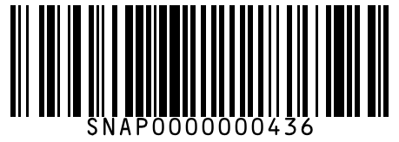
#437 | Rin Detergent Bar 250 g
Brand: Rin
Variant: 250.000 g
SKU Code: SMSKU-000437
MRP: ₹22.00 | Sell: ₹22.00 | Discount: None | Final: ₹22.00
Available Qty: 30
Barcode: SNAP0000000437
 | 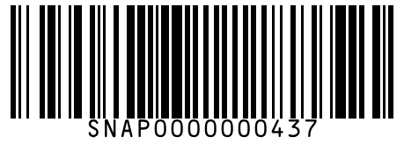
#438 | Comfort After Wash Fabric Conditioner Blue 220 ml
Brand: Comfort
Variant: 220.000 ml
SKU Code: SMSKU-000438
MRP: ₹65.00 | Sell: ₹60.00 | Discount: ₹5.00 flat | Final: ₹55.00
Available Qty: 18
Barcode: SNAP0000000438
 | 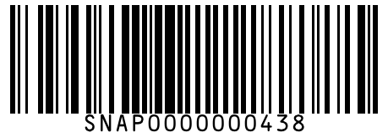
#439 | Comfort After Wash Fabric Conditioner Blue 860 ml
Brand: Comfort
Variant: 860.000 ml
SKU Code: SMSKU-000439
MRP: ₹215.00 | Sell: ₹205.00 | Discount: ₹10.00 flat | Final: ₹195.00
Available Qty: 8
Barcode: SNAP0000000439
 | 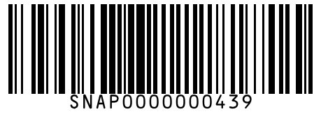
#440 | Harpic Power Plus Toilet Cleaner Original 500 ml
Brand: Harpic
Variant: 500.000 ml
SKU Code: SMSKU-000440
MRP: ₹105.00 | Sell: ₹100.00 | Discount: ₹5.00 flat | Final: ₹95.00
Available Qty: 20
Barcode: SNAP0000000440
 | 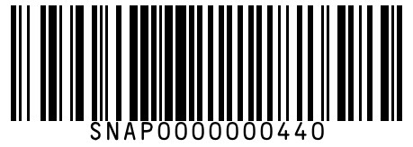
#441 | Harpic Power Plus Toilet Cleaner Original 1 L
Brand: Harpic
Variant: 1.000 L
SKU Code: SMSKU-000441
MRP: ₹195.00 | Sell: ₹185.00 | Discount: ₹10.00 flat | Final: ₹175.00
Available Qty: 10
Barcode: SNAP0000000441
 | 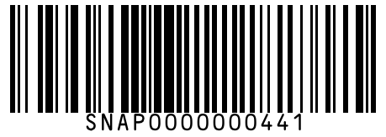
#442 | Lizol Disinfectant Surface Cleaner Citrus 500 ml
Brand: Lizol
Variant: 500.000 ml
SKU Code: SMSKU-000442
MRP: ₹110.00 | Sell: ₹105.00 | Discount: ₹5.00 flat | Final: ₹100.00
Available Qty: 14
Barcode: SNAP0000000442
 | 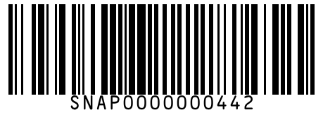
#443 | Lizol Disinfectant Surface Cleaner Citrus 975 ml
Brand: Lizol
Variant: 975.000 ml
SKU Code: SMSKU-000443
MRP: ₹200.00 | Sell: ₹190.00 | Discount: ₹10.00 flat | Final: ₹180.00
Available Qty: 7
Barcode: SNAP0000000443
 | 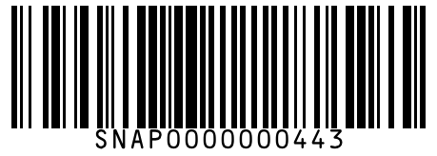
#444 | Colin Glass & Multisurface Cleaner 500 ml
Brand: Colin
Variant: 500.000 ml
SKU Code: SMSKU-000444
MRP: ₹95.00 | Sell: ₹90.00 | Discount: ₹5.00 flat | Final: ₹85.00
Available Qty: 12
Barcode: SNAP0000000444
 | 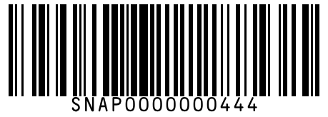
#445 | Domex Fresh Guard Ocean Fresh Disinfectant 500 ml
Brand: Domex
Variant: 500.000 ml
SKU Code: SMSKU-000445
MRP: ₹80.00 | Sell: ₹75.00 | Discount: ₹5.00 flat | Final: ₹70.00
Available Qty: 14
Barcode: SNAP0000000445
 | 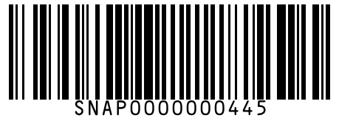
#446 | Odonil Bathroom Air Freshener Blocks Jasmine 75 g
Brand: Odonil
Variant: 75.000 g
SKU Code: SMSKU-000446
MRP: ₹55.00 | Sell: ₹52.00 | Discount: ₹3.00 flat | Final: ₹49.00
Available Qty: 18
Barcode: SNAP0000000446
 | 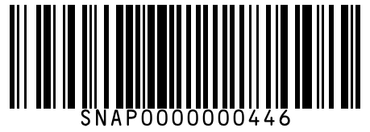
#447 | Good Knight Gold Flash Liquid Vapourizer Refill 45 ml
Brand: Good Knight
Variant: 45.000 ml
SKU Code: SMSKU-000447
MRP: ₹82.00 | Sell: ₹78.00 | Discount: ₹4.00 flat | Final: ₹74.00
Available Qty: 20
Barcode: SNAP0000000447
 | 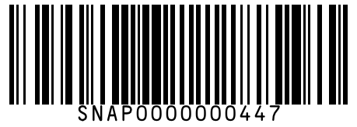
#448 | All Out Ultra Liquid Vapourizer Refill 45 ml
Brand: All Out
Variant: 45.000 ml
SKU Code: SMSKU-000448
MRP: ₹80.00 | Sell: ₹76.00 | Discount: ₹4.00 flat | Final: ₹72.00
Available Qty: 18
Barcode: SNAP0000000448
 | 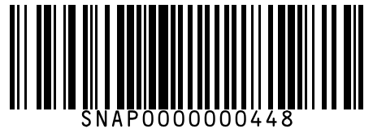
#449 | Scotch-Brite Scrub Pad Large 1 pc
Brand: Scotch-Brite
Variant: 1.000 pc
SKU Code: SMSKU-000449
MRP: ₹30.00 | Sell: ₹28.00 | Discount: ₹2.00 flat | Final: ₹26.00
Available Qty: 35
Barcode: SNAP0000000449
 | 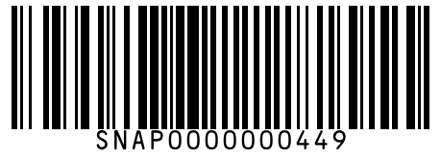
#450 | Britannia White Bread 400 g
Brand: Britannia
Variant: 400.000 g
SKU Code: SMSKU-000450
MRP: ₹40.00 | Sell: ₹40.00 | Discount: None | Final: ₹40.00
Available Qty: 30
Barcode: SNAP0000000450
 | 
#451 | Britannia Whole Wheat Bread 400 g
Brand: Britannia
Variant: 400.000 g
SKU Code: SMSKU-000451
MRP: ₹45.00 | Sell: ₹45.00 | Discount: None | Final: ₹45.00
Available Qty: 25
Barcode: SNAP0000000451
 | 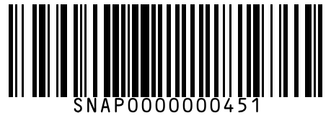
#452 | Harvest Gold White Sandwich Bread 300 g
Brand: Harvest Gold
Variant: 300.000 g
SKU Code: SMSKU-000452
MRP: ₹35.00 | Sell: ₹35.00 | Discount: None | Final: ₹35.00
Available Qty: 22
Barcode: SNAP0000000452
 | 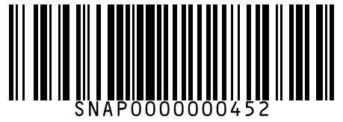
#453 | Harvest Gold Multigrain Bread 450 g
Brand: Harvest Gold
Variant: 450.000 g
SKU Code: SMSKU-000453
MRP: ₹55.00 | Sell: ₹52.00 | Discount: ₹3.00 flat | Final: ₹49.00
Available Qty: 15
Barcode: SNAP0000000453
 | 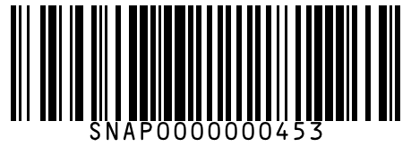
#454 | Modern Brown Bread 400 g
Brand: Modern
Variant: 400.000 g
SKU Code: SMSKU-000454
MRP: ₹42.00 | Sell: ₹40.00 | Discount: ₹2.00 flat | Final: ₹38.00
Available Qty: 18
Barcode: SNAP0000000454
 | 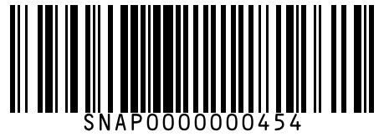
#455 | Britannia Milk Bread 400 g
Brand: Britannia
Variant: 400.000 g
SKU Code: SMSKU-000455
MRP: ₹48.00 | Sell: ₹45.00 | Discount: ₹3.00 flat | Final: ₹42.00
Available Qty: 16
Barcode: SNAP0000000455
 | 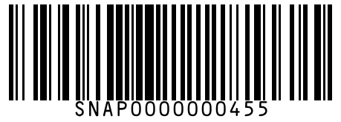
#456 | English Oven Gourmet Burger Buns 4 pcs
Brand: English Oven
Variant: 4.000 pcs
SKU Code: SMSKU-000456
MRP: ₹80.00 | Sell: ₹75.00 | Discount: ₹5.00 flat | Final: ₹70.00
Available Qty: 10
Barcode: SNAP0000000456
 | 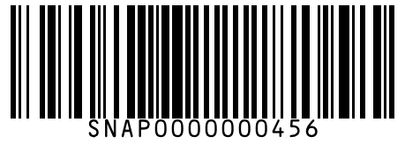
#457 | English Oven Pav Buns 6 pcs
Brand: English Oven
Variant: 6.000 pcs
SKU Code: SMSKU-000457
MRP: ₹60.00 | Sell: ₹58.00 | Discount: ₹2.00 flat | Final: ₹56.00
Available Qty: 12
Barcode: SNAP0000000457
 | 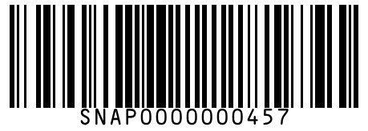
#458 | Cello Butterflow Ball Pen Blue (Pack of 10) 10 pcs
Brand: Cello
Variant: 10.000 pcs
SKU Code: SMSKU-000458
MRP: ₹100.00 | Sell: ₹90.00 | Discount: ₹10.00 flat | Final: ₹80.00
Available Qty: 15
Barcode: SNAP0000000458
 | 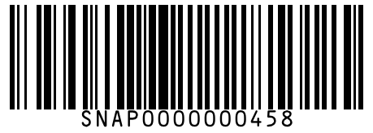
#459 | Reynolds Trimax Gel Pen Blue 1 pc
Brand: Reynolds
Variant: 1.000 pc
SKU Code: SMSKU-000459
MRP: ₹25.00 | Sell: ₹25.00 | Discount: None | Final: ₹25.00
Available Qty: 30
Barcode: SNAP0000000459
 | 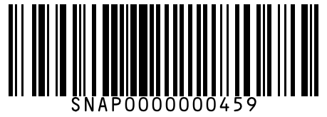
#460 | Classmate Spiral Notebook 200 Pages 1 pc
Brand: Classmate
Variant: 1.000 pc
SKU Code: SMSKU-000460
MRP: ₹80.00 | Sell: ₹75.00 | Discount: ₹5.00 flat | Final: ₹70.00
Available Qty: 20
Barcode: SNAP0000000460
 | 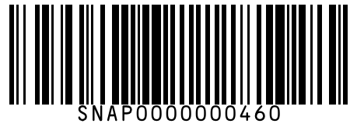
#461 | Camlin Kokuyo Mechanical Pencil 0.7mm 1 pc
Brand: Camlin
Variant: 1.000 pc
SKU Code: SMSKU-000461
MRP: ₹40.00 | Sell: ₹38.00 | Discount: ₹2.00 flat | Final: ₹36.00
Available Qty: 15
Barcode: SNAP0000000461
 | 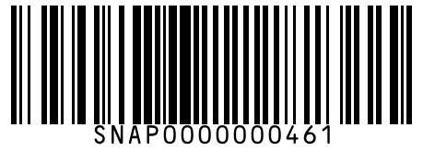
#462 | Fevicol SH Squeeze Bottle Glue 200 g
Brand: Fevicol
Variant: 200.000 g
SKU Code: SMSKU-000462
MRP: ₹95.00 | Sell: ₹90.00 | Discount: ₹5.00 flat | Final: ₹85.00
Available Qty: 12
Barcode: SNAP0000000462
 | 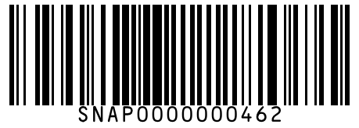
#463 | 3M Post-it Notes Pad (100 Sheets) 100 pcs
Brand: 3M
Variant: 100.000 pcs
SKU Code: SMSKU-000463
MRP: ₹90.00 | Sell: ₹85.00 | Discount: ₹5.00 flat | Final: ₹80.00
Available Qty: 10
Barcode: SNAP0000000463
 | 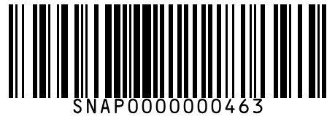
#464 | 7UP Lemon Soft Drink 250 ml
Brand: 7UP
Variant: 250.000 ml
SKU Code: SMSKU-000464
MRP: ₹20.00 | Sell: ₹20.00 | Discount: None | Final: ₹20.00
Available Qty: 30
Barcode: SNAP0000000464
 | 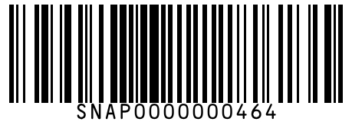
#465 | 7UP Lemon Soft Drink 500 ml
Brand: 7UP
Variant: 500.000 ml
SKU Code: SMSKU-000465
MRP: ₹40.00 | Sell: ₹40.00 | Discount: None | Final: ₹40.00
Available Qty: 20
Barcode: SNAP0000000465
 | 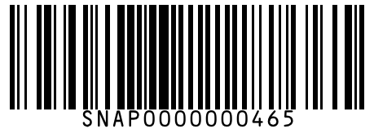
#466 | 7UP Lemon Soft Drink 2 L
Brand: 7UP
Variant: 2.000 L
SKU Code: SMSKU-000466
MRP: ₹95.00 | Sell: ₹90.00 | Discount: ₹5.00 flat | Final: ₹85.00
Available Qty: 8
Barcode: SNAP0000000466
 | 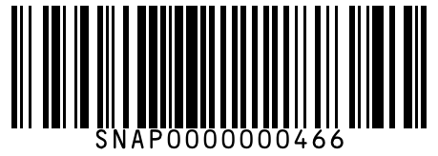
#467 | Mirinda Orange Soft Drink 250 ml
Brand: Mirinda
Variant: 250.000 ml
SKU Code: SMSKU-000467
MRP: ₹20.00 | Sell: ₹20.00 | Discount: None | Final: ₹20.00
Available Qty: 28
Barcode: SNAP0000000467
 | 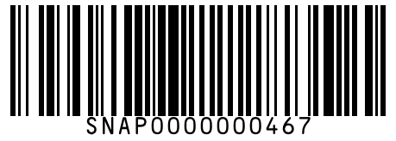
#468 | Mirinda Orange Soft Drink 500 ml
Brand: Mirinda
Variant: 500.000 ml
SKU Code: SMSKU-000468
MRP: ₹40.00 | Sell: ₹40.00 | Discount: None | Final: ₹40.00
Available Qty: 18
Barcode: SNAP0000000468
 | 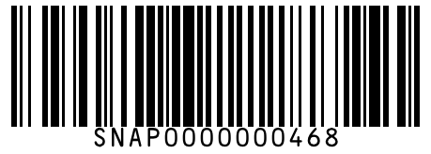
#469 | Mountain Dew Citrus Soft Drink 250 ml
Brand: Mountain Dew
Variant: 250.000 ml
SKU Code: SMSKU-000469
MRP: ₹20.00 | Sell: ₹20.00 | Discount: None | Final: ₹20.00
Available Qty: 25
Barcode: SNAP0000000469
 | 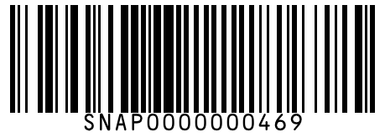
#470 | Mountain Dew Citrus Soft Drink 500 ml
Brand: Mountain Dew
Variant: 500.000 ml
SKU Code: SMSKU-000470
MRP: ₹40.00 | Sell: ₹40.00 | Discount: None | Final: ₹40.00
Available Qty: 16
Barcode: SNAP0000000470
 | 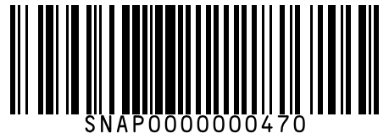
#471 | Mountain Dew Citrus Soft Drink 2 L
Brand: Mountain Dew
Variant: 2.000 L
SKU Code: SMSKU-000471
MRP: ₹95.00 | Sell: ₹90.00 | Discount: ₹5.00 flat | Final: ₹85.00
Available Qty: 7
Barcode: SNAP0000000471
 | 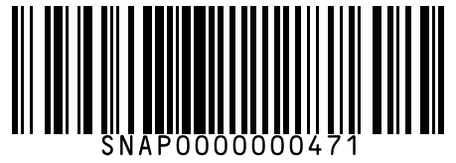
#472 | Real Guava Juice 200 ml
Brand: Real
Variant: 200.000 ml
SKU Code: SMSKU-000472
MRP: ₹30.00 | Sell: ₹28.00 | Discount: ₹2.00 flat | Final: ₹26.00
Available Qty: 18
Barcode: SNAP0000000472
 | 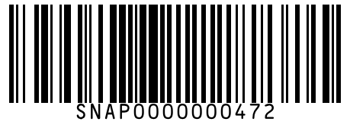
#473 | Real Guava Juice 1 L
Brand: Real
Variant: 1.000 L
SKU Code: SMSKU-000473
MRP: ₹115.00 | Sell: ₹108.00 | Discount: ₹7.00 flat | Final: ₹101.00
Available Qty: 8
Barcode: SNAP0000000473
 | 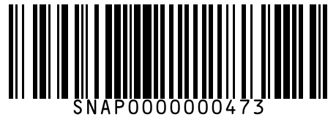
#474 | Minute Maid Pulpy Orange 400 ml
Brand: Minute Maid
Variant: 400.000 ml
SKU Code: SMSKU-000474
MRP: ₹45.00 | Sell: ₹42.00 | Discount: ₹3.00 flat | Final: ₹39.00
Available Qty: 16
Barcode: SNAP0000000474
 | 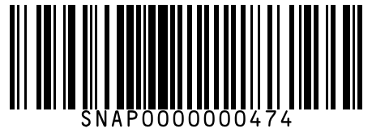
#475 | Minute Maid Pulpy Orange 1 L
Brand: Minute Maid
Variant: 1.000 L
SKU Code: SMSKU-000475
MRP: ₹99.00 | Sell: ₹92.00 | Discount: ₹7.00 flat | Final: ₹85.00
Available Qty: 8
Barcode: SNAP0000000475
 | 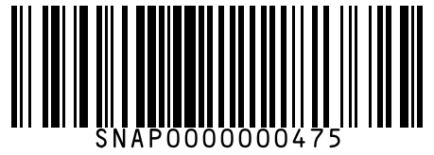
#476 | Paper Boat Chilled Shikanji 200 ml
Brand: Paper Boat
Variant: 200.000 ml
SKU Code: SMSKU-000476
MRP: ₹30.00 | Sell: ₹28.00 | Discount: ₹2.00 flat | Final: ₹26.00
Available Qty: 14
Barcode: SNAP0000000476
 | 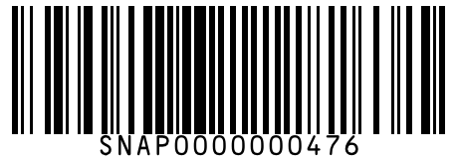
#477 | Bisleri Mineral Water 500 ml
Brand: Bisleri
Variant: 500.000 ml
SKU Code: SMSKU-000477
MRP: ₹20.00 | Sell: ₹20.00 | Discount: None | Final: ₹20.00
Available Qty: 60
Barcode: SNAP0000000477
 | 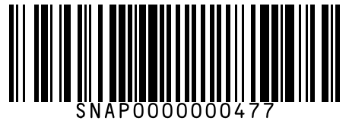
#478 | Bisleri Mineral Water 1 L
Brand: Bisleri
Variant: 1.000 L
SKU Code: SMSKU-000478
MRP: ₹30.00 | Sell: ₹30.00 | Discount: None | Final: ₹30.00
Available Qty: 40
Barcode: SNAP0000000478
 | 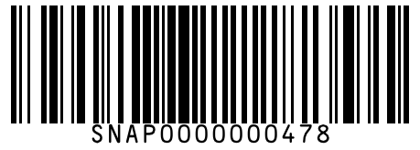
#479 | Bisleri Mineral Water 2 L
Brand: Bisleri
Variant: 2.000 L
SKU Code: SMSKU-000479
MRP: ₹50.00 | Sell: ₹48.00 | Discount: ₹2.00 flat | Final: ₹46.00
Available Qty: 20
Barcode: SNAP0000000479
 | 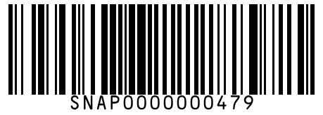
#480 | Wagh Bakri Premium Leaf Tea 250 g
Brand: Wagh Bakri
Variant: 250.000 g
SKU Code: SMSKU-000480
MRP: ₹145.00 | Sell: ₹138.00 | Discount: ₹7.00 flat | Final: ₹131.00
Available Qty: 15
Barcode: SNAP0000000480
 | 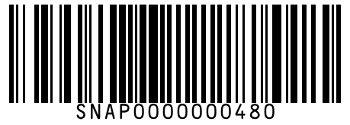
#481 | Wagh Bakri Premium Leaf Tea 500 g
Brand: Wagh Bakri
Variant: 500.000 g
SKU Code: SMSKU-000481
MRP: ₹280.00 | Sell: ₹268.00 | Discount: ₹12.00 flat | Final: ₹256.00
Available Qty: 8
Barcode: SNAP0000000481
 | 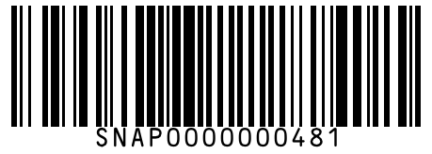
#482 | MDH Rajma Masala 100 g
Brand: MDH
Variant: 100.000 g
SKU Code: SMSKU-000482
MRP: ₹68.00 | Sell: ₹64.00 | Discount: ₹4.00 flat | Final: ₹60.00
Available Qty: 15
Barcode: SNAP0000000482
 | 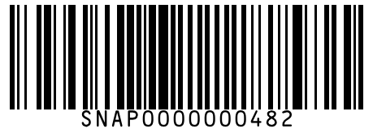
#483 | Everest Pav Bhaji Masala 50 g
Brand: Everest
Variant: 50.000 g
SKU Code: SMSKU-000483
MRP: ₹50.00 | Sell: ₹48.00 | Discount: ₹2.00 flat | Final: ₹46.00
Available Qty: 20
Barcode: SNAP0000000483
 | 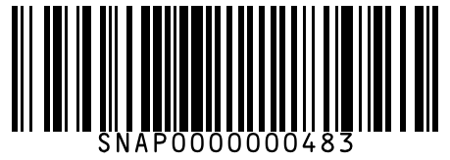
#484 | Everest Pav Bhaji Masala 100 g
Brand: Everest
Variant: 100.000 g
SKU Code: SMSKU-000484
MRP: ₹95.00 | Sell: ₹90.00 | Discount: ₹5.00 flat | Final: ₹85.00
Available Qty: 12
Barcode: SNAP0000000484
 | 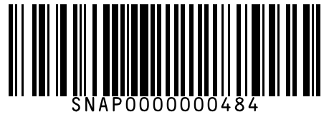
#485 | Catch Garlic Powder 100 g
Brand: Catch
Variant: 100.000 g
SKU Code: SMSKU-000485
MRP: ₹88.00 | Sell: ₹82.00 | Discount: ₹6.00 flat | Final: ₹76.00
Available Qty: 14
Barcode: SNAP0000000485
 | 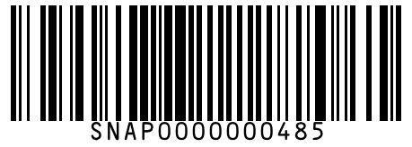
#486 | Shan Biryani Masala Mix 65 g
Brand: Shan
Variant: 65.000 g
SKU Code: SMSKU-000486
MRP: ₹72.00 | Sell: ₹68.00 | Discount: ₹4.00 flat | Final: ₹64.00
Available Qty: 10
Barcode: SNAP0000000486
 | 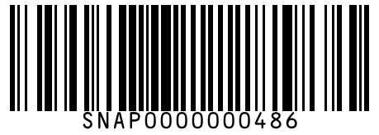
#487 | Haldiram's Chivda 400 g
Brand: Haldiram's
Variant: 400.000 g
SKU Code: SMSKU-000487
MRP: ₹130.00 | Sell: ₹125.00 | Discount: ₹5.00 flat | Final: ₹120.00
Available Qty: 12
Barcode: SNAP0000000487
 | 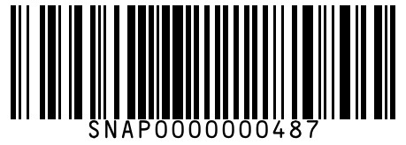
#488 | Bikaji Bhujia 200 g
Brand: Bikaji
Variant: 200.000 g
SKU Code: SMSKU-000488
MRP: ₹75.00 | Sell: ₹70.00 | Discount: ₹5.00 flat | Final: ₹65.00
Available Qty: 14
Barcode: SNAP0000000488
 | 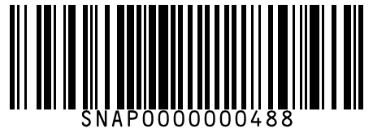
#489 | Bikaji Bhujia 400 g
Brand: Bikaji
Variant: 400.000 g
SKU Code: SMSKU-000489
MRP: ₹145.00 | Sell: ₹135.00 | Discount: ₹10.00 flat | Final: ₹125.00
Available Qty: 8
Barcode: SNAP0000000489
 | 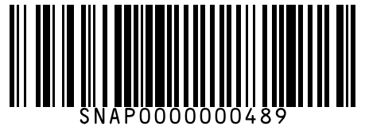
#490 | Uncle Chipps Spicy Treat 26 g
Brand: Uncle Chipps
Variant: 26.000 g
SKU Code: SMSKU-000490
MRP: ₹10.00 | Sell: ₹10.00 | Discount: None | Final: ₹10.00
Available Qty: 30
Barcode: SNAP0000000490
 | 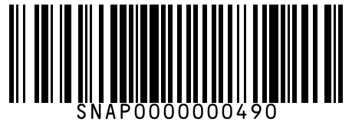
#491 | Uncle Chipps Spicy Treat 52 g
Brand: Uncle Chipps
Variant: 52.000 g
SKU Code: SMSKU-000491
MRP: ₹20.00 | Sell: ₹20.00 | Discount: None | Final: ₹20.00
Available Qty: 22
Barcode: SNAP0000000491
 | 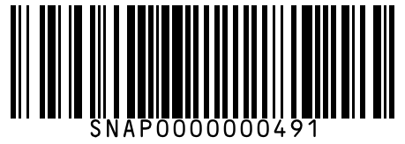
#492 | Natkhat Puffed Rice Murmura 200 g
Brand: Natkhat
Variant: 200.000 g
SKU Code: SMSKU-000492
MRP: ₹30.00 | Sell: ₹28.00 | Discount: ₹2.00 flat | Final: ₹26.00
Available Qty: 20
Barcode: SNAP0000000492
 | 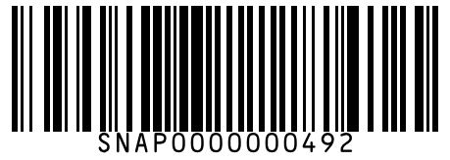
#493 | Parle Hide & Seek Chocolate Biscuits 100 g
Brand: Parle
Variant: 100.000 g
SKU Code: SMSKU-000493
MRP: ₹35.00 | Sell: ₹33.00 | Discount: ₹2.00 flat | Final: ₹31.00
Available Qty: 22
Barcode: SNAP0000000493
 | 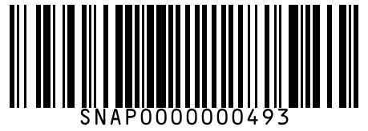
#494 | Parle Hide & Seek Chocolate Biscuits 200 g
Brand: Parle
Variant: 200.000 g
SKU Code: SMSKU-000494
MRP: ₹65.00 | Sell: ₹62.00 | Discount: ₹3.00 flat | Final: ₹59.00
Available Qty: 14
Barcode: SNAP0000000494
 | 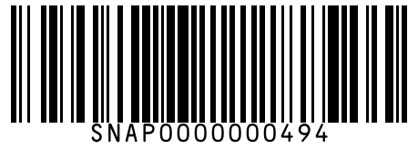
#495 | Britannia Good Day Butter Cookies 200 g
Brand: Britannia
Variant: 200.000 g
SKU Code: SMSKU-000495
MRP: ₹55.00 | Sell: ₹52.00 | Discount: ₹3.00 flat | Final: ₹49.00
Available Qty: 18
Barcode: SNAP0000000495
 | 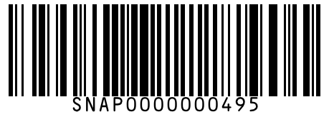
#496 | Parle 20-20 Cashew & Badam Biscuits 150 g
Brand: Parle
Variant: 150.000 g
SKU Code: SMSKU-000496
MRP: ₹40.00 | Sell: ₹38.00 | Discount: ₹2.00 flat | Final: ₹36.00
Available Qty: 15
Barcode: SNAP0000000496
 | 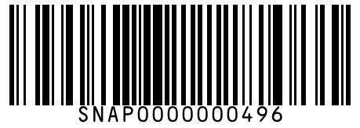
#497 | Amul Milk Chocolate Bar 150 g
Brand: Amul
Variant: 150.000 g
SKU Code: SMSKU-000497
MRP: ₹165.00 | Sell: ₹158.00 | Discount: ₹7.00 flat | Final: ₹151.00
Available Qty: 12
Barcode: SNAP0000000497
 | 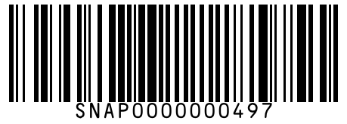
#498 | Cadbury Bournville Dark Chocolate 80 g
Brand: Cadbury
Variant: 80.000 g
SKU Code: SMSKU-000498
MRP: ₹140.00 | Sell: ₹133.00 | Discount: ₹7.00 flat | Final: ₹126.00
Available Qty: 10
Barcode: SNAP0000000498
 | 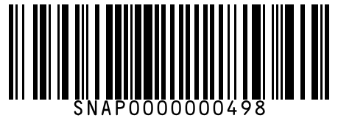
#499 | Munch Crispier Chocolate Bar 18 g
Brand: Munch
Variant: 18.000 g
SKU Code: SMSKU-000499
MRP: ₹10.00 | Sell: ₹10.00 | Discount: None | Final: ₹10.00
Available Qty: 35
Barcode: SNAP0000000499
 | 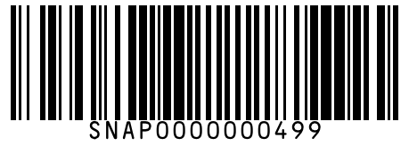
#500 | Dabur Honey 250 g
Brand: Dabur
Variant: 250.000 g
SKU Code: SMSKU-000500
MRP: ₹185.00 | Sell: ₹175.00 | Discount: ₹10.00 flat | Final: ₹165.00
Available Qty: 14
Barcode: SNAP0000000500
 | 
#501 | Dabur Honey 500 g
Brand: Dabur
Variant: 500.000 g
SKU Code: SMSKU-000501
MRP: ₹360.00 | Sell: ₹345.00 | Discount: ₹15.00 flat | Final: ₹330.00
Available Qty: 8
Barcode: SNAP0000000501
 | 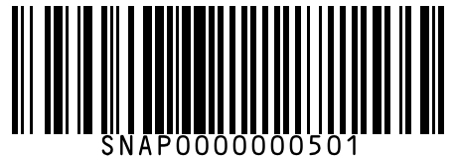
#502 | Apis Himalayan Honey 250 g
Brand: Apis
Variant: 250.000 g
SKU Code: SMSKU-000502
MRP: ₹175.00 | Sell: ₹165.00 | Discount: ₹10.00 flat | Final: ₹155.00
Available Qty: 10
Barcode: SNAP0000000502
 | 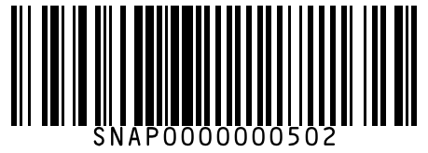
#503 | Happilo Premium Cashews 100 g
Brand: Happilo
Variant: 100.000 g
SKU Code: SMSKU-000503
MRP: ₹175.00 | Sell: ₹165.00 | Discount: ₹10.00 flat | Final: ₹155.00
Available Qty: 12
Barcode: SNAP0000000503
 | 
#504 | Happilo Premium Cashews 200 g
Brand: Happilo
Variant: 200.000 g
SKU Code: SMSKU-000504
MRP: ₹340.00 | Sell: ₹325.00 | Discount: ₹15.00 flat | Final: ₹310.00
Available Qty: 6
Barcode: SNAP0000000504
 | 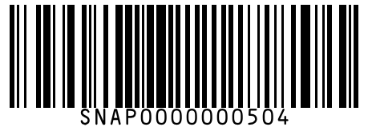
#505 | Happilo Premium Almonds 100 g
Brand: Happilo
Variant: 100.000 g
SKU Code: SMSKU-000505
MRP: ₹155.00 | Sell: ₹148.00 | Discount: ₹7.00 flat | Final: ₹141.00
Available Qty: 12
Barcode: SNAP0000000505
 | 
#506 | Happilo Premium Almonds 200 g
Brand: Happilo
Variant: 200.000 g
SKU Code: SMSKU-000506
MRP: ₹300.00 | Sell: ₹285.00 | Discount: ₹15.00 flat | Final: ₹270.00
Available Qty: 6
Barcode: SNAP0000000506
 | 
#507 | Nutraj Mixed Nuts 200 g
Brand: Nutraj
Variant: 200.000 g
SKU Code: SMSKU-000507
MRP: ₹295.00 | Sell: ₹280.00 | Discount: ₹15.00 flat | Final: ₹265.00
Available Qty: 8
Barcode: SNAP0000000507
 | 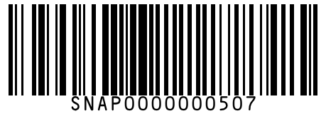
#508 | Parachute Coconut Oil Jar 500 ml
Brand: Parachute
Variant: 500.000 ml
SKU Code: SMSKU-000508
MRP: ₹195.00 | Sell: ₹185.00 | Discount: ₹10.00 flat | Final: ₹175.00
Available Qty: 12
Barcode: SNAP0000000508
 | 
#509 | Parachute Coconut Oil Jar 1 L
Brand: Parachute
Variant: 1.000 L
SKU Code: SMSKU-000509
MRP: ₹375.00 | Sell: ₹358.00 | Discount: ₹17.00 flat | Final: ₹341.00
Available Qty: 6
Barcode: SNAP0000000509
 | 
#510 | Fortune Soyabean Refined Oil 1 L
Brand: Fortune
Variant: 1.000 L
SKU Code: SMSKU-000510
MRP: ₹130.00 | Sell: ₹125.00 | Discount: ₹5.00 flat | Final: ₹120.00
Available Qty: 18
Barcode: SNAP0000000510
 | 
#511 | Fortune Soyabean Refined Oil 5 L
Brand: Fortune
Variant: 5.000 L
SKU Code: SMSKU-000511
MRP: ₹620.00 | Sell: ₹595.00 | Discount: ₹25.00 flat | Final: ₹570.00
Available Qty: 6
Barcode: SNAP0000000511
 | 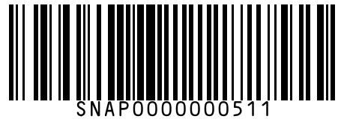
#512 | Garnier Fructis Long & Strong Shampoo 175 ml
Brand: Garnier
Variant: 175.000 ml
SKU Code: SMSKU-000512
MRP: ₹199.00 | Sell: ₹190.00 | Discount: ₹9.00 flat | Final: ₹181.00
Available Qty: 10
Barcode: SNAP0000000512
 | 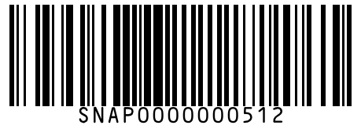
#513 | Garnier Fructis Long & Strong Shampoo 340 ml
Brand: Garnier
Variant: 340.000 ml
SKU Code: SMSKU-000513
MRP: ₹380.00 | Sell: ₹362.00 | Discount: ₹18.00 flat | Final: ₹344.00
Available Qty: 5
Barcode: SNAP0000000513
 | 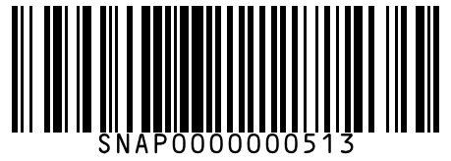
#514 | WOW Onion Black Seed Hair Oil 100 ml
Brand: WOW
Variant: 100.000 ml
SKU Code: SMSKU-000514
MRP: ₹349.00 | Sell: ₹330.00 | Discount: ₹19.00 flat | Final: ₹311.00
Available Qty: 8
Barcode: SNAP0000000514
 | 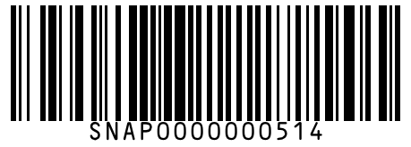
#515 | Mamaearth Onion Shampoo for Hair Growth 250 ml
Brand: Mamaearth
Variant: 250.000 ml
SKU Code: SMSKU-000515
MRP: ₹349.00 | Sell: ₹330.00 | Discount: ₹19.00 flat | Final: ₹311.00
Available Qty: 7
Barcode: SNAP0000000515
 | 
#516 | Dabur Red Toothpaste 100 g
Brand: Dabur
Variant: 100.000 g
SKU Code: SMSKU-000516
MRP: ₹68.00 | Sell: ₹65.00 | Discount: ₹3.00 flat | Final: ₹62.00
Available Qty: 18
Barcode: SNAP0000000516
 | 
#517 | Dabur Red Toothpaste 200 g
Brand: Dabur
Variant: 200.000 g
SKU Code: SMSKU-000517
MRP: ₹128.00 | Sell: ₹122.00 | Discount: ₹6.00 flat | Final: ₹116.00
Available Qty: 10
Barcode: SNAP0000000517
 | 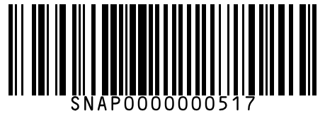
#518 | Himalaya Complete Care Toothpaste 80 g
Brand: Himalaya
Variant: 80.000 g
SKU Code: SMSKU-000518
MRP: ₹62.00 | Sell: ₹58.00 | Discount: ₹4.00 flat | Final: ₹54.00
Available Qty: 16
Barcode: SNAP0000000518
 | 
#519 | Himalaya Complete Care Toothpaste 150 g
Brand: Himalaya
Variant: 150.000 g
SKU Code: SMSKU-000519
MRP: ₹112.00 | Sell: ₹106.00 | Discount: ₹6.00 flat | Final: ₹100.00
Available Qty: 10
Barcode: SNAP0000000519
 | 
#520 | Rin Advanced Powder Detergent 500 g
Brand: Rin
Variant: 500.000 g
SKU Code: SMSKU-000520
MRP: ₹42.00 | Sell: ₹40.00 | Discount: ₹2.00 flat | Final: ₹38.00
Available Qty: 25
Barcode: SNAP0000000520
 | 
#521 | Rin Advanced Powder Detergent 1 kg
Brand: Rin
Variant: 1.000 kg
SKU Code: SMSKU-000521
MRP: ₹80.00 | Sell: ₹76.00 | Discount: ₹4.00 flat | Final: ₹72.00
Available Qty: 16
Barcode: SNAP0000000521
 | 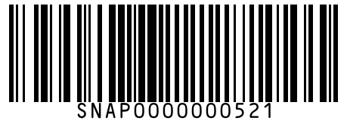
#522 | Rin Advanced Powder Detergent 2 kg
Brand: Rin
Variant: 2.000 kg
SKU Code: SMSKU-000522
MRP: ₹155.00 | Sell: ₹148.00 | Discount: ₹7.00 flat | Final: ₹141.00
Available Qty: 8
Barcode: SNAP0000000522
 | 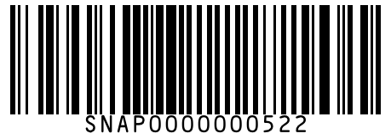
#523 | Wheel Active 3 Detergent Powder 500 g
Brand: Wheel
Variant: 500.000 g
SKU Code: SMSKU-000523
MRP: ₹30.00 | Sell: ₹30.00 | Discount: None | Final: ₹30.00
Available Qty: 30
Barcode: SNAP0000000523
 | 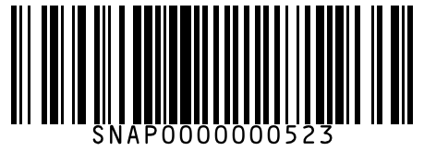
#524 | Wheel Active 3 Detergent Powder 2 kg
Brand: Wheel
Variant: 2.000 kg
SKU Code: SMSKU-000524
MRP: ₹110.00 | Sell: ₹105.00 | Discount: ₹5.00 flat | Final: ₹100.00
Available Qty: 14
Barcode: SNAP0000000524
 | 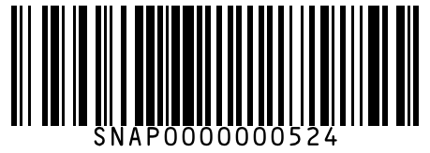
#525 | Lizol Pine Fresh Floor Cleaner 500 ml
Brand: Lizol
Variant: 500.000 ml
SKU Code: SMSKU-000525
MRP: ₹110.00 | Sell: ₹105.00 | Discount: ₹5.00 flat | Final: ₹100.00
Available Qty: 14
Barcode: SNAP0000000525
 | 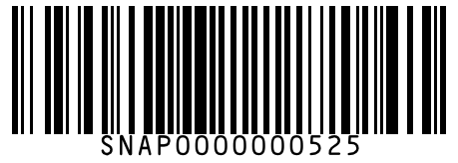
#526 | Exo Dishwash Bar 200 g
Brand: Exo
Variant: 200.000 g
SKU Code: SMSKU-000526
MRP: ₹22.00 | Sell: ₹20.00 | Discount: ₹2.00 flat | Final: ₹18.00
Available Qty: 30
Barcode: SNAP0000000526
 | 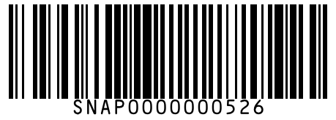
#527 | Exo Dishwash Bar 600 g
Brand: Exo
Variant: 600.000 g
SKU Code: SMSKU-000527
MRP: ₹58.00 | Sell: ₹55.00 | Discount: ₹3.00 flat | Final: ₹52.00
Available Qty: 15
Barcode: SNAP0000000527
 | 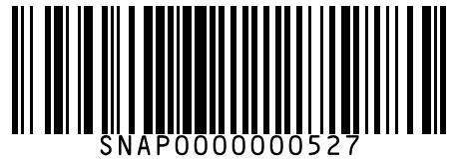
#528 | HIT Mosquito & Fly Killer Spray 200 ml
Brand: HIT
Variant: 200.000 ml
SKU Code: SMSKU-000528
MRP: ₹155.00 | Sell: ₹148.00 | Discount: ₹7.00 flat | Final: ₹141.00
Available Qty: 12
Barcode: SNAP0000000528
 | 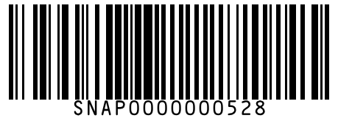
#529 | Mortein Power Guard Mosquito Coil 10 pcs
Brand: Mortein
Variant: 10.000 pcs
SKU Code: SMSKU-000529
MRP: ₹48.00 | Sell: ₹45.00 | Discount: ₹3.00 flat | Final: ₹42.00
Available Qty: 20
Barcode: SNAP0000000529
 | 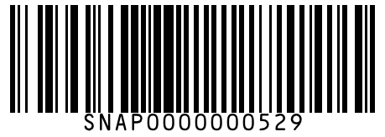
#530 | Milky Mist Paneer 200 g
Brand: Milky Mist
Variant: 200.000 g
SKU Code: SMSKU-000530
MRP: ₹92.00 | Sell: ₹88.00 | Discount: ₹4.00 flat | Final: ₹84.00
Available Qty: 14
Barcode: SNAP0000000530
 | 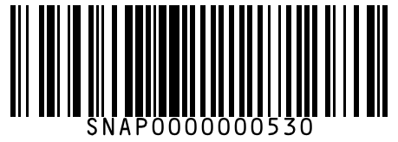
#531 | Milky Mist Paneer 500 g
Brand: Milky Mist
Variant: 500.000 g
SKU Code: SMSKU-000531
MRP: ₹220.00 | Sell: ₹210.00 | Discount: ₹10.00 flat | Final: ₹200.00
Available Qty: 7
Barcode: SNAP0000000531
 | 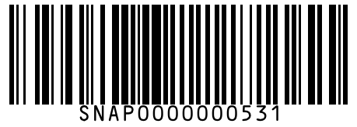
#532 | Amul Masti Spiced Buttermilk 200 ml
Brand: Amul
Variant: 200.000 ml
SKU Code: SMSKU-000532
MRP: ₹18.00 | Sell: ₹18.00 | Discount: None | Final: ₹18.00
Available Qty: 35
Barcode: SNAP0000000532
 | 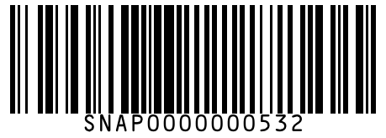
#533 | Maggi Masala Oats Veggie 39 g
Brand: Maggi
Variant: 39.000 g
SKU Code: SMSKU-000533
MRP: ₹25.00 | Sell: ₹25.00 | Discount: None | Final: ₹25.00
Available Qty: 20
Barcode: SNAP0000000533
 | 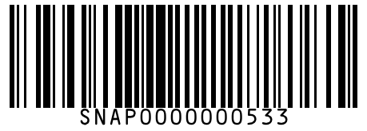
#534 | MTR Ready to Eat Chole 300 g
Brand: MTR
Variant: 300.000 g
SKU Code: SMSKU-000534
MRP: ₹99.00 | Sell: ₹92.00 | Discount: ₹7.00 flat | Final: ₹85.00
Available Qty: 10
Barcode: SNAP0000000534
 | 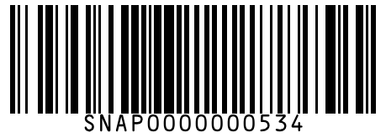
#535 | Gits Gulab Jamun Mix 500 g
Brand: Gits
Variant: 500.000 g
SKU Code: SMSKU-000535
MRP: ₹120.00 | Sell: ₹115.00 | Discount: ₹5.00 flat | Final: ₹110.00
Available Qty: 10
Barcode: SNAP0000000535
 | 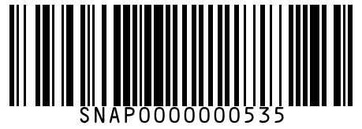
#536 | Gits Dosa Mix 500 g
Brand: Gits
Variant: 500.000 g
SKU Code: SMSKU-000536
MRP: ₹120.00 | Sell: ₹115.00 | Discount: ₹5.00 flat | Final: ₹110.00
Available Qty: 12
Barcode: SNAP0000000536
 | 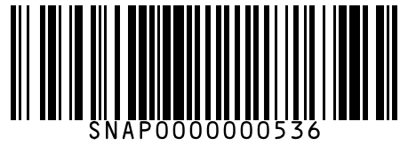
#537 | Bagrry's White Oats Quick Cook 400 g
Brand: Bagrry's
Variant: 400.000 g
SKU Code: SMSKU-000537
MRP: ₹165.00 | Sell: ₹155.00 | Discount: ₹10.00 flat | Final: ₹145.00
Available Qty: 10
Barcode: SNAP0000000537
 | 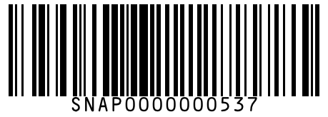
#538 | Bagrry's White Oats Quick Cook 1 kg
Brand: Bagrry's
Variant: 1.000 kg
SKU Code: SMSKU-000538
MRP: ₹385.00 | Sell: ₹365.00 | Discount: ₹20.00 flat | Final: ₹345.00
Available Qty: 5
Barcode: SNAP0000000538
 | 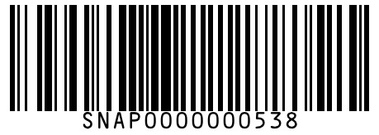
#539 | Quaker Oats Plus 5 Protein Cereals 500 g
Brand: Quaker
Variant: 500.000 g
SKU Code: SMSKU-000539
MRP: ₹210.00 | Sell: ₹200.00 | Discount: ₹10.00 flat | Final: ₹190.00
Available Qty: 8
Barcode: SNAP0000000539
 | 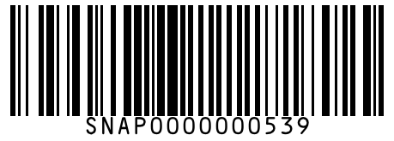
#540 | Maggi Hot & Sweet Tomato Sauce 200 g
Brand: Maggi
Variant: 200.000 g
SKU Code: SMSKU-000540
MRP: ₹55.00 | Sell: ₹52.00 | Discount: ₹3.00 flat | Final: ₹49.00
Available Qty: 14
Barcode: SNAP0000000540
 | 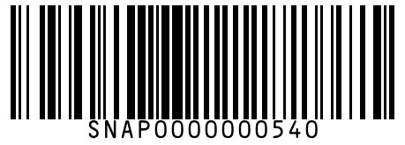
#541 | Maggi Hot & Sweet Tomato Sauce 400 g
Brand: Maggi
Variant: 400.000 g
SKU Code: SMSKU-000541
MRP: ₹99.00 | Sell: ₹94.00 | Discount: ₹5.00 flat | Final: ₹89.00
Available Qty: 8
Barcode: SNAP0000000541
 | 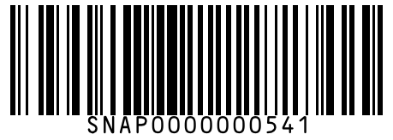
#542 | Dr. Oetker Funfoods Eggless Mayonnaise 275 g
Brand: Dr. Oetker
Variant: 275.000 g
SKU Code: SMSKU-000542
MRP: ₹130.00 | Sell: ₹125.00 | Discount: ₹5.00 flat | Final: ₹120.00
Available Qty: 10
Barcode: SNAP0000000542
 | 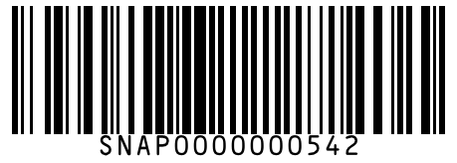
#543 | Heinz Tomato Ketchup 300 g
Brand: Heinz
Variant: 300.000 g
SKU Code: SMSKU-000543
MRP: ₹145.00 | Sell: ₹138.00 | Discount: ₹7.00 flat | Final: ₹131.00
Available Qty: 10
Barcode: SNAP0000000543
 | 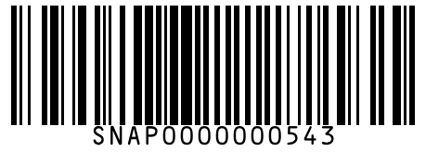
#544 | Heinz Tomato Ketchup 900 g
Brand: Heinz
Variant: 900.000 g
SKU Code: SMSKU-000544
MRP: ₹390.00 | Sell: ₹375.00 | Discount: ₹15.00 flat | Final: ₹360.00
Available Qty: 4
Barcode: SNAP0000000544
 | 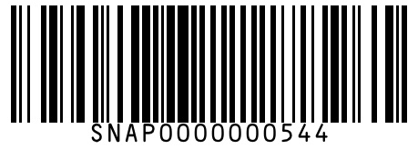
#545 | Huggies Soft Skin Baby Wipes 80 pcs
Brand: Huggies
Variant: 80.000 pcs
SKU Code: SMSKU-000545
MRP: ₹199.00 | Sell: ₹190.00 | Discount: ₹9.00 flat | Final: ₹181.00
Available Qty: 10
Barcode: SNAP0000000545
 | 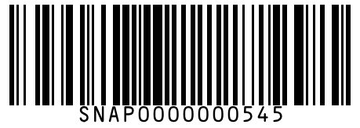
#546 | Himalaya Baby Lotion 200 ml
Brand: Himalaya
Variant: 200.000 ml
SKU Code: SMSKU-000546
MRP: ₹175.00 | Sell: ₹168.00 | Discount: ₹7.00 flat | Final: ₹161.00
Available Qty: 10
Barcode: SNAP0000000546
 | 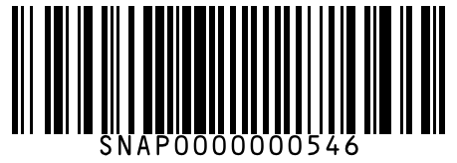
#547 | Himalaya Baby Lotion 400 ml
Brand: Himalaya
Variant: 400.000 ml
SKU Code: SMSKU-000547
MRP: ₹320.00 | Sell: ₹305.00 | Discount: ₹15.00 flat | Final: ₹290.00
Available Qty: 5
Barcode: SNAP0000000547
 | 